BAC Digital Performance
Easy Read Guide

Summary
This is an easy read guide to tell you how to access BAC’s digital performances.

How to Log onto Your Performance
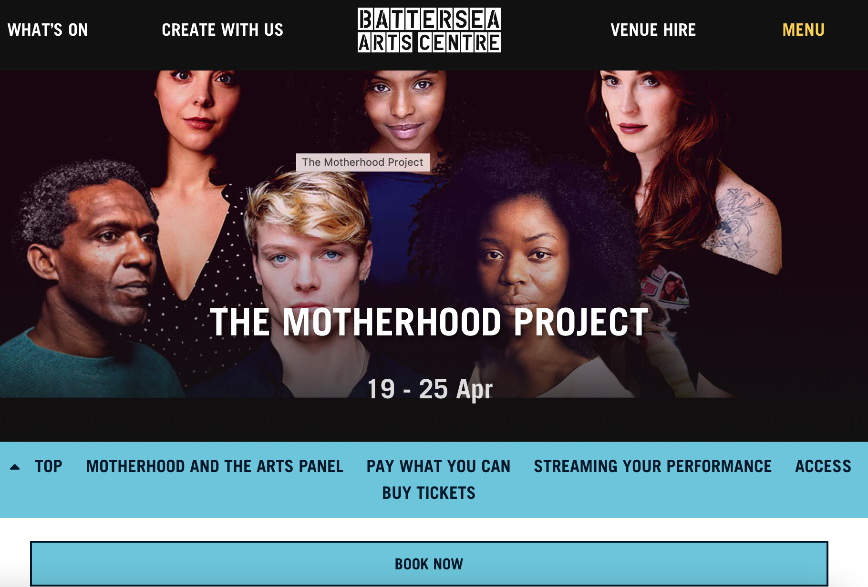 | Go to the page of the performance you want to see.  For example, if you are going to see Motherhood you would go to this page
 | Click on the button that says ‘Watch now’
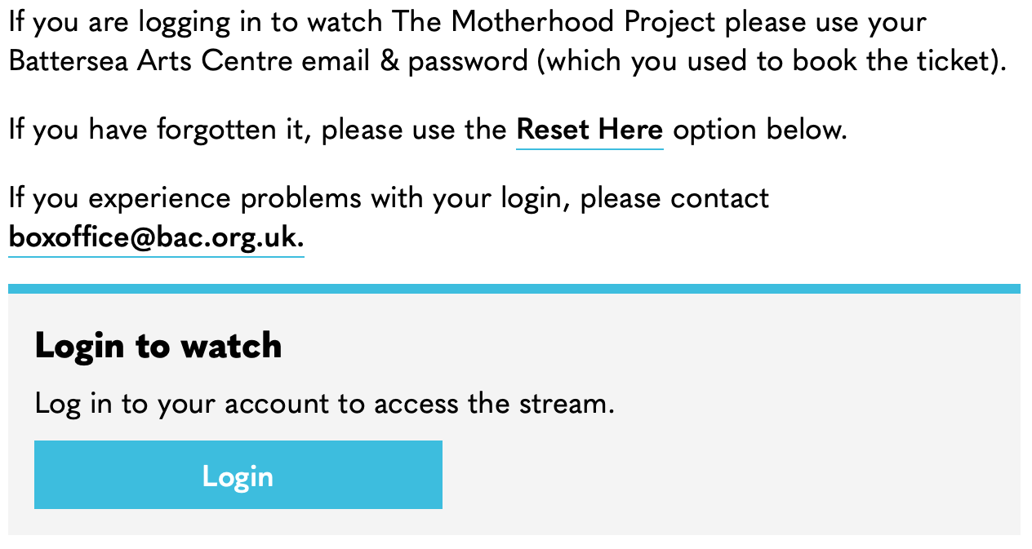 | The ‘watch now’ link will take you to a login page.  Click the ‘login’ button
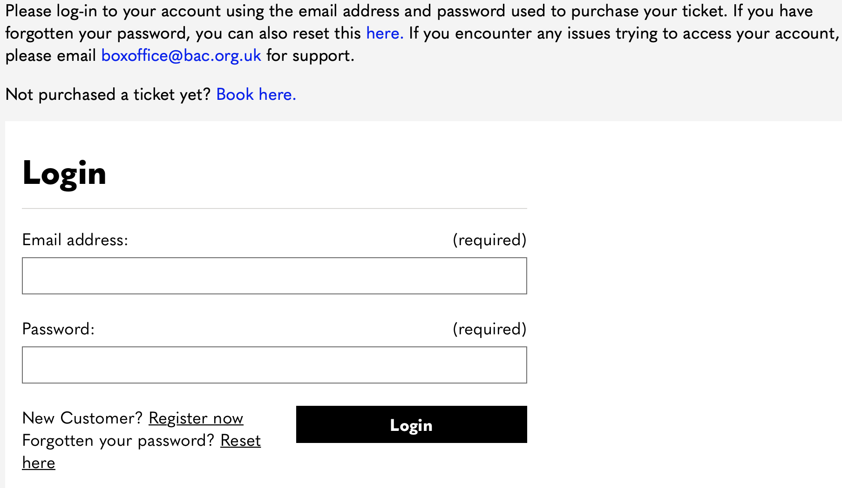 | Login using the same information you used to buy the ticket. This is:  - Your email  - Your password
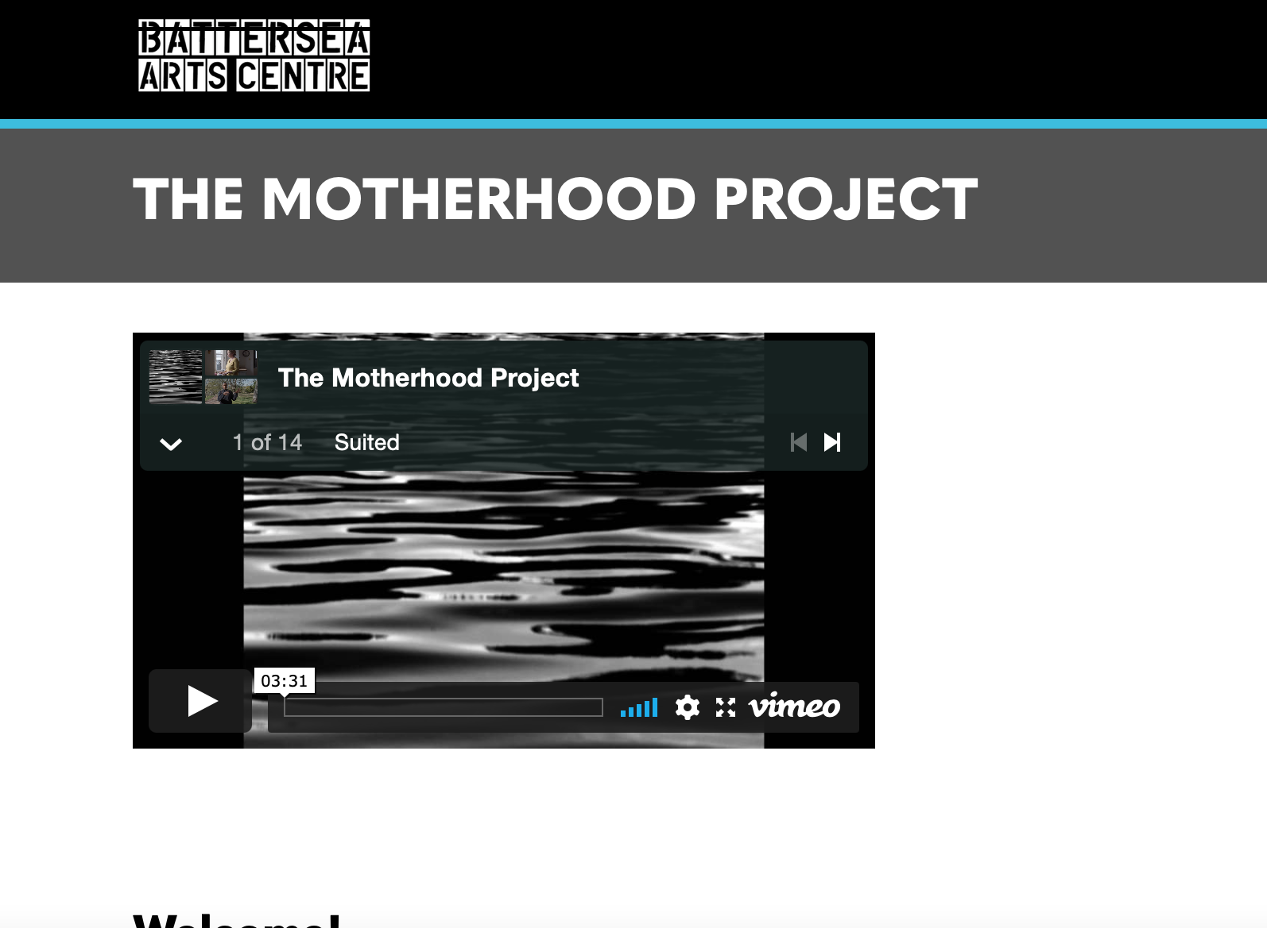 | This will take you to a page where you can play your performance.  For example, this picture shows the page for The Motherhood Project.
 | Enjoy the performance!

Some of the stock imagery comes from Disabled and Here, a project creating stock images celebrating disabled Black, Indigenous, people of colour. The photographer credits from Disabled and Here for this Easy Read guide are Tojo Andrianarivo and Chona Kasunga.

