The Dan Daw Show – Pre show Information

This information is to help you decide if The Dan Daw Show is for you. Content notes, including what happens in the show, are further in the document.

The Space
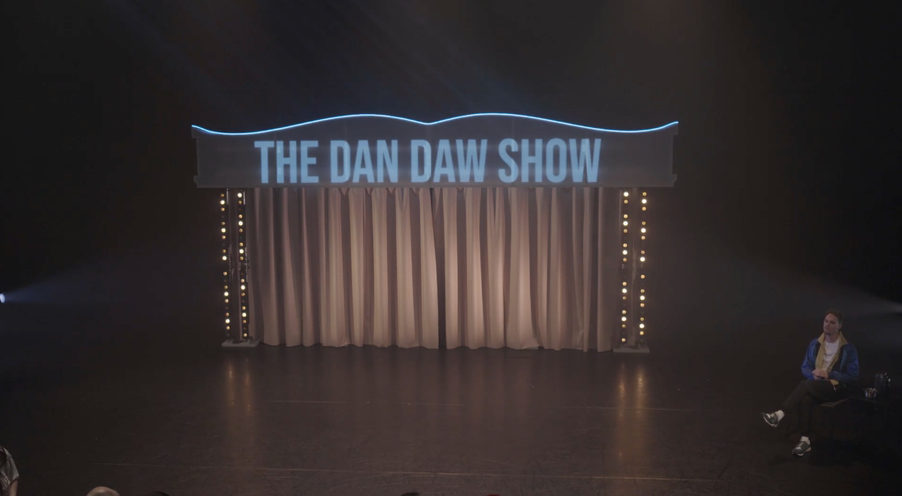

The Performers
- The performers are:

Dan Daw (who plays himself)

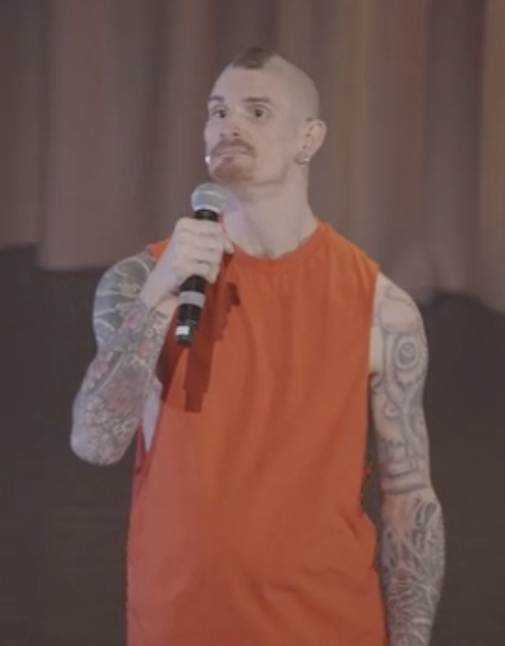

Christopher Owen (who plays KrisX)
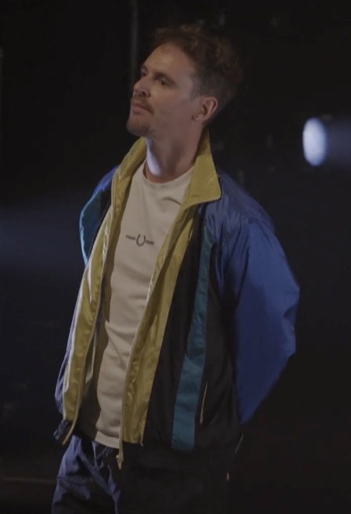

Lighting and Sound
- The entire show is very loud
- There will bright flashing lights through the whole performance
- Sometimes there is music while people are speaking but the entire show is captioned

Participation
- Dan Daw will encourage you to cheer for him at the start of the show
- There is no audience participation in the show

Content Notes
In The Dan Daw Show, Dan and KrisX move and talk. First, Dan introduces himself and KrisX. Dan explains that he has made everything in the show happen. KrisX tells Dan what to do. Sometimes Dan says when he has had enough. KrisX and Dan dance together. Dan tells KrisX that the tattoo on his back is an Oni and it is Dan’s armour for the world outside. Dan and KrisX move together again. Dan gets in a box made of latex and all the air is vacuumed out, so it squeezes Dan. Dan gets out. Dan and KrisX dance again. Dan talks about how good the performance feels and how grateful he is to be in his body. Dan puts on an Oni costume, but instead of just being armour it is also pride and joy. The Oni costume inflates.
The show is about letting go of shame to access pride, and the initial vulnerability, and then joy, in asking for what you want and need. The show talks about and shows kink and power play. It shows consensual suffocation and domination, but all on Dan’s terms.

Access Information
- The performance is 90 minutes long
- There is no interval
- The performance space has step-free access via a lift
- All performances are Relaxed this means you can move or make noise if you need to and can go in and out of the performance space
- All performances are captioned (the captioning does not include music description)
- Latecomers will be permitted
- There will be a space for disabled audience members to debrief after each show
- There will be a sensory adaptive show on Tuesday 3 May
  - This means that the lights, sound and haze will be adapted for people with sensory sensitivities. The house lights will also be up.
- Ear defenders are available to borrow from the box office for anyone who might find these useful
- There is an accessible toilet on every floor of the building
- There is a chill out space outside the performance space that is available anytime the building is open

