The Dan Daw Show
Easy Read Guide
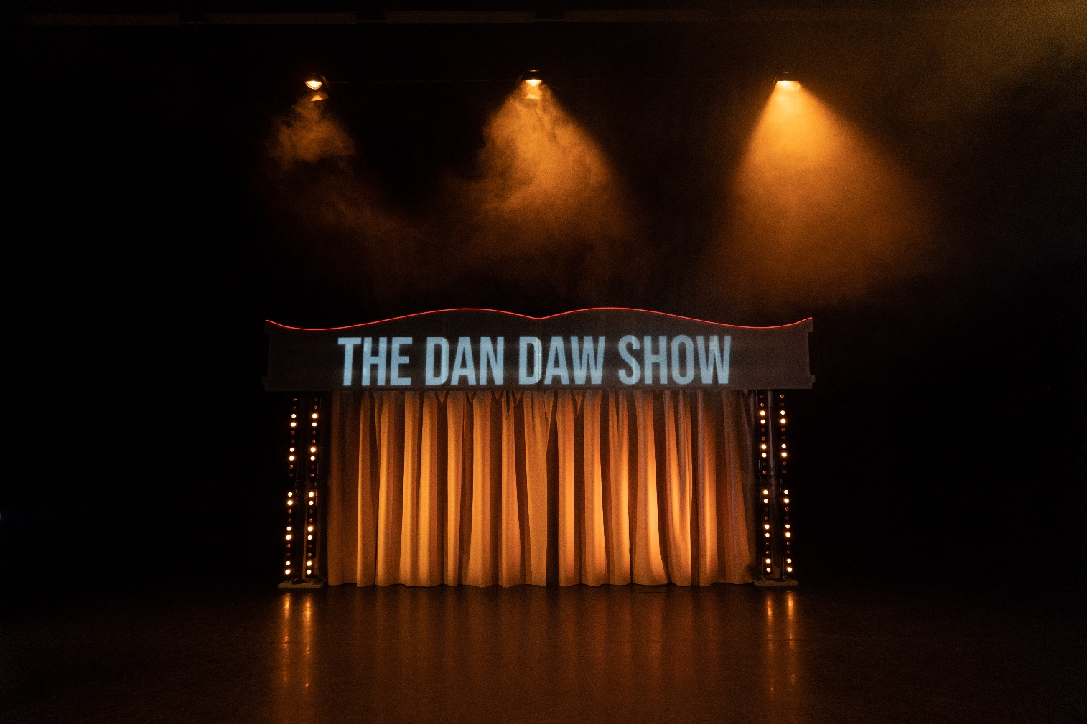

What to Expect and Access
 | The Dan Daw show is about Dan reclaiming his pride and power in a world that disables him
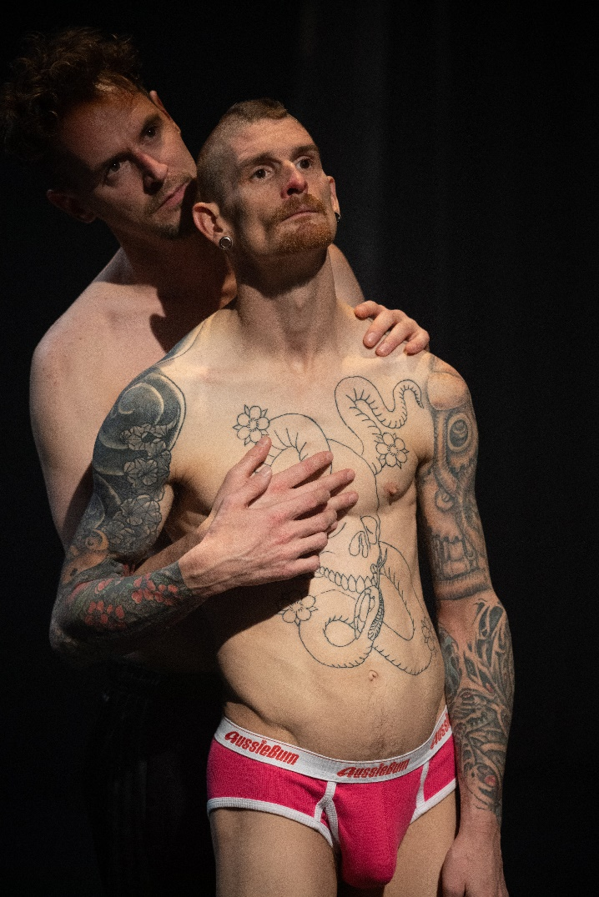 | The show is based on Kink, and how that needs Care, Intimacy, and Resilience.  Kink is something that gives you pleasure that some people might think is out-of-the ordinary.  Care is how people look after and support each other.  Intimacy is being close to another person, and can be different things with different people.  Resilience is keeping on going, when things are difficult.
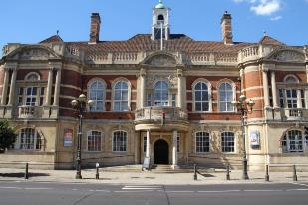 | The Dan Daw Show is at Battersea Arts Centre.  It is in the theatre called the Council Chamber.
+ | The performance is 90 minutes long.  There is no interval
One hour before the show, at 7pm, there is Pre-Show Access in the Council Chamber.

This is for you if it is helpful for you to be in the theatre space before the show.

You can explore the set, the stage, the props and see how bright the lights get, and how loud the music can go.

Someone from the show team will be there who can answer any questions, and give you information on the show.

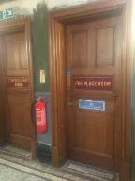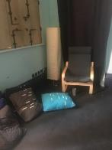 | All performances are relaxed performances.  This means you can move and make noise.  You can leave the show and come back in at any point.  There is a chill out space on the same floor as the performance.
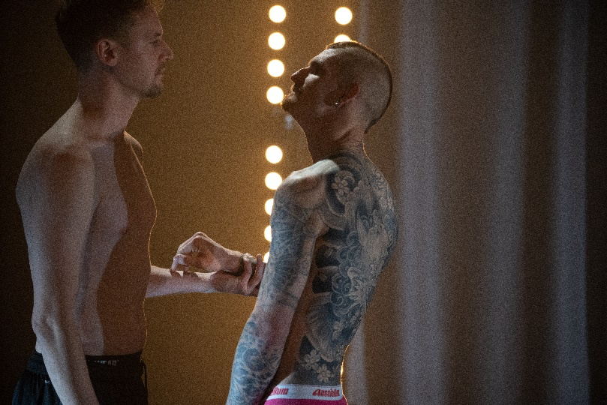 | During the show, there are bright lights.  During the show the lights facing the audience flash sometimes.  If you want to see how bright the lights get, come to the theatre for the Pre-Show Access when you can see for yourself before the show.  The Pre-Show Access begins one hour before the show starts, and lasts for 30 minutes.  If bright and flashing lights are difficult for you, there is a sensory adaptive show on 3rd May at 8pm.  In this show, the lights will not be as bright, and the flashing will be much slower.
During the show, the music sometimes gets loud.

There is a warning symbol that shows up 5 seconds before the music gets intense.

If you want to see how loud the sound gets, come to the theatre for the Pre-Show Access when you can see for yourself.

The Pre-Show Access begins one hour before the show starts, and lasts for 30 minutes.

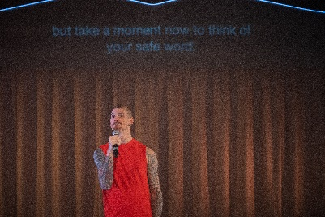 | Every show has captioning
 | There will be beanbags to sit on
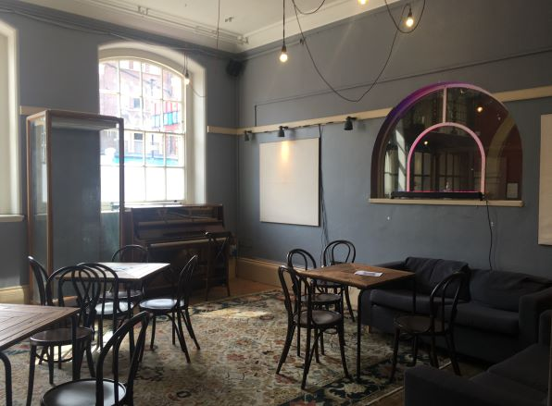 | After the show, if you need some time or space before going back into the world, The Dan Daw Show Lounge is on the Ground Floor, in the Waiting Room.  The Lounge is a relaxed space to think and get ready to be in the world again.  There will be someone from the show in the Lounge if you have any questions or need to talk.

Who are the performers?
Dan Daw
Christopher Owen, who play KrisX

What happens?
 | Dan will hang around as you come in
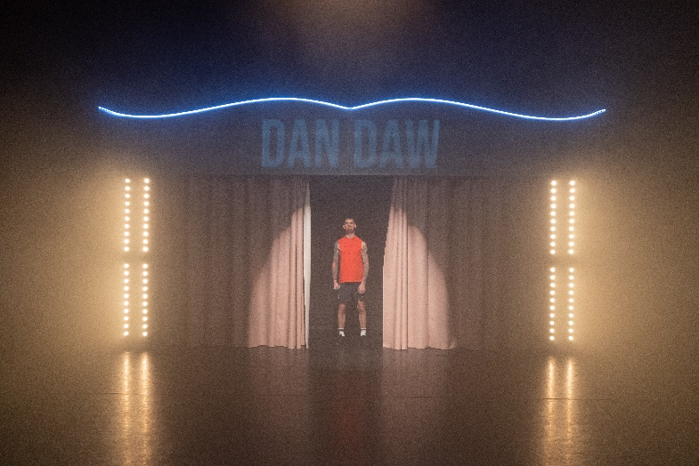 | Dan will vanish behind the curtain and come back out.  Dan will introduce himself and tell you about the show.  The things you should know about the show are:  - Dan wants everything that’s going to happen to happen  - There won’t be any blood, scat, extreme pain or fucking  - There will be suffocation, loud noises and sexy disabled people
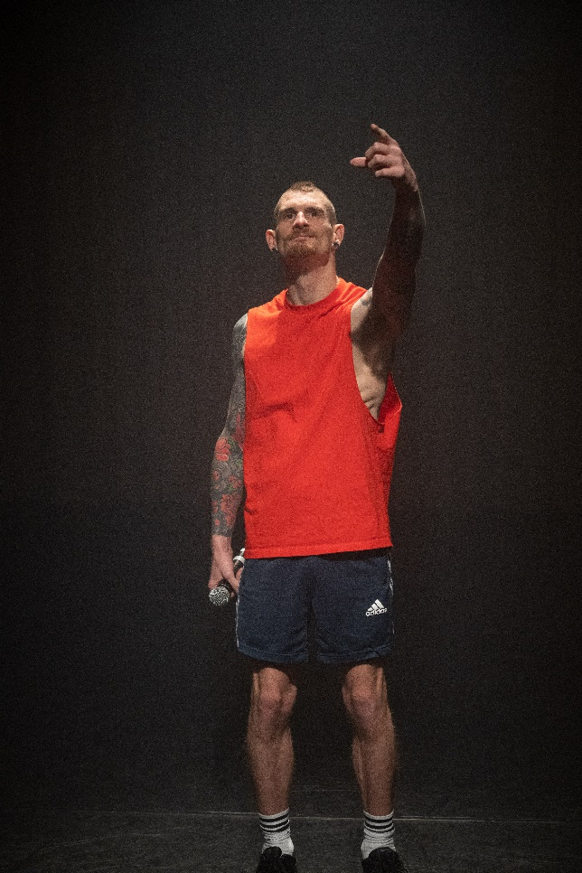 | Dan introduces KrisX  Dan explains that this show is about Dan getting fucked in ways he wants in a society that’s all about fucking over disabled people
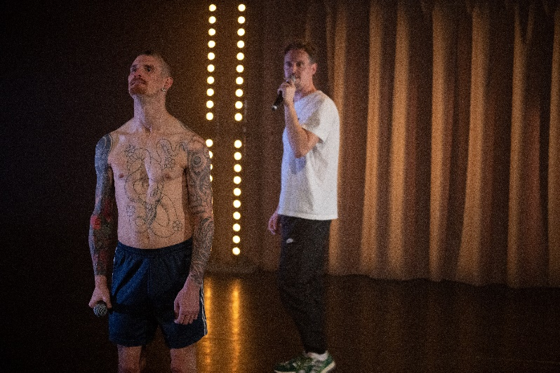 | KrisX tells Dan to put the microphone down.  KrisX has the power.
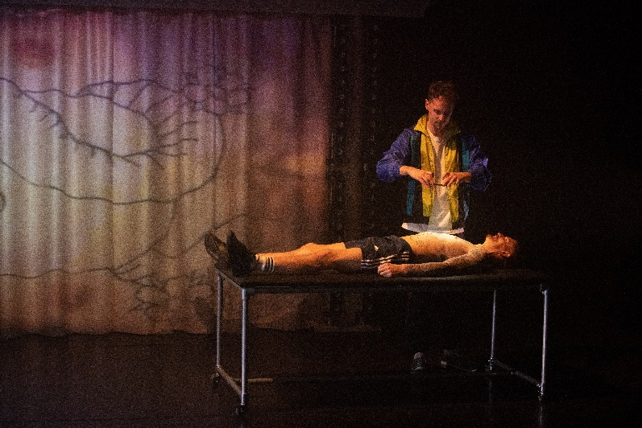 | KrisX tells Dan to get on a long table  KrisX films Dan’s body and we can see it.  This section is all about us looking at Dan’s body the way KrisX and Dan want us to look at Dan.
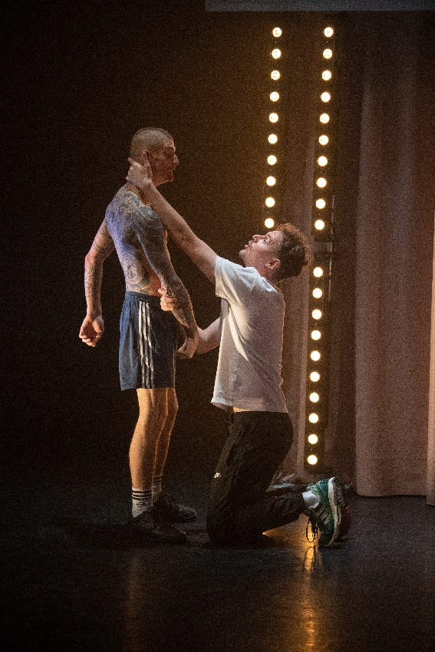 | In the next section KrisX and Dan move together.  KrisX is always in control of the movement. He decides where and how Dan moves.
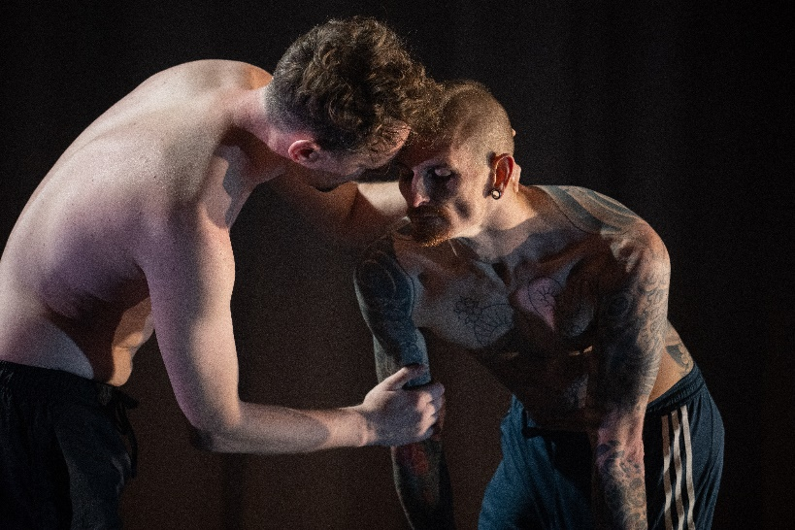 | They stop and talk about what they have just done.  KrisX makes sure Dan is doing okay and tells Dan that KrisX has got him.  They move together again.  This section is about KrisX taking care of Dan and giving Dan what he needs.
They take a break from moving but not from playing with power.

KrisX asks Dan about the tattoo on Dan’s back.

Dan explains that the tattoo is an Omi.

The Omi is Dan’s protection against the outside world.
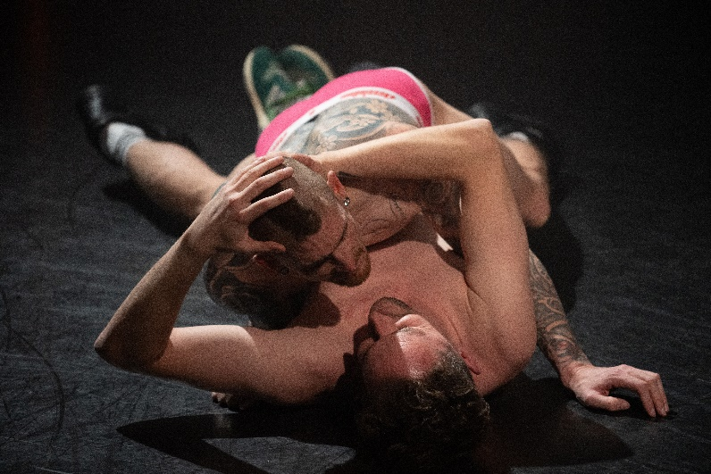 | In the next section KrisX and Dan move harder and faster.  This section is about KrisX and Dan feeling really good moving together.
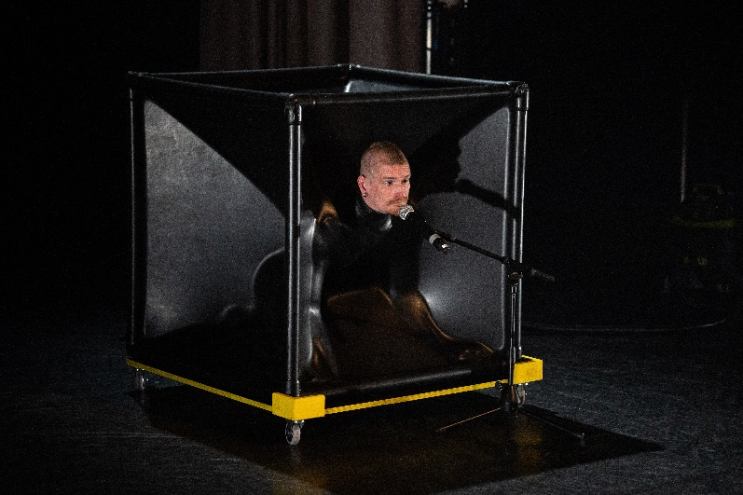 | In the next section KrisX wheels out a big latex box.  Dan gets inside and KrisX sucks all the air out.  Dan says it feels safe and good, like a hug
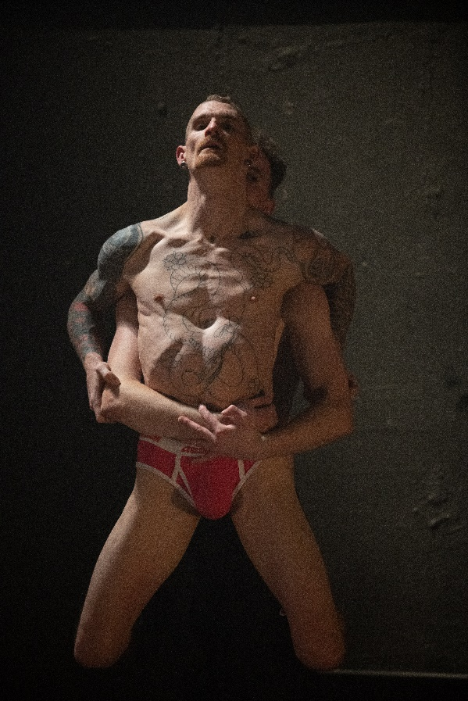 | In the next section KrisX and Dan move even harder and faster.  At the end Dan looks at the audience looking at him.
Dan tells us that he loves his body.

Dan wanted us to see him be sexy and joyous and not want to have to apologise.
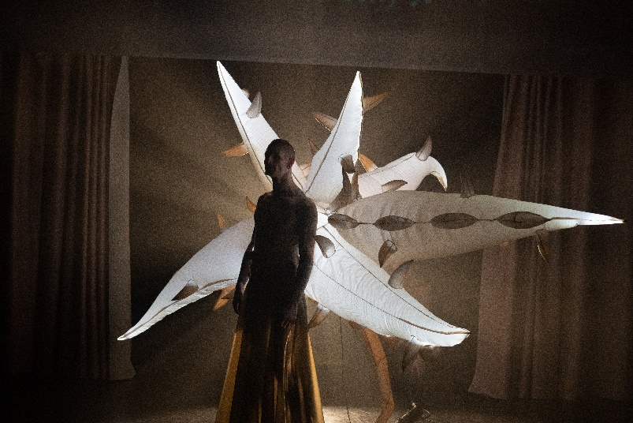 | KrisX puts a costume on Dan.  Dan becomes the Omi on his back.  Dan protects himself from the unfairness of the world through his joy.  The show ends.

