BBC Proms – Pre show Information

This information is to help you decide if the BBC Proms are for you.

The Space

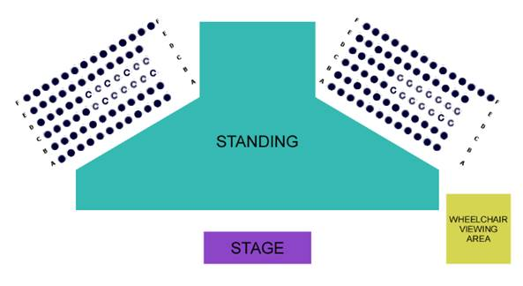

There will be seats on risers. There will also be space to stand.

The Performers

* The performers are:
  + Leif Ove Andsnes - piano
  + Matthew Truscott - violin
  + Joel Hunter - viola
  + Frank-Michael Guthmann – cello
  + [Please insert photos of each performer next to their name]

Lighting and Sound

* There are no strobes or rapidly moving lights in this performance
* The performance will generally be loud, there may be some sudden loud moments
* The performers will perform Piano Trio in B flat major and Piano Quartet in E flat major by Mozart

Participation

There is no audience participation.

Access Information

* The performance is about 50 minutes long with no intermission
* The performance space has step-free access
* All performances are Relaxed this means you can move or make noise if you need to and can go in and out of the performance space
* Latecomers will be permitted
* Ear defenders are available to borrow from the box office for anyone who might find these useful
* There is an accessible toilet on every floor of the building
* There are all gender toilets on the first floor of the buildingd
* There is a chill out space on the first floor that is available anytime the building is open