Grin Digital – Pre show Information

This information is to help you decide if Grin Digital is for you. Content notes, including what happens, are further in the document.

The Space

The Performers
- The performers are:

Kemono L. Riot
Divine Tasinda
[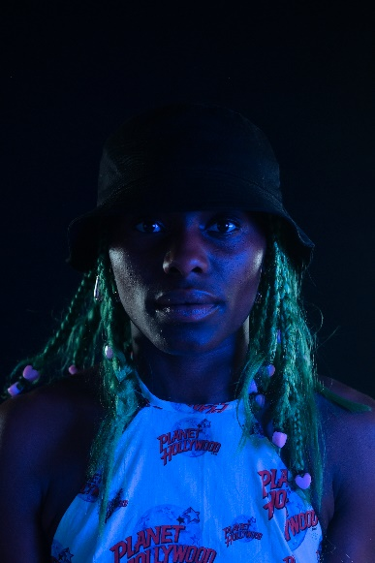
There are videos to help you get to know the performers and people who worked on Grin better:
Meet Kemono L.Riot - https://vimeo.com/583616076
Meet Patricia Panther - https://vimeo.com/583614768
Meet Divine Tasinda: https://vimeo.com/583611123

Lighting and Sound
- You can adjust your sound level on your device
  - Around 3:40 the volume of the music increases
  - From 19:00 – 21:00 there is silence with loud bass pulses
- You can adjust the brightness on your device
- From 30:00 – 33:00 the camera is handheld and little bit shaky
- No one speaks in the performance

Participation
- There is no audience participation in this digital performance

Content Notes
Grin is a dance piece. There is no clear story line and the relationship between the two performers changes throughout the show.
Grin is about caring for each other, hope, generousity and about resisting the story that African and Carribean dance is very sexual.
Access Information
- The video is 50 minutes long
- There is no interval but you can pause it anytime you need to
- You can move or make noise
- There is an audio described version of the video. When you log into your account there will be two links, one of which will be for the audio described version

