The Shadow Whose Prey The Hunter Becomes
Easy Read Guide
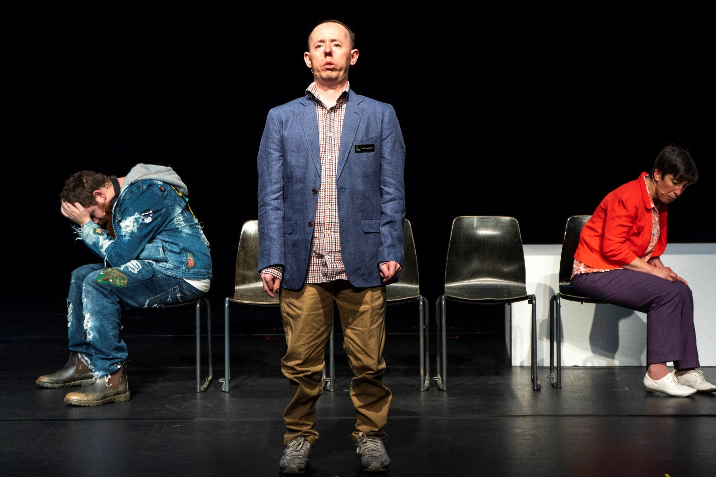*

*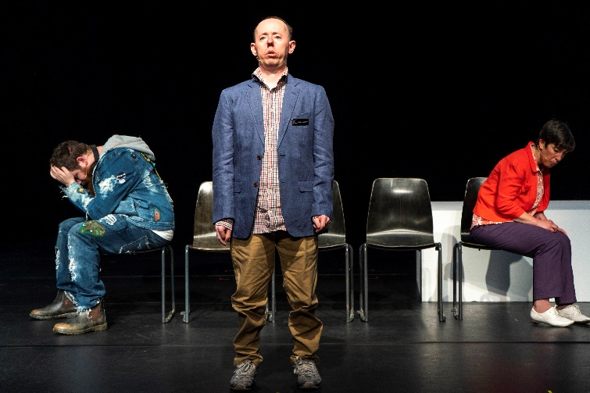 | The Shadow Whose Prey the Hunter Becomes is about:  - Artificial Intelligence or AI. These are computer programs that are very smart and can make decisions.  - How we make sure everyone has a say about big decisions?  - The ways the world hurts people with intellectual disabilities.
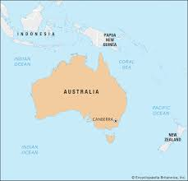 | The people who made The Shadow Whose Prey The Hunter Becomes come from Australia.  People in Australia have different words for disability than we do in England.  So in the show, they talk about ‘people with intellectual disabilities’, not ‘people with learning disabilities’.
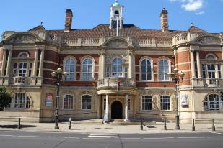 | The Shadow Whose Prey the Hunter Becomes takes place at BAC.  There is more information about BAC here: https://bac.org.uk/access/  There is also a visual guide to the building on that web page.
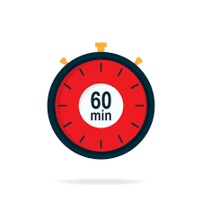 | The performances is 60 minutes long.
All performances are relaxed performances.

This means you can move and make noise.

You can leave the show and come back in at any point.

There aren’t any flashing or moving lights.

There is a couple of seconds of darkness at the end.

Sometimes there is music while the performers are talking. Most of the performance is captioned.

The music at the end will start quiet and then get quite loud.

You can borrow ear defenders and fidget toys from the box office.

Who are the performers?
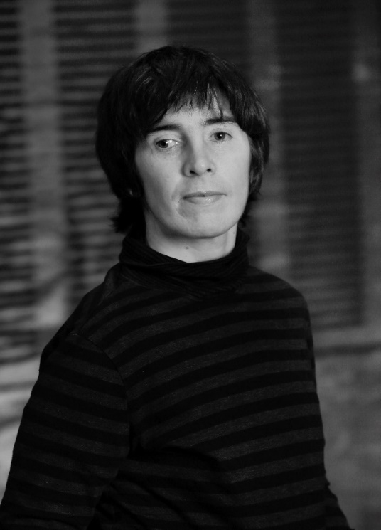 | Sarah Mainwaring plays Sarah.
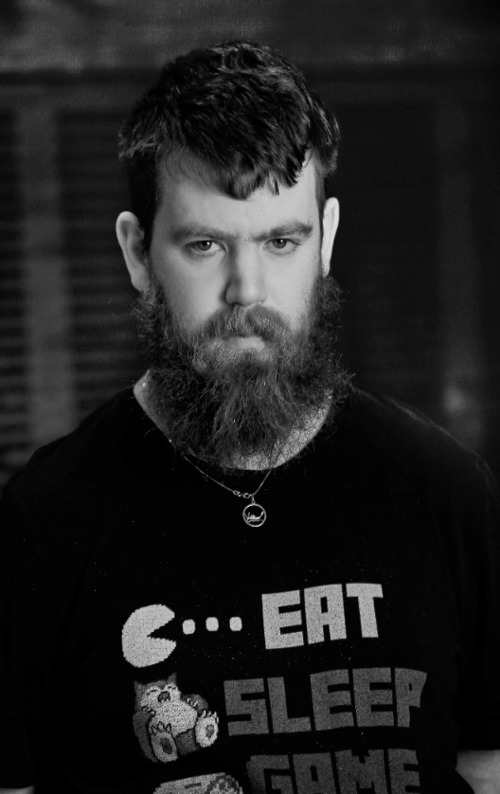 | Scott Price plays Scott.
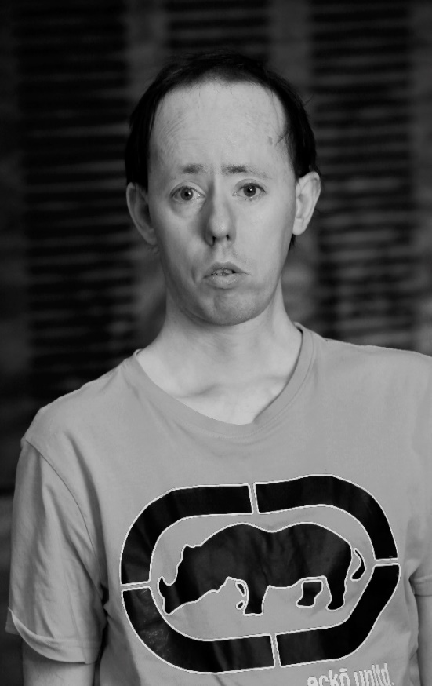 | Simon Laherty plays Simon.

What Happens?
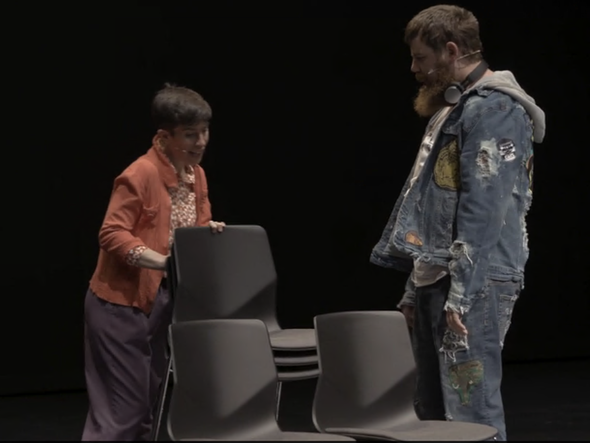 | Scott explains to Sarah when it is and isn’t okay to touch other people and yourself.
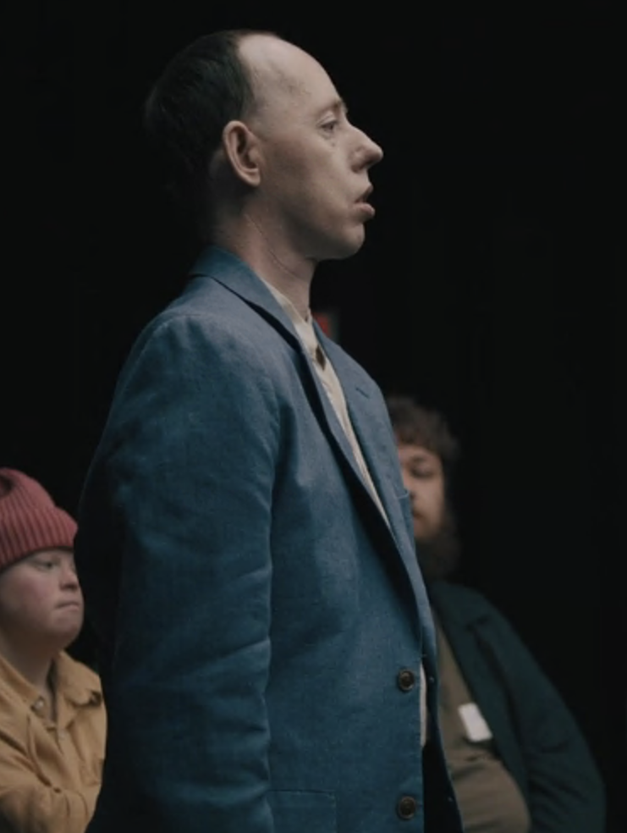 | Simon comes in.  He welcomes everyone to the meeting.
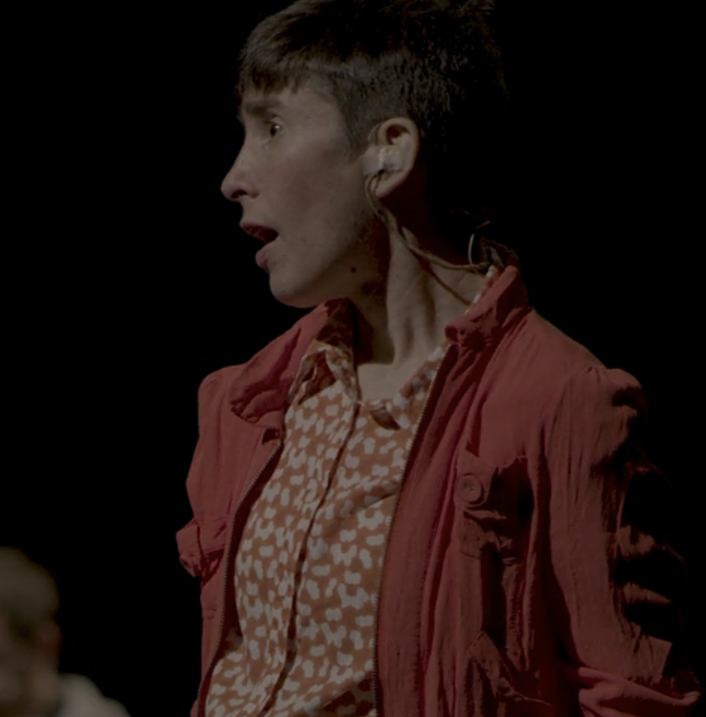 | Sarah forgets what she wants to say.  Scott and Simon talk about Sarah like she’s not there.  Scott wants Sarah to say what she thinks in the meeting. But Sarah doesn’t know what she wants to say.
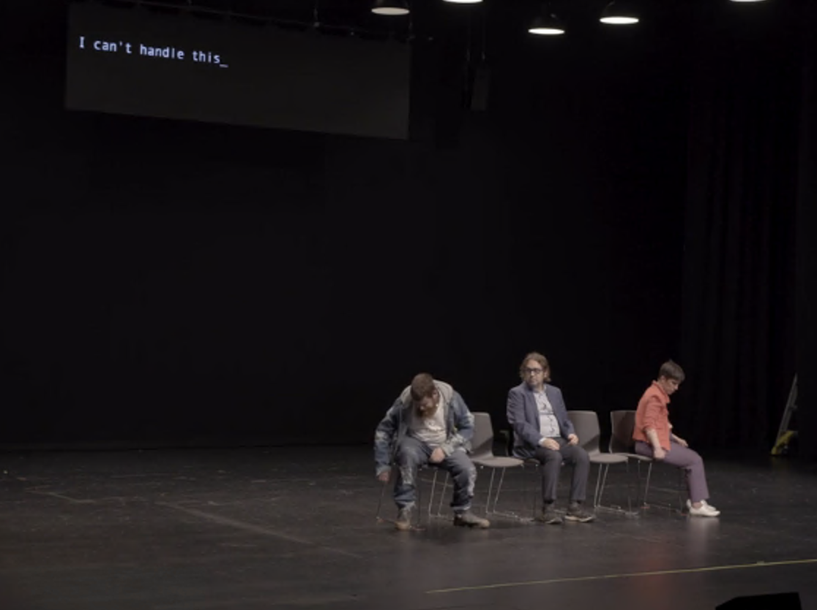 | They talk about the different words for disability.  Sarah talks about how she doesn’t like that their words are captioning.
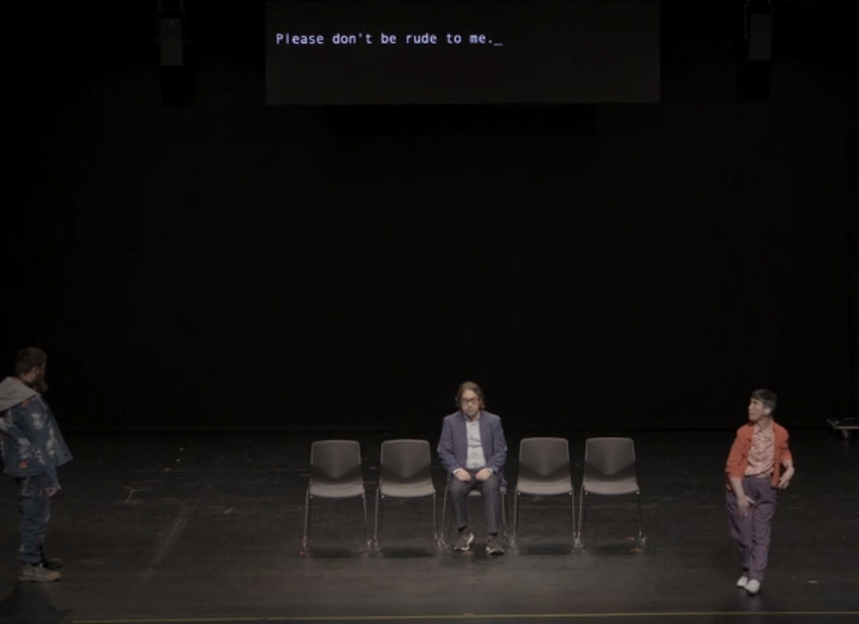 | The captioning AI starts talking back to them.
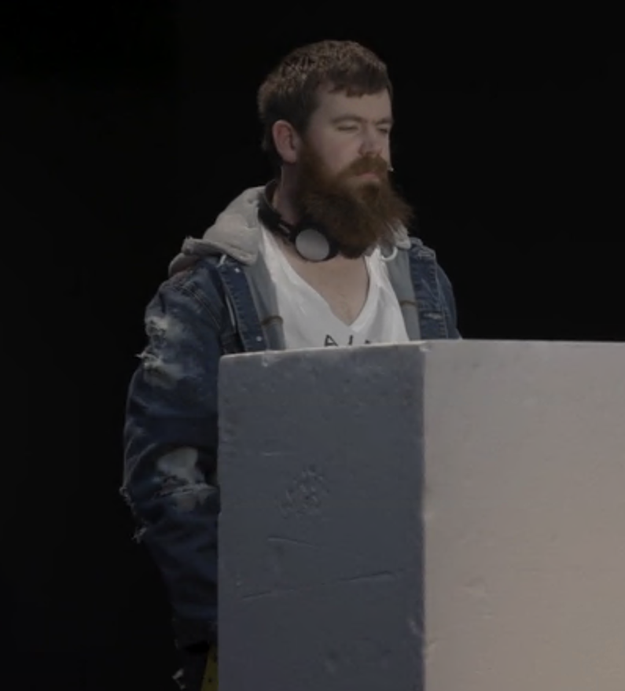 | Scott talks about the history of violence against people with intellectual disabilities.  Sarah helps him tell these stories.  They ask the audience what they make of this.  Scott says the audience can’t understand. Scott talks about the audience like they aren’t there. Scott talks about the audience like they are people with intellectual disabilities.
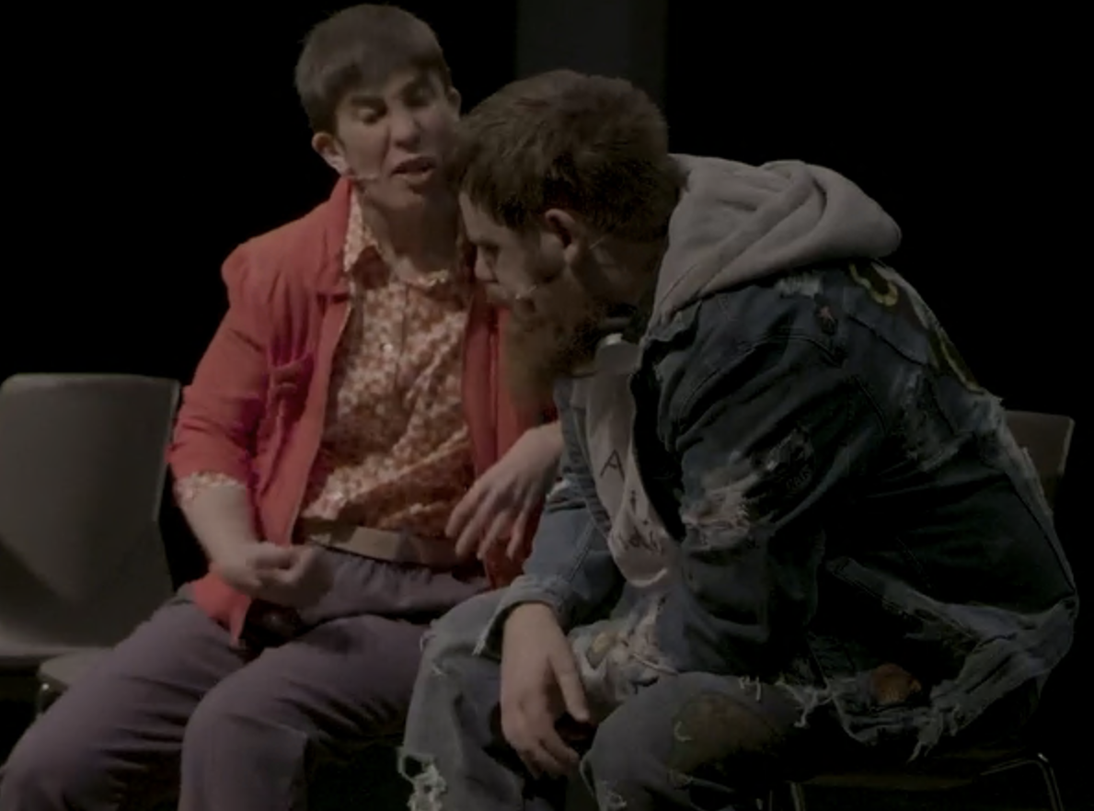 | Scott says that he and Simon are vocal and charismatic people with disabilities. This leaves Sarah out.  Scott gets upset he left Sarah out.  He asks to be alone.
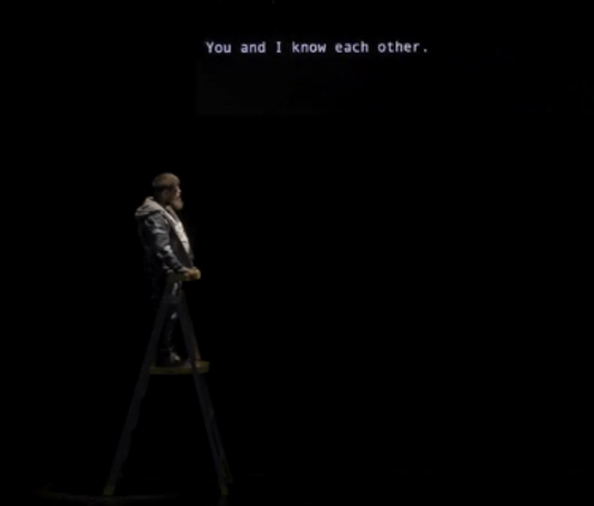 | Scott talks to Siri about how hard it is to make other people understand what he is saying.  Scott says sorry to Sarah.
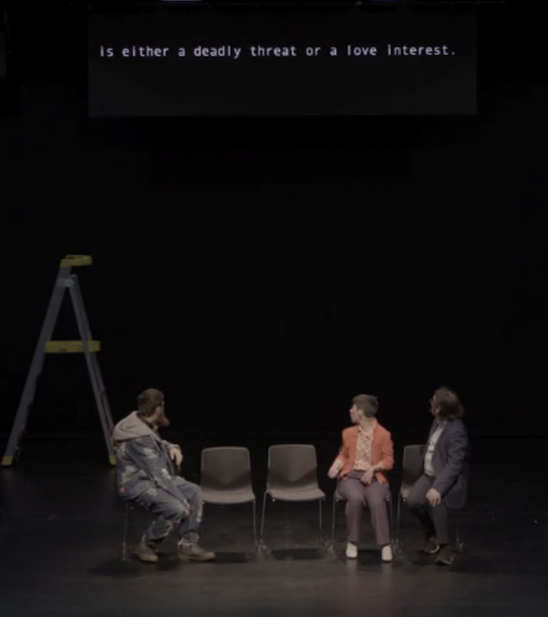 | Sarah explains about artificial intelligence or AI. These are computer programs that are very smart and can make decisions.  Simon asks how people will be treated when computers are smarter than people.  Maybe when computers are smarter than people, everyone will be treated like people with intellectual disabilities.
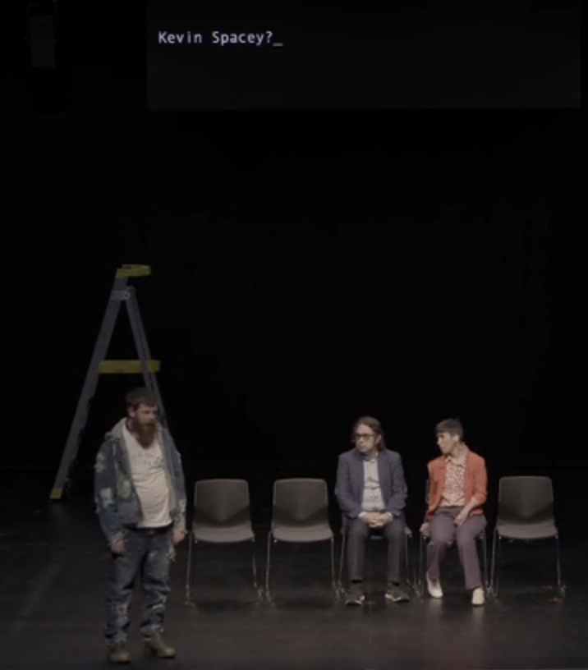 | Scott and the AI talk about Kevin Spacey abusing boys.
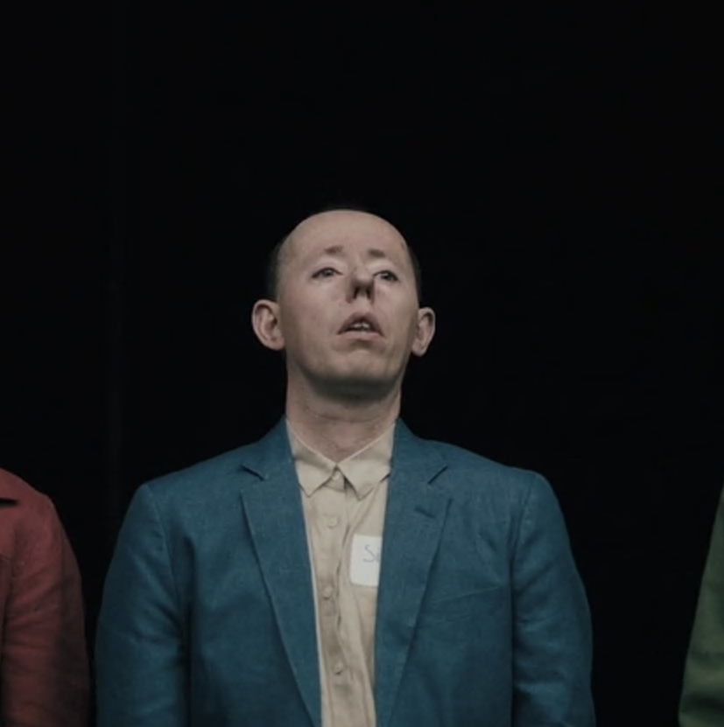 | Simon talks about how he called the meeting.  Simon says he is the mayor of the town. He is in charge and Sarah will work for him.  Sarah tells him to fuck off.
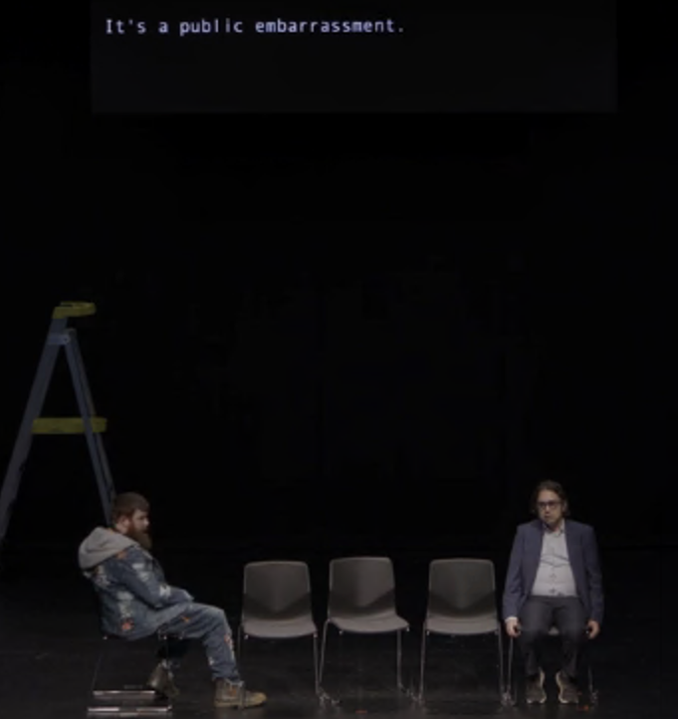 | The AI tells Simon he has failed at the town meeting. The AI tells Simon that he should be ashamed.  The AI offers to speak to the audience for the Sarah, Scott and Simon.
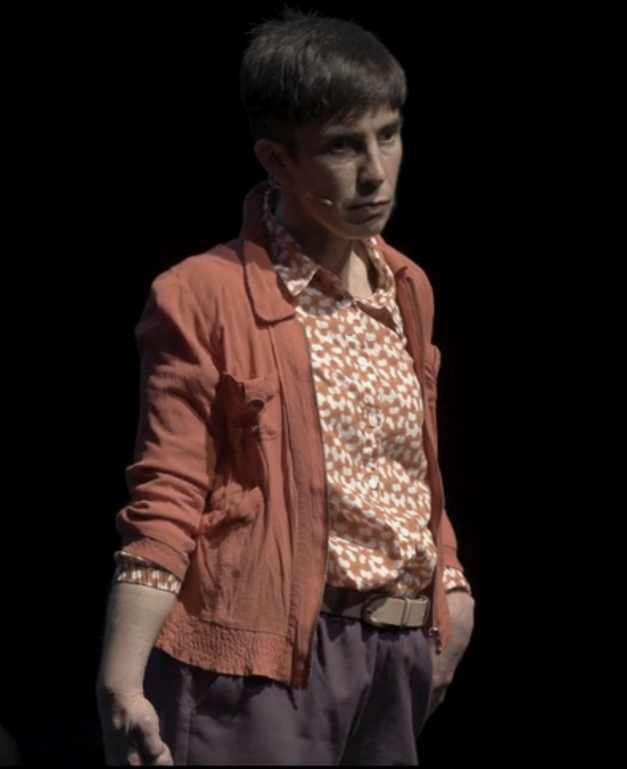 | Sarah says she will speak to the audience.  She tells the audience that in future they will have to be scared of being wrong. In the future the audience will have a hard time making other people understand them.  In the future, everyone will have an intellectual disability.
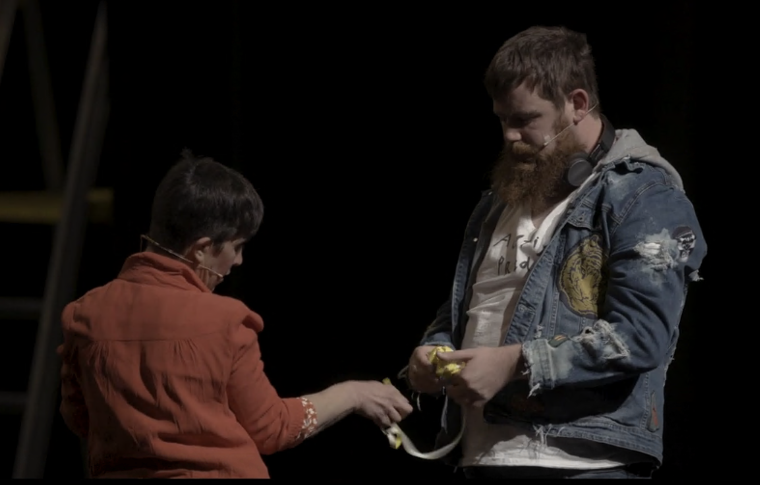 | The meeting ends.  Sarah and Scott clean up the chairs.  They talk about what to do if an artist they like hurts people.  The show ends.

Images in this Easy Read Guide marked by * are by Kira Kynd. All other images are from The Shadow Whose Prey The Hunter Becomes film or archival footage of a performance of The Shadow Whose Prey The Hunter Becomes.

