The Shadow Whose Prey The Hunter Becomes – Pre show Information

This information is to help you decide if The Shadow Whose Prey The Hunter Becomes is for you. Content notes, including what happens in the show, are further in the document.

The Space
- The performance will take place in the Grand Hall
- There will be seating for audience and a space for the performers

The Performers

The performers are:

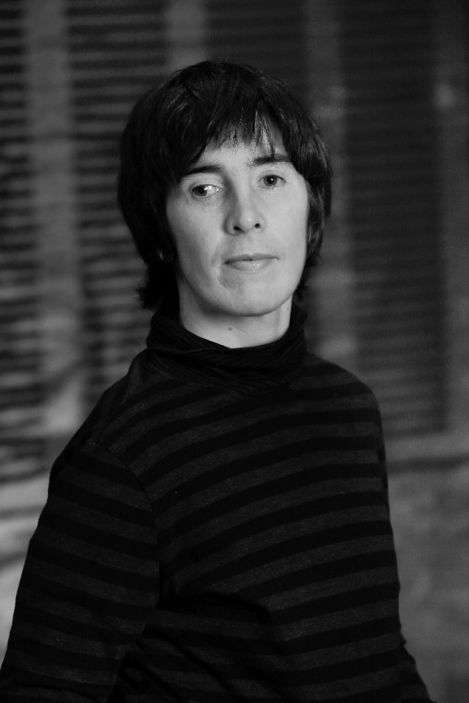 Sarah Mainwaring

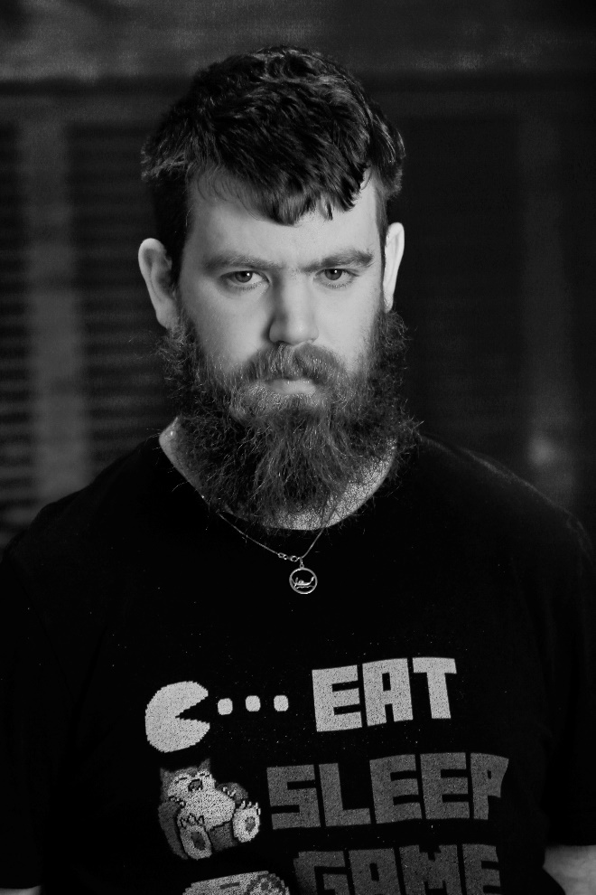 Scott Price

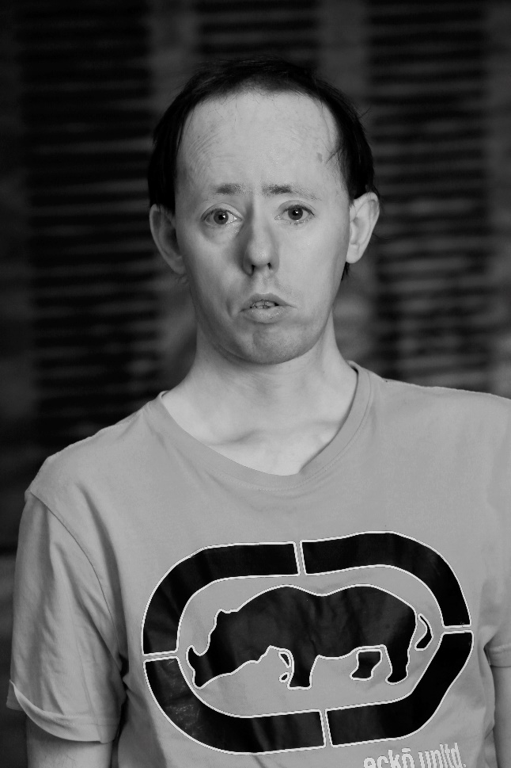 Simon Laherty

Lighting and Sound
- There will be no sudden loud music or sounds
- There is a build of music towards the end that is quite loud
- There are no flashing moving lights
- There might be one short moment of complete darkness at the end

Participation
- There is very little audience participation in the show
- The performers may ask the audience questions, but you can always say no

Access Information
- The performance is 60 minutes long
- There is no interval
- The performance space has step-free access via a lift
- Some of the performance is captioned. Some of it is not
- There will be an audio described performance on 22 October. The audio describer will be Dot Alma
- All performances are Relaxed this means you can move or make noise if you need to and can go in and out of the performance space
- Latecomers will be permitted
- Ear defenders and fidget toys are available for anyone who might find these useful
- There is an accessible toilet on every floor of the building
- There is a chill out space that is available anytime the building is open

Content Notes
The Shadow Whose Prey the Hunter Becomes takes place at a town hall. The performance talks about and shows a lot of different issues, particularly the abuse of people with intellectual disabilities in the past. This includes:
- How hard the language around disability is
- How some people with intellectual disabilities get taught to say yes to everything
- How many people with intellectual disabilities do not have power over their lives
- How some people with intellectual disabilities are not paid for their work
- How some people with intellectual disabilities are given pills to make them less active
- How artificial intelligence (computers) are becoming smarter than people

Please note that Australia and the UK have very different language for disability. In Australia ‘people with intellectual disabilities’ is polite. This is the language used the show.

