Little Red Robin Hood
Easy Read Guide
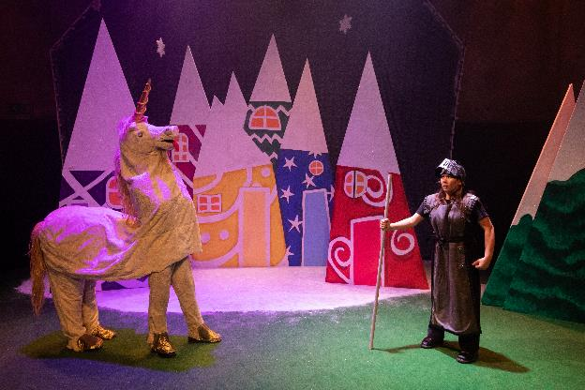

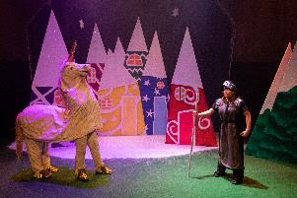 | Little Red Robin Hood is a panto.  It has fairy tale characters, songs and people who like being bad.  In a panto you can talk to the performers and characters and they will talk back.
It takes place at Battersea Arts Centre.

If you want more information about Battersea Arts Centre look at our visual guide.
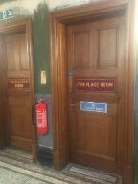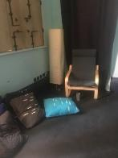 | The performance is a relaxed performance.  This means you can move and make noise.  You can leave the show and come back in at any point.  There is a chill out space on the same floor as the performance.
There will be lots of bright lights and really fast lights.

There are sensory adaptive performances on:
- Friday, 9 December, 1:00pm
- Thursday, 15 December 7:00pm

The sensory adaptive performance won’t have those bright and fast lights.
The whole show is loud.

The sensory adaptive performance will be quieter.

If you don’t like loud noises you can wear ear defenders.

There will be ear defenders you can borrow at the performance.
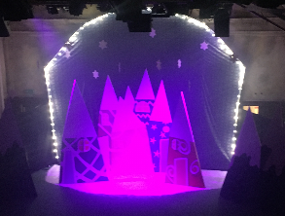 | If you’d like to know a little more about the show or spend more time in the theatre before the show you can go to a familiarization tour.  The familiarization tours are:  - Friday, 9 December, noon  - Sunday, 18 December, 10:00am
There is an audio described performance on Saturday 17 December at 2:00pm.

In this show you can get a headset. Roz, the audio describer, will describe what the show looks like and you will hear it in the headset.

There is also a touch tour at 1:00pm.

In the touch tour Roz will show you the stage and objects in the show. You will also meet the performers.

This is so you know more about what the show looks like when you’re listening to the audio description.

Who are the performers?
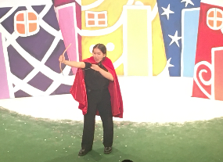 | This is Miya.  Miya plays an usher and Little Red. She also plays lots of other people.
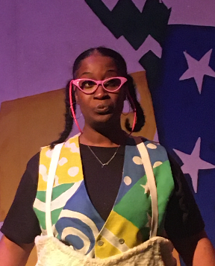 | This is Simone.  Simone plays an usher and Little Red’s Mum and the Big Bad Wolf. She also plays lots of other people.
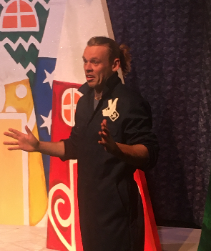 | This is Sam. He play the driver, the Sheriff of Nottingham and Grandma Cher. He also plays lots of other people.

What happens?
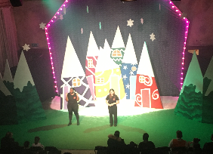 | Miya and Simone are ushers for the biggest panto in London, one that Cher performs in.  But just before the show starts the performers get stuck on the Tube.  Miya and Simone decide to perform the entire panto themselves.
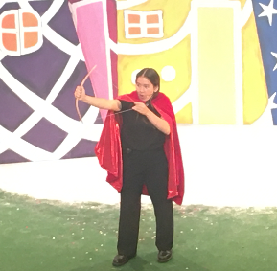 | Miya plays Little Red.  Little Red’s hero is Robin Hood who comes to their village every winter with a sack of presents for everyone.
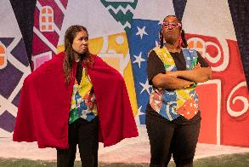 | Simone plays Little Red’s Mum.  Little Red’s Mum doesn’t think Robin Hood is good and they get into a fight.  Little Red decides to go to her Grandma’s house.
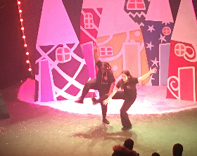 | Miya and Simone try to do a big dance number but it’s hard to do without the other people.
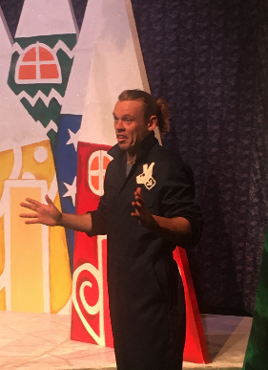 | Sam, a delivery driver walks into the performance because he is lost.  Miya and Simone ask him to help them do the show.
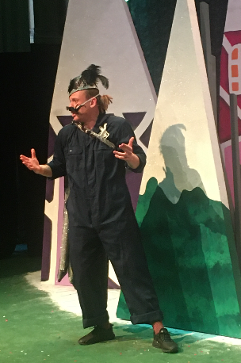 | The townspeople are expecting Robin Hood to arrive.  But instead the Sheriff of Nottingham shows up.  The Sheriff encourages the audience to boo him. The boos might be loud.
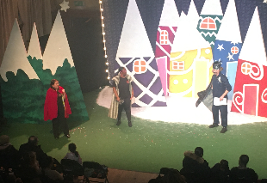 | The Sheriff reveals that he has locked up Robin Hood and his outlaws.  Without Robin Hood to stop him the Sheriff is going to throw everyone out of their homes so he can build a car park.
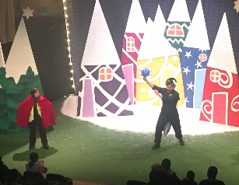 | The Sheriff says that if anyone can beat him in an archery contest that he won’t knock down everyone’s homes for a car park.  The Sheriff holds up balloons as a target.  The balloons won’t pop, Sam will let the air out of them instead.  So the balloons will fly around, but they won’t make sudden loud noises.
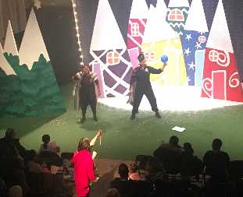 | Little Red shoots but instead of hitting the balloon she shoots the Sheriff in his bum.  She’s upset so she runs away into the forest.
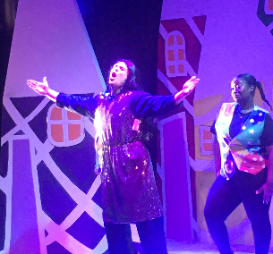 | The ushers are super excited that Cher is going to perform.  But Cher can’t do the show so Sam the delivery driver has to perform as Cher’s part.  Cher is Little Red’s Grandma.
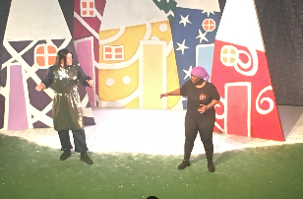 | Grandma Cher goes into the forest to look for Little Red.
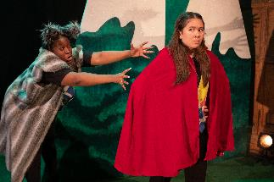 | Little Red is running through the forest.  She asks for the audience to help her by yelling if there’s anything dangerous.  This part of the show might be loud The Wolf sneaks up behind Little Red and throws a net over her, trapping her.  Little Red manages to get free by and runs off to find Grandma Cher.  .
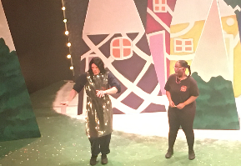 | Grandma Cher and Little Red’s Mum meet in another part of the forest.  Grandma Cher hung out with Robin Hood when they were younger and Little Red’s Mum felt neglected.
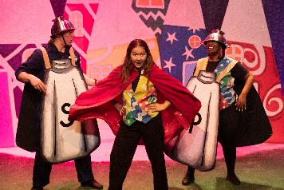 | There’s a big dance with people dressed up as salt and pepper shakers.
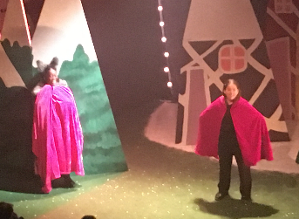 | Little Red makes it to Grandma Cher’s house.  But the Wolf is there dressed up as Grandma.  The Wolf tricks Little Red and catches her.
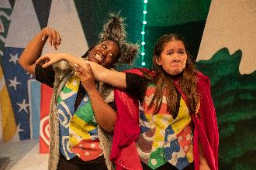 | The Sheriff tells the Wolf to take Little Red and lock her up in the Tower of Nottingham.
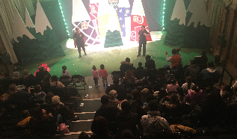 | Then the interval happens.  You can leave the theatre and come back.  Or you can stay in the theatre.
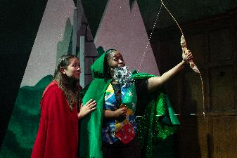 | The show starts again.  Little Red is locked up in the Tower of Nottingham where she meets Robin Hood.  Robin Hood has a bow for Little Red from her Grandma.  Robin Hood tries to shoot it but the arrow goes into Little Red’s leg.  But then Little Red accidentally shoots Robin Hood in his butt.
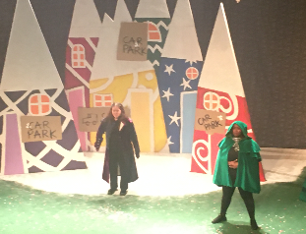 | Robin Hood realizes that Little Red’s Grandma is Cher, and that Grandma Cher, the Wolf and Robin Hood all knew each other when they were young.
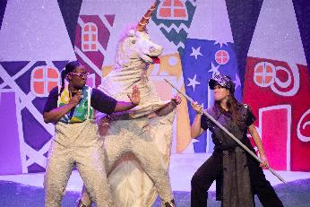 | Grandma Cher and Little Red’s Mum try to break into the Tower of Nottingham.  At the same time Little Red and Robin Hood break out.  Little Red and her Mum are captured and thrown back in the Tower of Nottingham but they manage to escape.
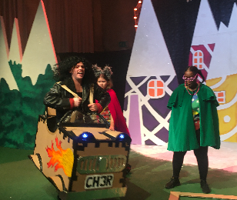 | Little Red, her mum, Grandma Cher and Robin Hood go to confront the Sheriff of Nottingham.
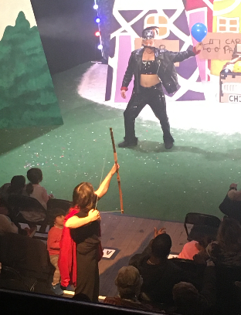 | The Sheriff challenges them to another contest and Little Red shoots the balloon.  Again, the performers will let the balloon deflate instead of popping them.
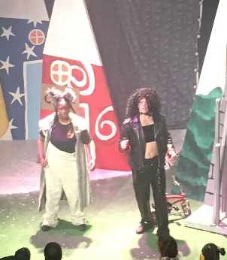 | It’s revealed that the wolf is Fandango, the long lost love of Grandma Cher.
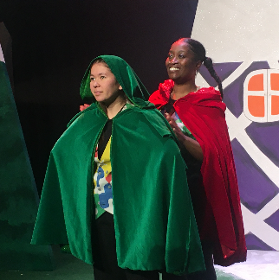 | The townspeople make Little Red’s mum the new Sheriff of Nottingham and make Little Red the new Robin Hood.
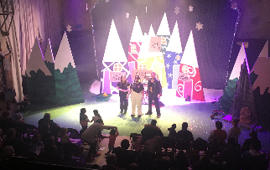 | The show ends with everyone happy!

