TANZ – Pre show Information

This information is to help you decide if TANZ is for you. Content notes, including what happens in the show, are further in the document.

The Space
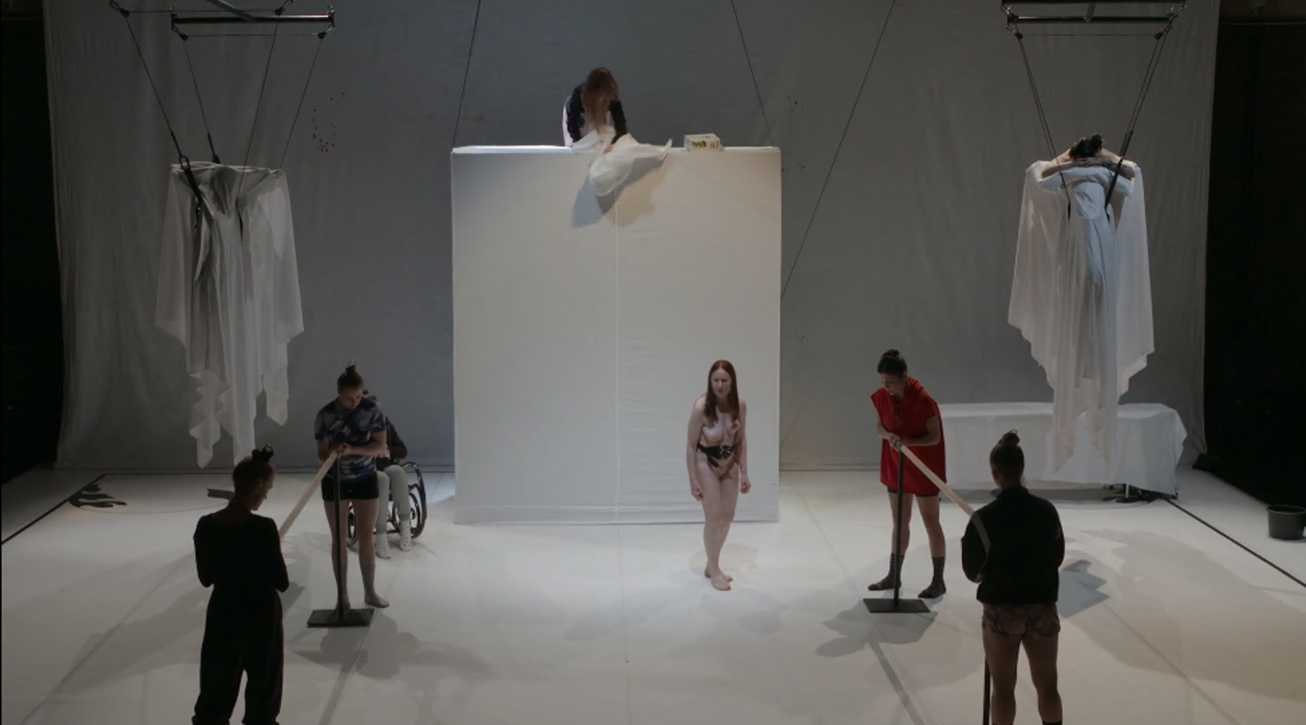
The space changes over the show. To start it is all white with shapes draped in white clothes at the back. There are screens on either side of the stage that a camera onstage streams to.

The Performers
We will update this section once we know who the performers are.

Lighting and Sound
If you want to know more about when these particular sensory elements happen and what they involve you can read the content summary at the end of this document.
- There are three moments of complete darkness. Two of these go on for three to four minutes.
- There are strobe lights
- There is a vacuum used on stage for several minutes
- There is the sound of a motorcycle failing to start, running and a loud car horn
- There is the sound of thunder and a car crash
- There is sudden loud electronic music
- There is the sound of a baby crying
- There is screaming
- There are wolf howls
- There are high pitched piercing scraping sounds for about five minutes
- There’s a lot of grunting and crying
- There is the sound of tap dancing
- There is a lot of haze

Participation
Most of TANZ doesn’t involve audience participation. There is one section with a lot of audience participation.

In this section:
- One of the dancers will talk to the audience. She will ask the audience to give her cash.
- She will ask for an assistant once she has the money. The assistant covers her eyes.
- The audience will pass the money around.
- Another dancer will ask everyone to sit the same way as the person who ends up holding the money so the first dancer has to guess who has the money.
- Then, the first dancer will try to sell the audience trees in a forest.

You don’t have to participate in this if you don’t want to. The dancers will ask for volunteers.

Access Information
- The performance is 2 hours and 15 minutes long
- There is no interval
- The performance space has step-free access via a lift
- All performances are Relaxed this means you can move or make noise if you need to and can go in and out of the performance space
- Latecomers will be permitted
- Ear defenders and fidget toys are available for anyone who might find these useful
- There is an accessible toilet on every floor of the building
- There is a chill out space outside the performance space that is available anytime the building is open

Content Notes
TANZ is about changing what your body can do and who you are by repeating movements. It is inspired by romantic ballets.
TANZ contains:
- Nudity
- Fake blood
- Onstage piercing and suspension from that piercing
- Onstage masturbation
- Fighting, including with a fake gun

If you want to know more, including when particular things occur you can read the content summary on the following page. Or you can email access@bac.org.uk if you’d like to ask questions.

Content Summary
TANZ starts with darkness and eerie sounds for about two minutes. Then there is a ballet class taught by a naked ballet mistress. As the ballet class goes on the ballet dancers take off their clothes. Two other performers brush their hair over their eyes and dunk their heads in pails of water. Then they wrap their hair around metal circles. At one point another performer films the ballet dancers.
A performer holds the vacuum cleaner and starts it like it’s a motorcycle.
The ballet mistress talks happily about how fabulous and sexy the ballet dancers are. She talks in detail about how turned on she is.
The performer who used the vacuum as a motor cycle comes on with blood on her face. The ballet mistress asks the dancers questions.
The ballet mistress asks the ballet dancers to do yoga poses that show off their vulvas. The ballet mistress looks at all the dancers’ vaginas. There are the sounds of a wolf growling.
The ballet mistress lies down and the dancers walk over her. She is very happy. The ballet mistress tells the dancers about how they can masturbate. The dancers follow her instructions.
Then a voice yells, “In the name of our father the Lord Jesus Christ let me have it in my butt”. A dancers flies across the stage and there is sudden darkness.
A caldron appears on stage. One of the dancers falls and there is very loud electronic music. Two dancers close another into a long box on wheels. They open the box and the dancer has disappeared. In her place is a bloody baby doll and a large sucker.
One of the dancer hits the baby doll several times and throws it in the cauldron. There is the sound of a motor cycle revving and loud drums. The dancers drowns another dancer in the cauldron. There’s a lot of screaming. When she won’t die she throws a hair dryer in and there are strobe lights.
One of the dancers does more ballet at the barre. The other dancers suspend themselves from their hair.
They unwrap the white shapes which are motorcycles hanging from the ceiling. Some of the dancers hang from the motorcycles.
One of the performers talks to the audience. She explains about romantic ballets. Often romantic ballets have two halves, the first somewhere inside and the second in the forest where the magic is. And there is always a witch who will make everything terrible for everyone.
She talks about how they have all spent time changing their bodies in classes with other people. She explains they are interested in looking at the audience.
She asks the audience for cash. She gets the cash and asked audience for an assistant. The assistant covers her eyes. The audience passes around the money. Another dancer will ask everyone to sit the same way as the person who ends up holding the money.

The first dancer talks to the audience. She explains about a forest that the audience can invest in. Two puppets in wedding dresses kiss behind them. Once a tree is bought in the forest the puppets waltz around to dance music.
They start the second act. There is a witch with a long hooked nose in the forest. Everyone dances.
The witch smears fake blood on the ballet mistresses’ thighs and vulva. The witch puts a fake rat in her vulva. A camera feeds the image onto big screens on either side of the stage.
Then two of the dancers clean up the ballet mistress. The lights fade to black and there is about a minute of total blackness where the only lights are a flashlight and the lights of the motorcycles. There is the sound of a crash. The blackness goes on for another three minutes.
When the lights come up the dancers are now ghosts. There are crash mats on stage. There is a loud crashing sound and dancers fly and then all fall down. They get up and do this several times.
During this one of the dancers is on a table at the back. Another dancer pierces the skin on her back to insert hooks. The camera with a live feed focuses on this so it is on the screens on stage. There are high pitched piercing scraping sounds made by using a bow on the motorcycles. The piercing scraping sounds will go on for
Two dancers dance and appear to move another dancer without touching her. There’s a lot of grunting and crying. The dancer who is being moved starts dancing with a fake arm and leg. Another dancer squirts fake blood over her and the arm and leg.
They all sing. A dancer in sneakers pretends to tap dance. They do some gestures that make fun of traditional ballet mime and talk at the same time. The ballet mistress goes to sleep on the floor.
The dancer whose back is pierced is suspended from those piercings. There is sudden loud music and pinatas drop. The dancers try to hit them, narrowly missing the suspended dancer.
The suspended dancer comes down. She wakes up the ballet mistress and gives her a cigarette.
There is a loud crash and two dancers fight. There is a sound like machine gun and strobe lights. One dancer hits another off the motorcycles. Another falls. One dancer takes a fake gun and pretends to shoot the other dancers. There is a lot of screaming.
One dancer gets her arm stuck in a wall and another pretends to saw it off. The wolf pretends to eat another dancer. The dancers pretend to kill the wolf.
They hoist the wolf on a tall spike and spin it around. Then it falls as if pierced through by the spike. They take the wolf off the spike.
One dancer explains she doesn’t want to be a wicked witch and she will try again tomorrow. She falls asleep. They bring the barres back in and the dancers practice pointe work. Then, the ballet mistress says they can stop because the audience would like to applaud. TANZ ends.

