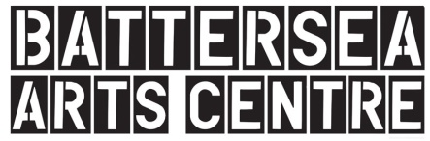
Battersea Arts Centre Visual Guide
This visual guide is for people coming to visit Battersea Arts Centre (BAC). It will tell you about how to get to BAC. It will tell you about what you can find on:
- The ground floor of BAC
- The first floor of BAC
- The grand hall floor of BAC
If any of this is confusing you can email Kelsie at kelsiea@bac.org.uk. She can answer any questions about the building.
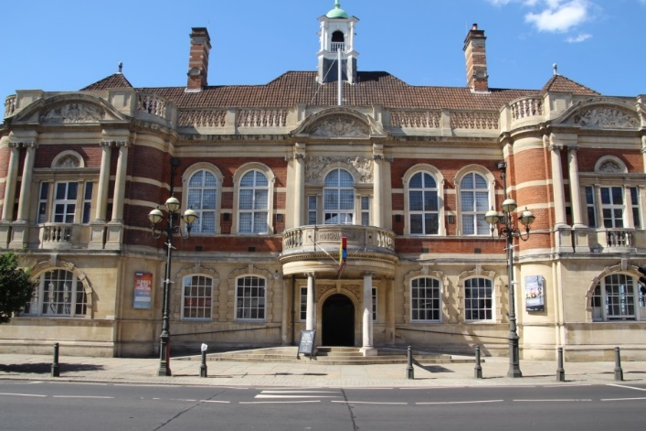 | Welcome to Battersea Arts Centre. Lots of different, creative things happen here.

Getting Here
You can get to BAC a few different ways.
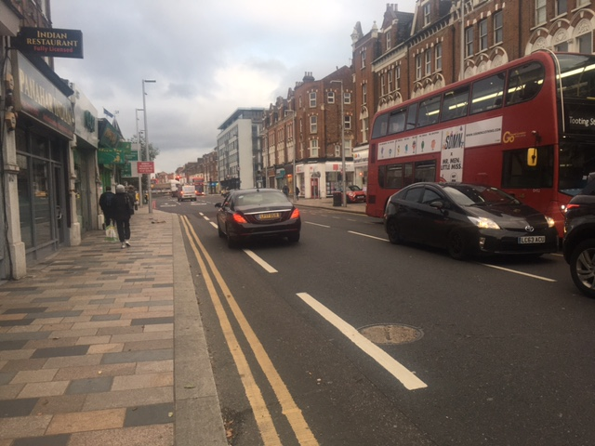 | You can take a train to Clapham Junction and then walk from there.
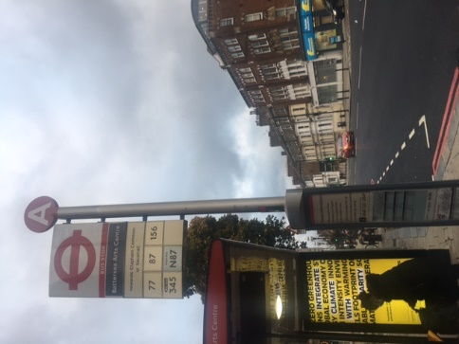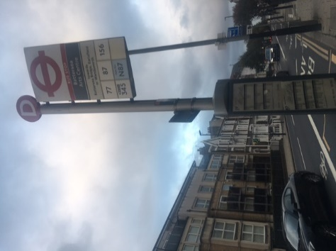 | You can take the bus. The 77, 87, 156, 345 and N87 all stop near BAC.
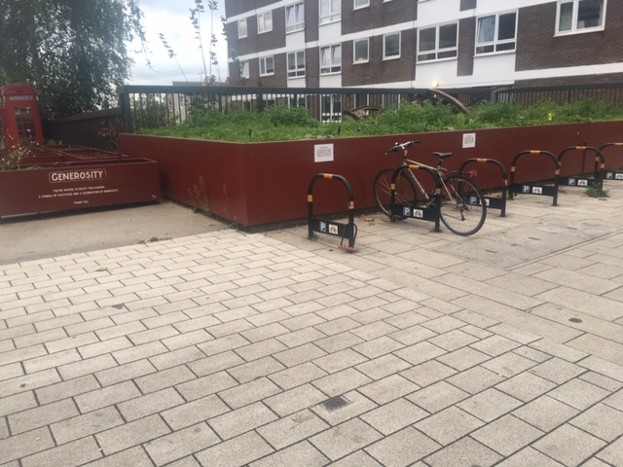 | You can cycle. There are bike racks in front and behind BAC.
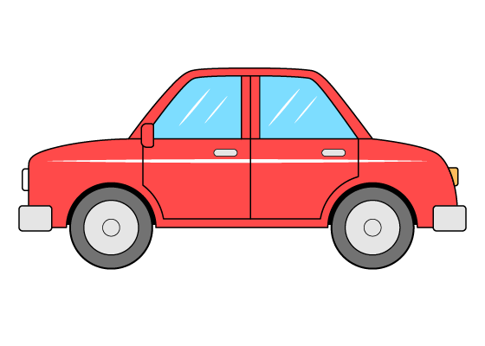 | You can drive. There is not a lot of parking near BAC.
 | This is the main entrance. There are some steps and two ramps.

Ground Floor BAC
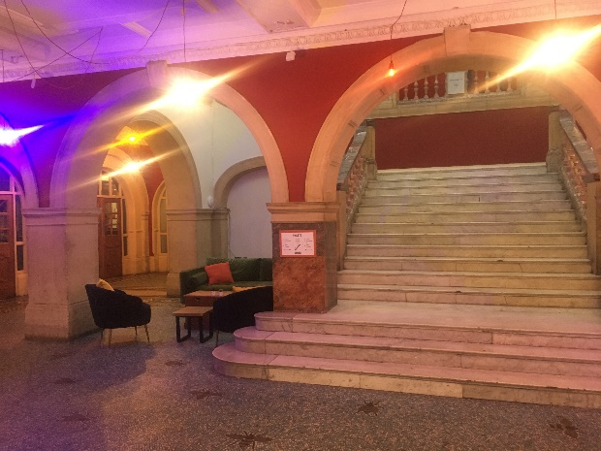 | Just inside is the foyer. There might be lots of people and lots of noise in the foyer.
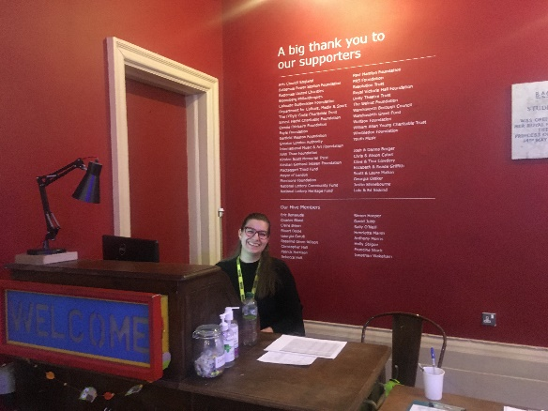 | This is the welcome desk. You can ask the person there questions.
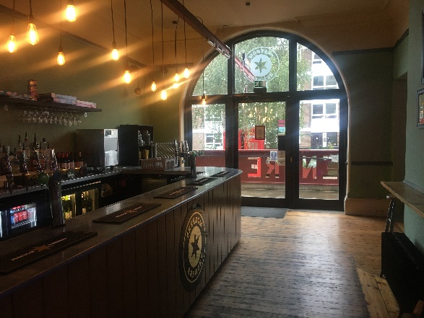 | This is the Freedom Tap Room. You can buy food and drinks here. There might be lots of people and lots of noise.
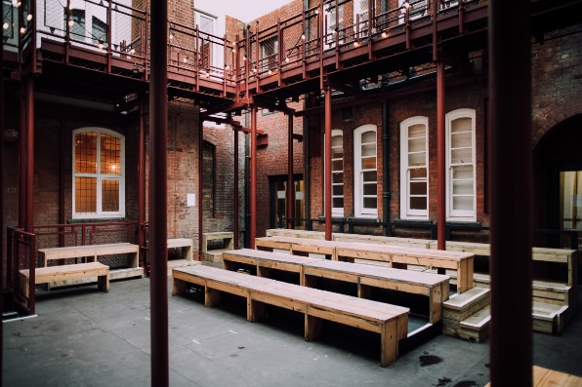 | This is the courtyard. You might go there to see a comedy show.
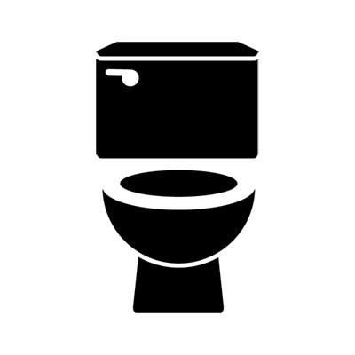 | On the ground floor there are men’s, women’s and gender neutral accessible toilets.
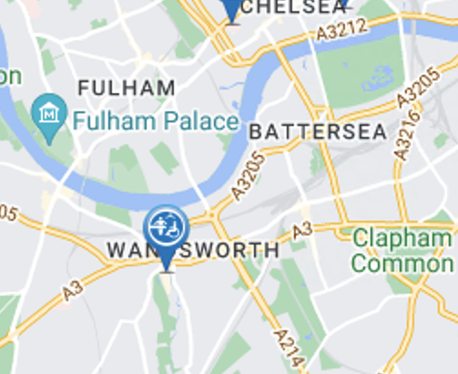 | BAC doesn’t have a Changing Places Toilet.  The closest Changing Places toilet is in the Southside Shopping Centre
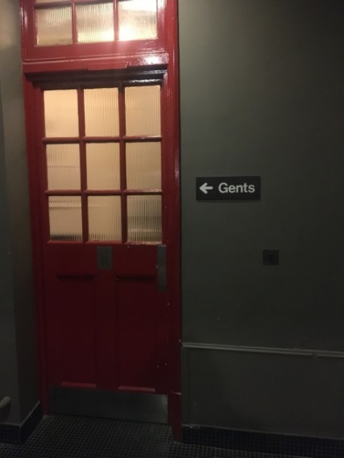 | This is the men’s toilets on the ground floor.
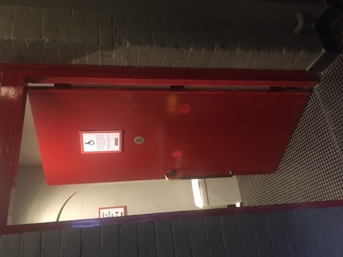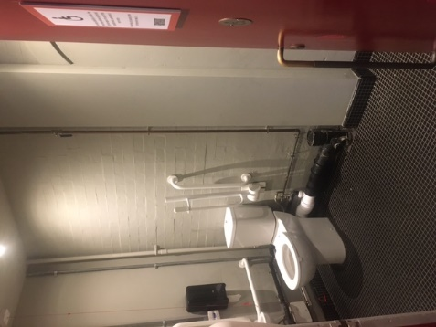 | This is the accessible toilet by the men’s toilet
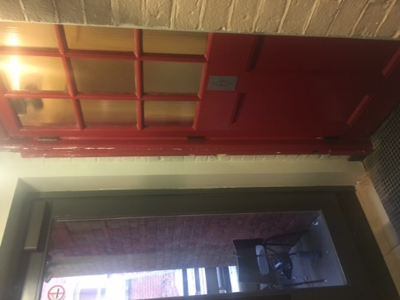 | This is the women’s toilet
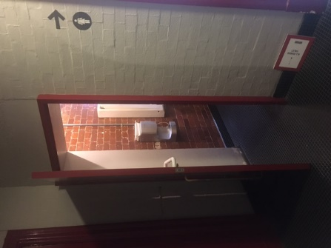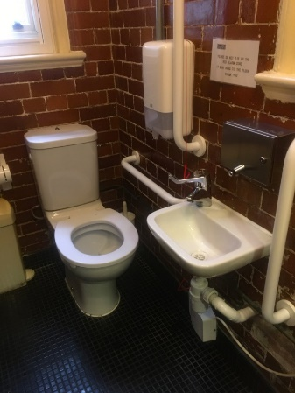 | This is the accessible toilet by the women’s toilet.
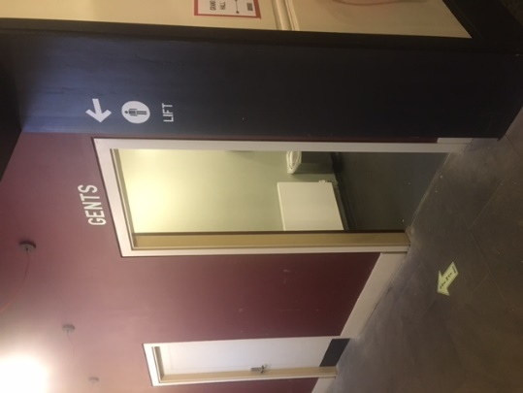 | This the is men’s toilets by the lift
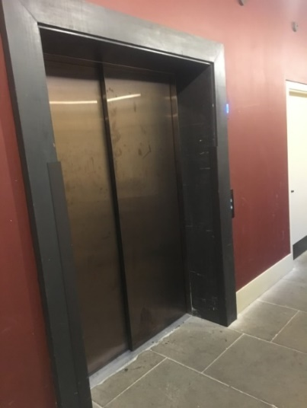 | This is the lift. It can take you down to the Grand Hall or up to the first floor.

First Floor
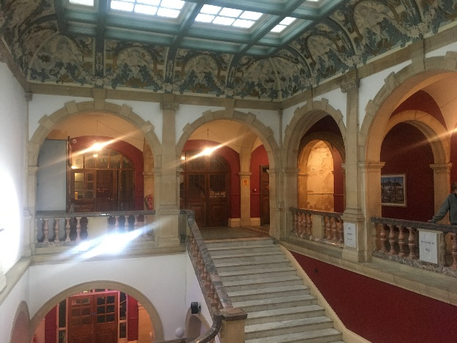 | The first floor has performance spaces, toilets and the chill out space
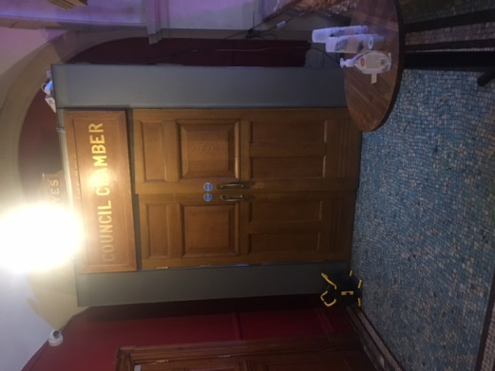 | This is the Council Chamber. You might see a show here. You might go to an event here.
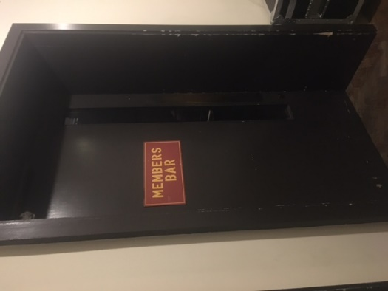 | This is the Members Bar. You might see a show here. You might go to an event here.
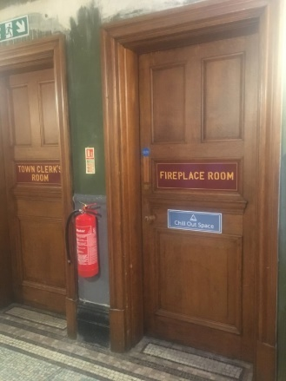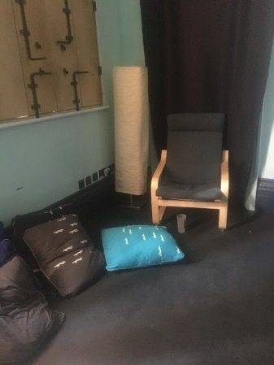 | If you need a break you can go to the chill out space.  It is quieter in the chill out space. You can turn the lights up or down. There are pillows, mats and blankets so you can lie down if you want.
 | There are women’s, men’s, accessible and gender neutral toilets on the first floor.
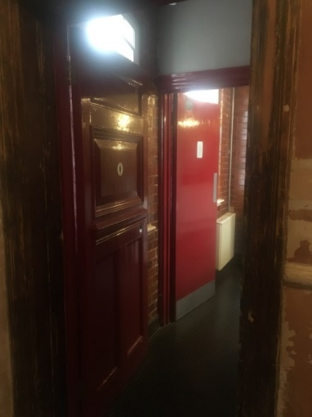 | These are the women’s toilets on the first floor.
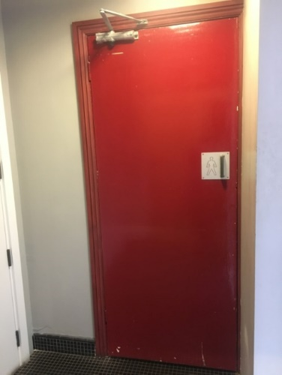 | These are the men’s toilets
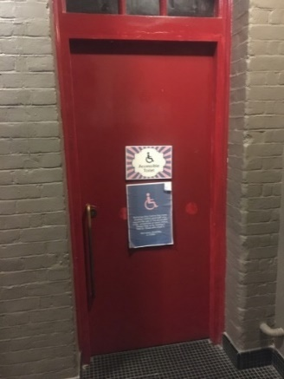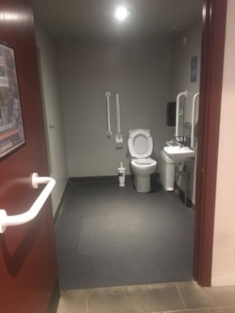 | This is the accessible toilet.
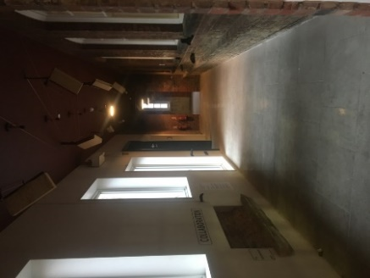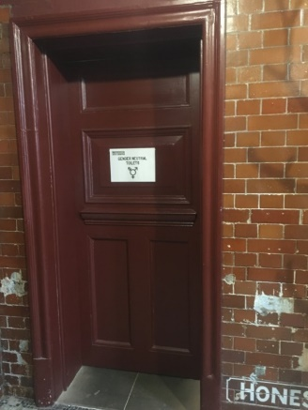 | This is the gender neutral toilet.  It is down the hallway with hands coming out of the wall

Grand Hall Level
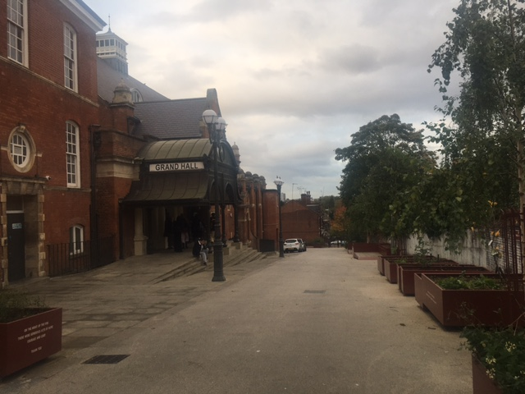 | You might enter the building through the Grand Hall entrance
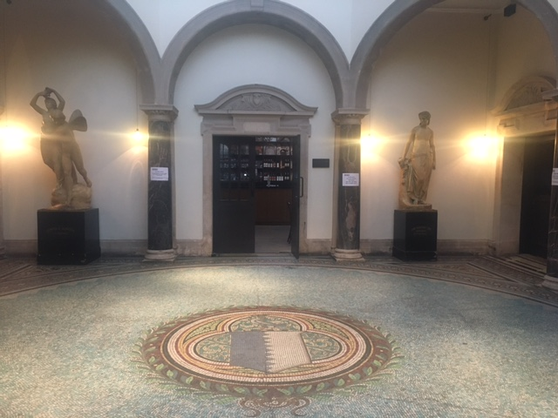 | Just inside is the Octagonal Hall and the Grand Hall Bar. You can buy drinks and snacks in the Grand Hall Bar. This space might be noisy and full of people.
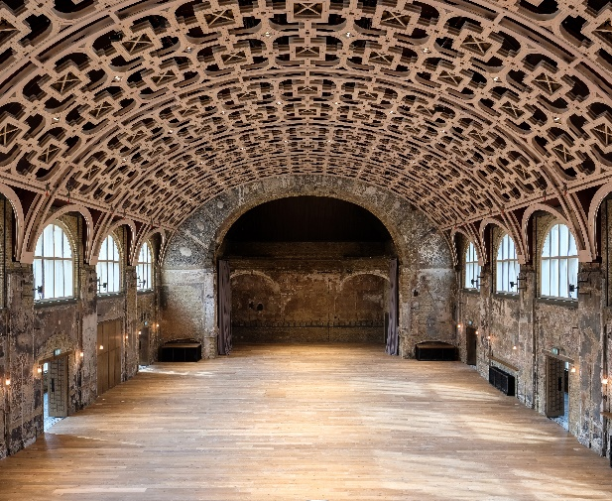 | This is the Grand Hall. This space might be noisy and full of people.
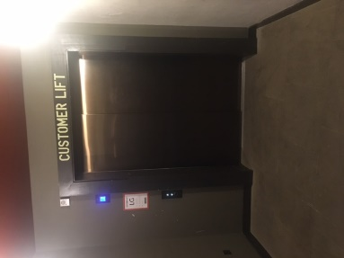 | This is the lift to the ground floor and the first floor.
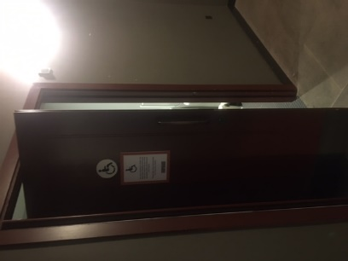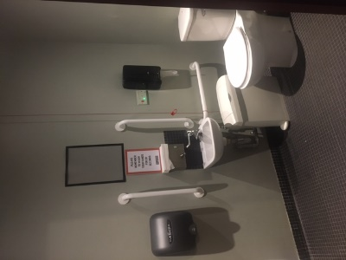 | This is the toilet beside the lift.

