Town Hall Forum Event
Easy Read Guide

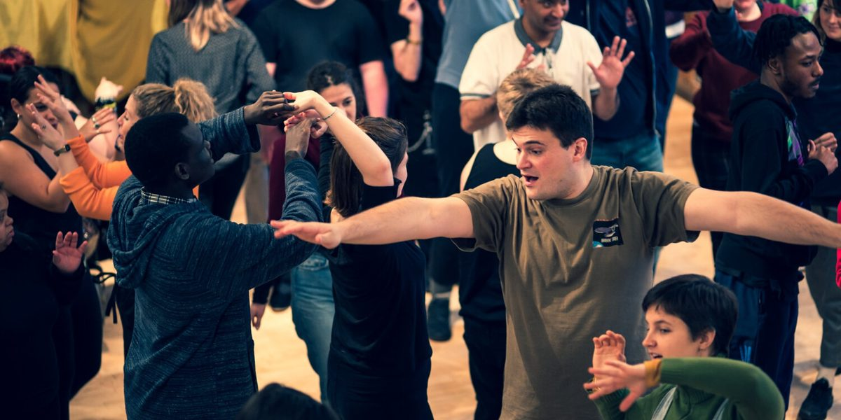

When and Where is the Town Hall Forum Event?
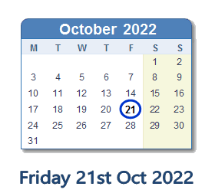 | The Town Hall Forum Event is on Friday 21 October from 2:30 – 5:30pm.
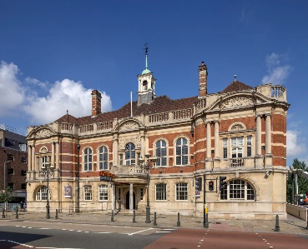 | It is at Battersea Arts Centre in the Grand Hall.
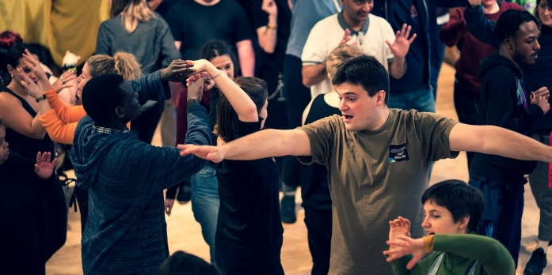 | It is hosted by Access All Areas.  Access All Areas is a theatre company of autistic and learning disabled artists.
 | There will be captions on a screen for anyone who needs them.

What will happen?
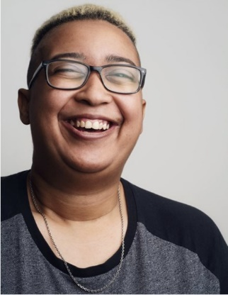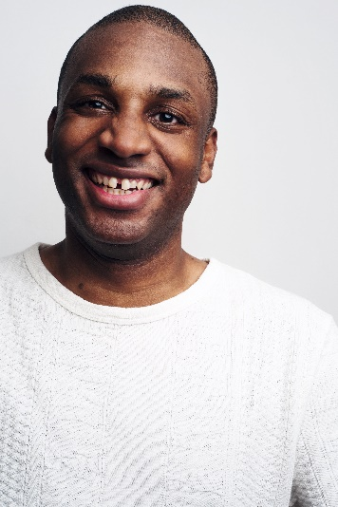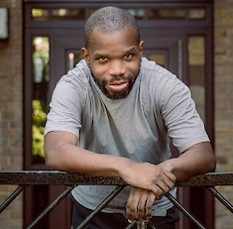 | Charlene and Helen will tell everyone a little about the event.  Charlene, Lee, Paul, Hayley and Helen will talk about Access All Areas and Back to Back.  They’ll tell you a little bit about what they did.
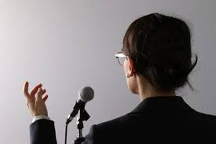 | A group of people will share about what they think about the questions:  When do you want to be spoken for?  When do you want your own voice?  There will be a film.  There might be performances or other art.
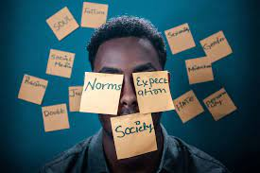 | A group of people will share about what they think about the questions:  - What are our own expectations of ourselves as learning disabled people?  - What are the labels and expectations others put on us?  There will be a film.  There might be performances or other art.
A group of people will share about what they think about the questions:

- What is going on now, and what's coming next?
- What steps need to be taken to get to the future we want?

There will be a film.

There might be performances or other art.

Then Matthew will speak.

Matthew is a from a company of artists with learning disabilities called Carousel.
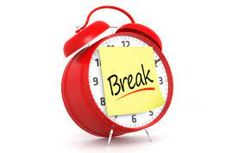 | Then there will be a break.
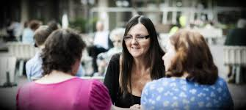 | Everyone will think about the questions together.  You will have a chance to say what you think.  If you want to, you can stand up and share your thoughts on stage.  You do not have to talk or move if you don’t want to.
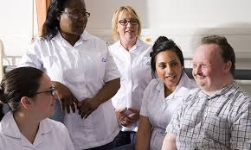 | We’ll talk as a big group about what we want to do next.  The Town Hall Forum Event will end.

