Hibernation – Pre show Information

This information is to help you decide if Hibernation is for you. Content notes, including what happens in the show, are further in the document.

The Space

The show is the Council Chamber. There will be seats on risers. There will be a stage. The stage will have some musical instruments and trees on it.
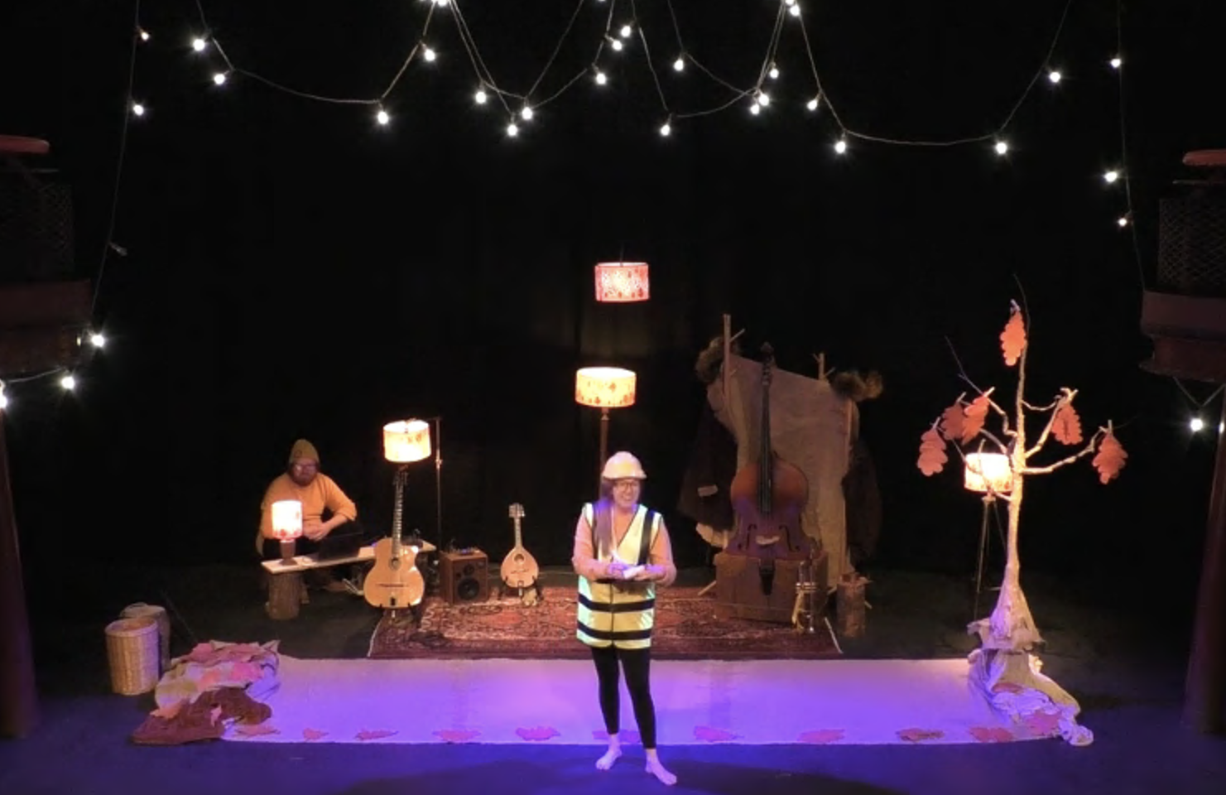

The Performers
The performers are:
- Clare Beresford
- Dominic Conway
- Alexander Scott

Lighting and Sound
- At the beginning, there will be gentle lights on both the audience and the performers.
- There are no flashing lights.
- There is no haze.
- During the film, the performers will talk over music a lot.
- Some of the songs are a little loud, especially when the performers are encouraging you and the rest of the audience to buzz or make other noises

Participation
The performers, especially the worker bee and queen bee will talk to you and other audience members a lot. You don’t have to talk with them if you don’t want to.
Sometimes you’ll be encouraged to buzz with the bees. You don’t have to if you don’t want to.

Access Information
- The show is 45 minutes long
- All performances are Relaxed this means you can move or make noise if you need to. You can go in and out of the performance space
- The performance at 2pm on 16 February will be BSL interpreted. Jacqui Beckford will be the interpreter. For the best view of the interpreter you should pick seats on the right hand side of the screen when buying tickets.
- The performance at 2pm on 17 February will be sensory adaptive. This means that the lights will be kept on at a low level throughout the performance. The music will be turned down a little bit. The performance will be changed to be friendly and comfortable for people who have sensory sensitivities.
- Latecomers will be permitted
- Ear defenders are available to borrow from the box office for anyone who might find these useful
- There is an accessible toilet on every floor of the building
- There is a chill out space outside the performance space that is available anytime the building is open.

Content Notes
The show is about hibernation. Hibernation is when animals go to sleep for the winter.

The show starts with the worker bee, Bee-atrice, welcoming everyone. She’s collecting names for a guest list for the Queen bee and might ask you your name or the name of your cuddly animal if you have brought one along. The worker bee then explains that everyone is there for the ‘Annual Bumblebee Hibernation Ceremony’ then teaches everyone some Queen bee etiquette before introducing the Queen bee, Bee-linda. Bee-linda chats to the audience and elaborates on her own Hibernation. They sing a song about hibernation.

Then the Queen and the worker bee send you and the audience on a tour of the forest to meet other animals that hibernate. You meet a Hazel Dormouse who sings about all the things that Hazel Dormice like to eat before hibernating for the winter. Then a snake joins and starts singing about how it likes to eat Hazel Dormice. Then the snake sings about how it’s misunderstood for needing to eat meat. Then you meet a bat who explains about echolocation. Another bat comes along and they sing about how bats hibernate. Then you meet bears. The bears sing about how great it is to be a bear, proclaiming themselves to be the best creature at hibernating. They ask the audience if they would like to try hibernating themselves and explain that to do that, they need to let the audience in on a very well kept bear-y secret. The secret is that despite giving the impression of being strong and scary, bears use lullabies to get to sleep. They then showcase a little bit of their lullaby but end up singing too much of it, and one of the bears puts himself to sleep. The other bear asks you to wake up the bear.

The worker bee returns and asks you to come back for the hibernation ceremony and crowning of the new queen bee, Bee-anca. Everyone cheers and buzzes the new queen bee. The new Queen bees goes into hibernation for the winter as the other two wish her sweet dreams and sing some of the Hibernation song chorus a final time.

