Shadow Film – Pre show Information

This information is to help you decide if the Shadow Film is for you. Content notes, including what happens in the show, are further in the document.

The Performers

The performers are:

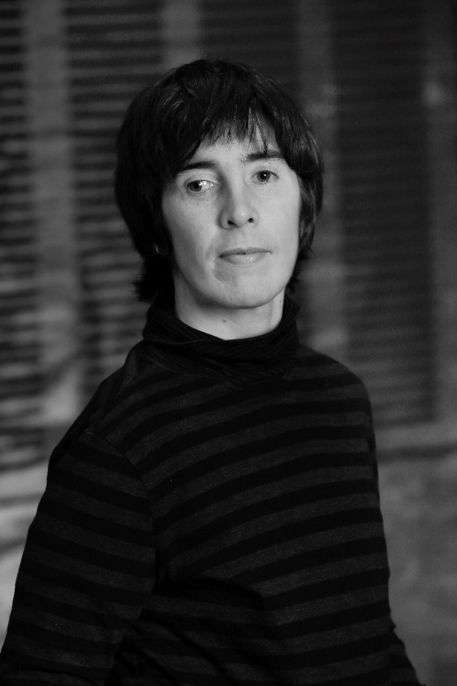 Sarah Mainwaring

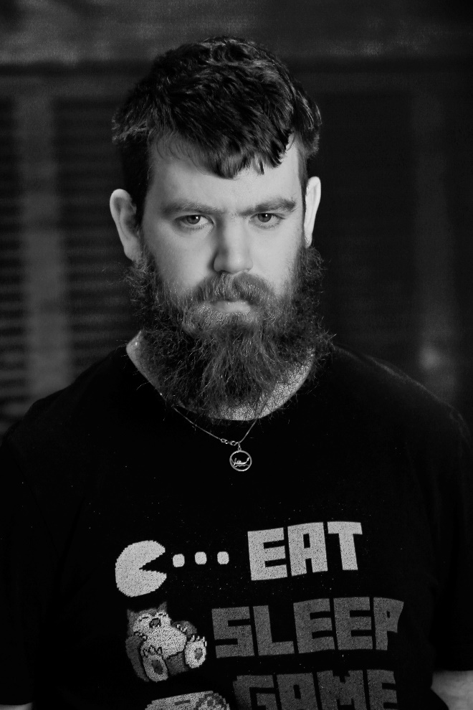 Scott Price

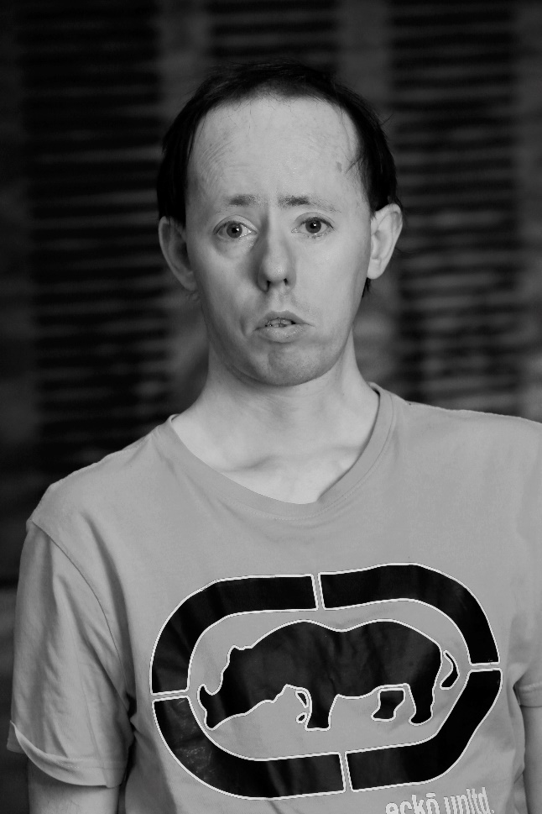 Simon Laherty
The film includes many other performers.
Lighting and Sound
- You can adjust your sound level on your device at any time
- You can adjust the brightness on your device at any time

Access Information
- The performance is 56 minutes long
- There is no interval but you can pause it anytime you need to
- You can move or make noise
- The video has captions throughout

Content Notes
The Shadow Film takes place in a town hall. The film talks about and shows a lot of different issues, particularly the abuse of people with intellectual disabilities in the past. This includes:
- How hard the language around disability is
- How some people with intellectual disabilities get taught to say yes to everything
- How many people with intellectual disabilities do not have power over their lives
- How some people with intellectual disabilities are not paid for their work
- How some people with intellectual disabilities are given pills to make them less active
- How artificial intelligence (computers) are becoming smarter than people

Please note that Australia and the UK have very different language for disability. In Australia ‘people with intellectual disabilities’ is polite. This is the language used the show.

