Hibernation

Easy Read Guide

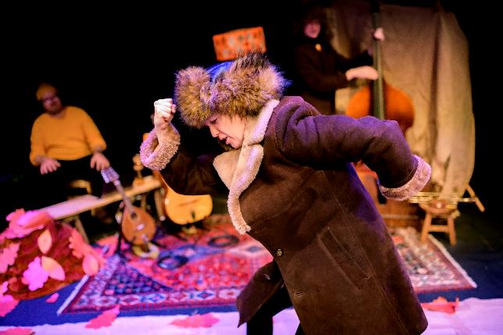

|  |  |
| --- | --- |
| \\bacserv1\folderredirection$\kelsiea\Downloads\Prod shot_HIBERNATION_Little Bulb Theatre BOV Oct 2022 PB-61.JPG | Hibernation is about hibernation.  Hibernation is when animals sleep through the winter. |
| S:\Relaxed Venue Project\Visual Guide Images\IMG_3045.jpg | Hibernation takes place at BAC.  There is more information about BAC here: https://bac.org.uk/access/  There is also a visual guide to the building on that web page. |
| \\bacserv1\folderredirection$\kelsiea\Desktop\download.png | The performances is 45 minutes long. |
| \\bacserv1\folderredirection$\kelsiea\Desktop\download.png | All performances are relaxed performances.  This means you can move and make noise.  You can leave the show and come back in at any point. |
| ken9581000k | There aren’t any flashing or moving lights.  There’s a lot of music played, often while people are talking.  Sometimes the performers will ask you to shout things. That will be a little loud.  You can borrow ear defenders and fidget toys from the box office. |
| C:\Users\kelsiea\AppData\Local\Microsoft\Windows\Temporary Internet Files\Content.Word\download.jpg | There will be a BSL interpreted show on Thursday, February 16th at 2:00pm  The interpreter will be Jacqui Beckford. |
| \\bacserv1\folderredirection$\kelsiea\Desktop\download.jpg | There will be a sensory adapted performance on Friday, February 17th at 2:00pm.  This means there will always be a little bit of light on.  The sounds will also be a little bit quieter. |

Who are the performers?

|  |  |
| --- | --- |
| C:\Users\kelsiea\AppData\Local\Microsoft\Windows\Temporary Internet Files\Content.Outlook\LCQLNR7C\HIBERNATION_Little Bulb Theatre BOV Oct 2022 PB-78.JPG | Dominic Conway plays a lot of different animals |
| C:\Users\kelsiea\AppData\Local\Microsoft\Windows\Temporary Internet Files\Content.Outlook\LCQLNR7C\HIBERNATION_Little Bulb Theatre BOV Oct 2022 PB-79.JPG | Alexander Scott controls the lights and music.  He also moves the autumn leaves and one of the bees |
| C:\Users\kelsiea\AppData\Local\Microsoft\Windows\Temporary Internet Files\Content.Outlook\LCQLNR7C\HIBERNATION_Little Bulb Theatre BOV Oct 2022 PB-77.JPG | Clare Beresford plays a lot of different animals |

What Happens?

|  |  |
| --- | --- |
| \\bacserv1\folderredirection$\kelsiea\Downloads\Hibernation at TERRESTRIAL_EAST WOODLANDS OCT 2022 creditPaulBlakemore -119.JPG | When you come in Bee-atrice will talk to you.  She will ask for your name and what you know about hibernation.  Bee-atrice explains that you are here for the annual bumblebee hibernation ceremony and what happens at the ceremony. |
| \\bacserv1\folderredirection$\kelsiea\Downloads\7.jpg | The queen arrives.  The Queen is very excited to see that so many guests have turned up for the hibernation ceremony.    She tells you about hibernation and waking up in the spring.  Today a new bee queen will be crowned.  The new queen is named Bee-anca.  Bee-atrice and the queen sing about hibernation. |
|  | You go on a tour of the forest and meet the animals who will be hibernating for the winter.  Bee-atrice teaches you about flying so you can get around the forest.  You can make some flying arm moves if you want. |
| \\bacserv1\folderredirection$\kelsiea\Downloads\Hibernation at TERRESTRIAL_EAST WOODLANDS OCT 2022 creditPaulBlakemore -131.JPG | First, you meet a mouse.  The mouse sings about eating lots before hibernating.  Then, you meet a snake.  The snake also needs to eat a lot before hibernating. |
| \\bacserv1\folderredirection$\kelsiea\Downloads\Prod shot_HIBERNATION_Little Bulb Theatre BOV Oct 2022 PB-36.JPG | The snake is scared of humans and pretends to be dead.  Then, the snake sings about how people shouldn’t judge animals who eat other animals. |
| \\bacserv1\folderredirection$\kelsiea\Downloads\Prod shot_HIBERNATION_Little Bulb Theatre BOV Oct 2022 PB-55.JPG | Then, you meet two bats.  The bats explain how they find their way around using sound.  They also explain how bats hibernate. |
| \\bacserv1\folderredirection$\kelsiea\Downloads\Prod shot_HIBERNATION_Little Bulb Theatre BOV Oct 2022 PB-61.JPG | Then, you meet two bears.  The bears sing about how good they are a hibernating  The bears let you in on a very well-kept secret that they use a lullaby to get to sleep. |
| \\bacserv1\folderredirection$\kelsiea\Downloads\HIBERNATION_Little Bulb Theatre BOV Oct 2022 PB-70.JPG | The bear sings a lullaby.  It is so good that he falls asleep.  You might want to help wake him up by shouting, ‘WAKE UP’.  This will be a bit loud. |
| \\bacserv1\folderredirection$\kelsiea\Downloads\HIBERNATION_Little Bulb Theatre BOV Oct 2022 PB-19 (1).JPG | Then it’s time for the bee hibernation ceremony.  Bee-anca is crowned and she goes to sleep. |
| \\bacserv1\folderredirection$\kelsiea\Downloads\HIBERNATION_Little Bulb Theatre BOV Oct 2022 PB-18.JPG | The performance ends.  You can clap for the performers if you want. |

Most of the photos in this Easy Read guide are by Paul Blakemore.