Part of working towards becoming a relaxed venue is giving our disabled audiences all the information they need to decide if a particular show is for them. We upload your forms to our website to make sure that everyone has all the information they need when they’re deciding to buy a ticket.

- How long is the show (including interval, if relevant)? How long is first part of the show? How long is the interval?

First Half: 19.30 - 20.15
Interval approx. 35 min
Second Half: 20.50 - 22.10

- What will the show space look like?

The show will be in BAC’s Grand Hall. When you come in, an organ is right above you. The stage will be under the organ. The central space will be for standing and dancing. There will be cabaret tables of either side of the room. At the opposite side of the room from the organ there will be a bar and more tables.
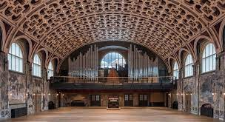

- Do you have any access materials (e.g. large print or braille programs, a touch model of the set, a script)?
All lyrics will be on large screens on the stage
I am sorry we are unable to provide additional materials as we do not know what songs will be selected until the night.

- Who are the performers? (ideally, we would love a photo of each performer in costume and a sentence introducing them)
Performer Kit Green will be playing his most beloved character Ida Barr who is faded Edwardian rapping pensioner in all her glory.
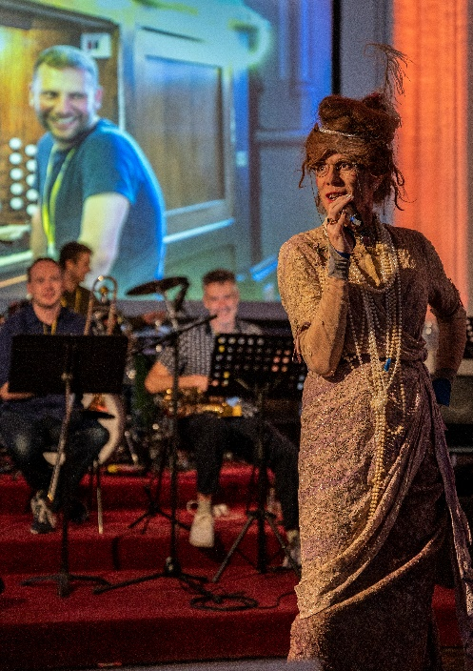
There will also be a band: Organist, Bass, Guitar, Trumpet, Trombone, Drums
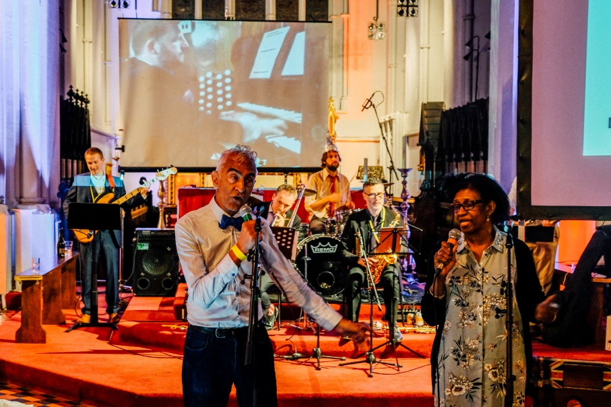
- What happens in the show?
First half: Everyone sings – we’ve already picked the songs for the crowd to sing. They will be universally well known so are all Karaoke classics with emphasis on the 80s 90s 00s.

During the first half the audience will have a chance to look at our song list and self-nominate to sing solo in the second half.

The second half is unknown! We will draw the songs from a tombola so even the band do not know what the song will be!

The soloists will be singing on stage but he rest of the audience will be singing with them and supporting them

We round off the night with some en-masse singing and do the hokey cokey!

- What are some of the themes in the show?
Community, coming together, singing and having a great time.
We encourage people to dress in what makes them feel great: the brighter and bolder the better.

- Are there elements that people might like to know about like swearing or nudity?
There may be the occasional expletive as this is an unscripted show but is not the basis of the performance.

- Are there any moments or themes within the show which could be traumatic?
People who self-nominate themselves to perform in the second half will come up to the stage, this does not affect the rest of the audience.

- Sensory Information
  - What will the lighting be like? Are there moments of sudden lighting change or moments of total or near darkness? Do you use haze? Are there strobe lights?
There will be no strobe lights, the room will have dramatic lighting, lights will change colour.

  - Is there loud music or sudden loud sounds at any point?
The organ is loud and cannot be easily volume controlled. We suggest anyone with sensitive ears to bring ear protection with them and we will offer earplugs at various locations throughout the performance space.
This is a relaxed performance so you are welcome to move around the space, make noise and come and go as you need to.

  - Are there any moments which might be surprising or unpredictable? For example, any moments where the action depends on audience participation?
The entire show requires audience participation for everyone and solos for those who would like to perform on stage in the second half.

  - Is there any food or drink onstage? Any offered to the audience? Any latex(e.g. balloons or condoms) onstage?
No

  - Are there further special effects that we should be aware of?
There is a bar within the performance space so there will be the consumption of alcohol during the performance

  - Will there be photography, audio recording or filming that might involve the audience?
Yes there will be filming and photography throughout the night. We shall ensure our photographer is clearly visible. Please notify them if you do not wish to be photographed.

