The Power of the Fragile - Pre-show Information
This information can help you decide if The Power of Fragile is for you. Content notes, including what happens in the show, are further in the document.
Access Information
- The performance is 75 minutes long
- There is no interval
- The performance space has step-free access
- All performances are Relaxed this means you can move or make noise if you need to and can go in and out of the performance space
- Arabic, Tunisian and English are used in the performance. Most of the performance is surtitled in English.
- Latecomers will be permitted
- Ear defenders are available for anyone who might find these useful
- There is an accessible toilet on every floor of the building
- There is a chill out space outside the performance space that is available anytime the building is open

The Space
The space will look a little like this:

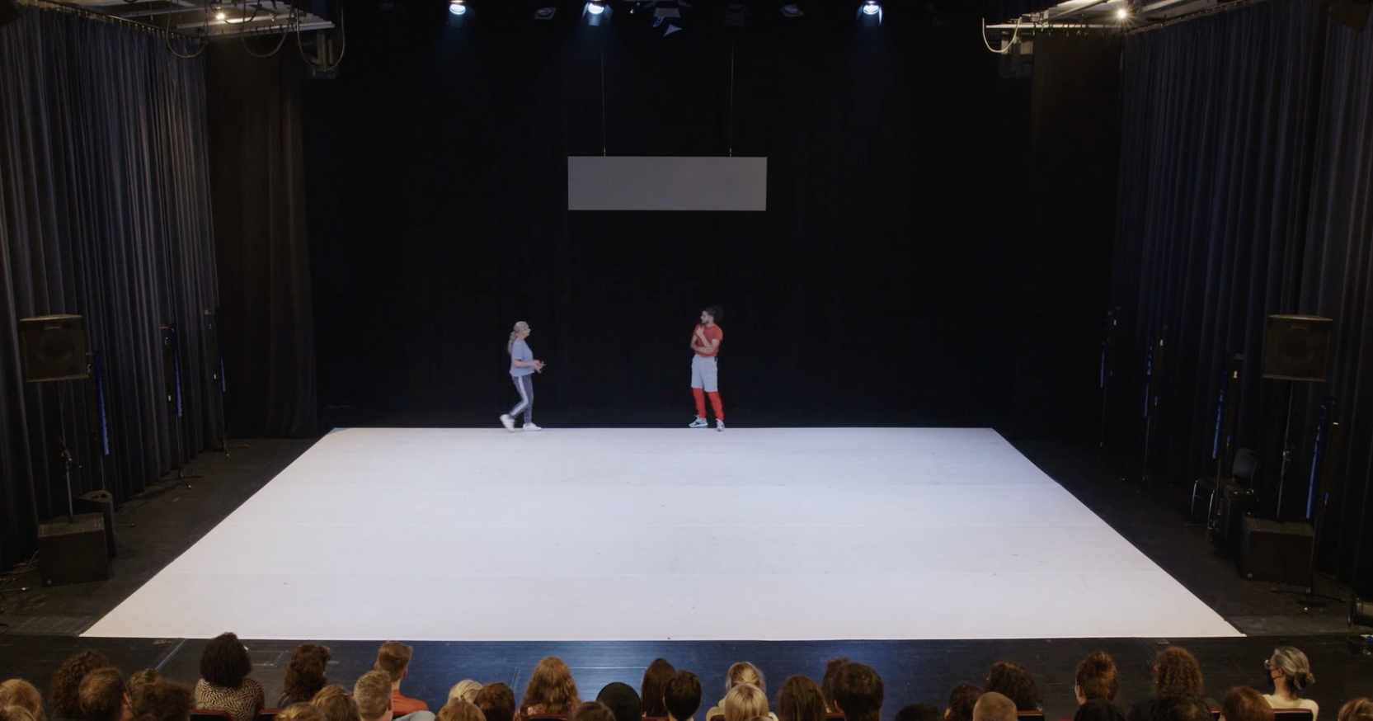

The Performers

Mohamed
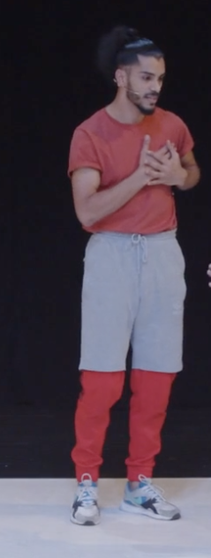

Latifa
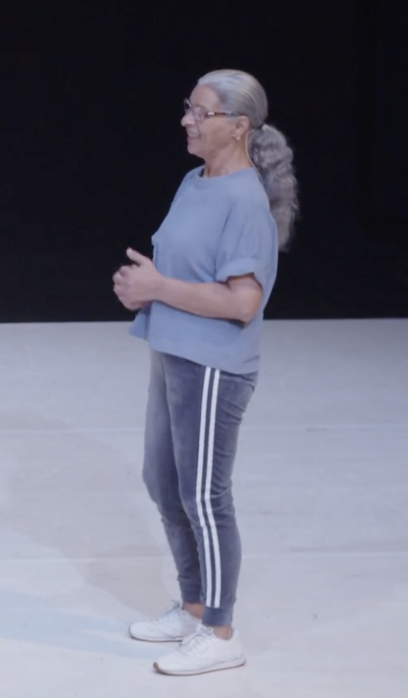

Lighting and Sound
- There is speaking over music
- There are no sudden loud noises but some of the music is a little loud
- There is a section about an hour in with a lot of flashing lights for about 1 ½ minutes
- There is a mirror used on stage at the end which might flash light towards the audience.

Participation
- The performers speak directly to the audience
- You don’t have to reply or participate in the performance

Content Notes
The Power of (the) Fragile is about love, dance family, the cruelty of barriers to moving between countries. If you want to know more about what happens in the performance there is a description on the next page.

What happens?
Mohamed and Latifa come onstage. Mohamed explains the theatre to Latifa, including backstage, downstage and upstage. He also explains conceptual dance and the fourth wall. As he continues to explain the theatre a voice over explains that this performance had been cancelled twice. Once by COVID-19 and once because Latifa’s visa was denied. Mohamed and Latifa move. Mohamed tells the story of his first audition in Belgium for Maurice Bejart for Le Sacre de Printemps. Mohamed and Latifa dance a little bit of Le Sacre. After they finish Mohamed explains a little bit about the music and who has choreographed to it. Latifa doesn’t like the music – it is boring and makes her fall asleep. Mohamed and Latifa dance with Latifa balanced on Mohamed’s feet. Latifa explains that she prefers Michael Jackson, Prince, artists like this. Latifa dances to Le Freak by Chic. Mohammed explains that his mother wanted to be a dancer.
Latifa tells her story of growing up in Tunisia, moving to Italy to work, meeting Mohamed’s father and returning to Tunis. As she tell her story, sometimes she stops. When she stops she and Mohamed dance together. She talks about how travel was easy in the 70s but that changed. Mohamed appears with something under his shit. It looks like his is pregnant or his belly is swollen. He lies down and Latifa cuts his shirt open with scissors. She pulls out dirt and leaves. She talks about when Mohamed left to study dance. She tried to visit him, but applying for visas was very difficult. She talks about how much it hurt knowing that he was alone. She keeps talking about the music gets louder and louder. Mohamed moves as if he is fighting something. There are a lot of rapid flashing lights. The lights flash for about 90 seconds.
Then, Latifa and Mohamed dance together, weaving around each other. They go off. Mohamed explains they are just trying something out. Latifa comes out in a beautiful dress and headdress. Latifa holds two crosses in her hands and then Mohamed holds the flag of the European Union behind her. Then he drapes it over her shoulders. Mohamed lifts Latifa on his shoulders and they joyfully dance around. They say thank you for coming and the show ends.

