One Song – Pre show Information

This information is to help you decide if One Song is for you. Content notes, including what happens in the show, are further in the document.

The Space

The show is in the Grand Hall There will be a stage and space for the audience.

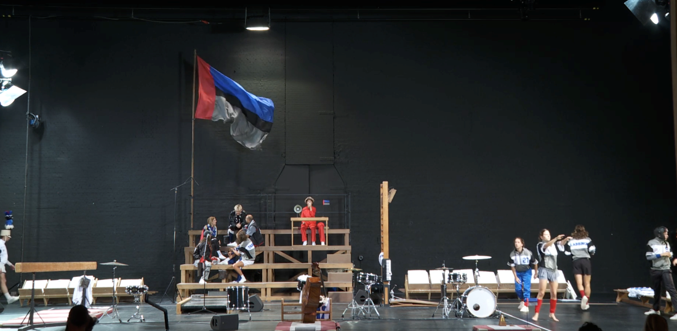

The Performers

The performers are:

* Simon Beeckaert
* Elisabeth Klinck
* Willem Lenaerts
* Milan Schudel
* Melvin Slabbinck
* Joppe Tanghe
* Karin Tanghe
* Wietse Tanghe

Lighting and Sound

* There will be loud music and sounds throughout the performance
* There will be flashing lights and lights in audience eyes

Participation

* There is no audience participation in this performance

Access Information

* The show is 60 minutes long
* There is no interval
* Chalk dust is used throughout the performance. If this won’t be good for you please sit farther from the stage
* All performances are Relaxed this means you can move or make noise if you need to. You can go in and out of the performance space
* Latecomers will be permitted
* There is an accessible toilet on every floor of the building
* There is a chill out space outside the performance space that is available anytime the building is open

Content Notes

One Song is about how sport and art can both help us understand grief. It’s interested in physical endurance and about letting go of things. The song that is sung again and again through the performance includes mentions of death, running for your life, grief and graves.

Detailed Description of Content

The performance starts with the performers warming up. An announcer is talking into a microphone. The microphone is bad. The sound is tinny and full of static. It’s almost impossible to understand what the announcer is saying. The announcer introduces the performers like they are football or basketball players, using numbers.

A metronome starts ticking. One of the performers gets up on the balance beam. They play the violin. One by one the other performers join in. One performer plays the base by doing sit ups. Another plays a keyborad by bouncing on a jumpboard. A performer runs on a treadmill and sings. Other performers play spectators who cheer them on.

The song the performer sings will repeat over and over for the rest of the performance. The song will mention running for your life, grief, graves and death. Sometimes the song gets slower, sometimes it gets faster. The performers keep pushing through. At one point the spectators start wrestling with each other.

Then, everyone goes into slow motion. They speed up again. They stop to dry off the stage. They place blue buckets around the stage as the cheerleader runs in circles.

They start the song again. The performer get more and more tired. They start to collapse. Other performers try to take over their parts from them. Finally, they all collapse except the cheerleader who is spinning in circles. The cheerleader collapses. Only the announcer is left. All the performers get up and they sing an anthem. The show is over.