You Heard Me – Pre show Information

This information is to help you decide if You Heard Me is for you. Content notes, including what happens in the show, are further in the document.

The Space

The show is in the Members Bar. There will be a stage and space for the audience.

The Performers

The performer is Luca Rutherford.
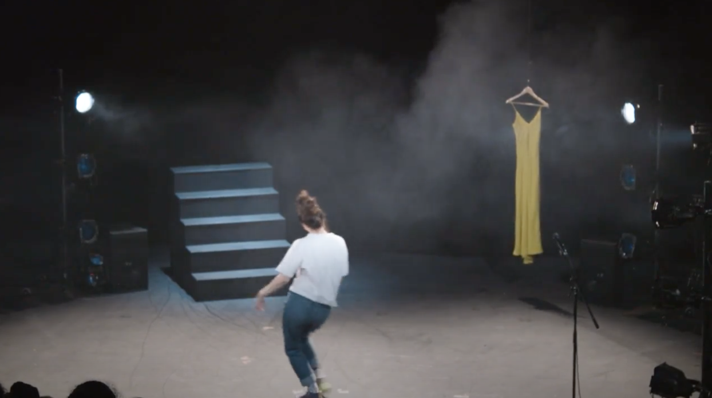

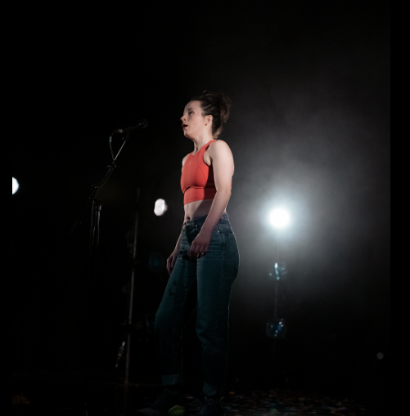

Lighting and Sound
- There will be loud sounds throughout the performance
- There will be speaking over music
- There will be flashing lights and there might be lights in audience eyes
- There will be several moments of complete darkness
- There will be haze

Participation
- There is no audience participation in this performance

Access Information
- The show is 45 minutes long
- There is no interval
- All performances are Relaxed this means you can move or make noise if you need to. You can go in and out of the performance space
- Latecomers will be permitted
- There is an accessible toilet on every floor of the building
- There is a chill out space outside the performance space that is available anytime the building is open
- There is a latex balloon in the performance.

Content Notes
You Heard Me is about taking up space and being loud. It’s also about sexual violence and all the reasons you might need to be loud. It is also about how you can be powerful in quiet ways and that is also important. You Heard Me has detailed descriptions of an attack. The description repeats because the performance also explores how your mind can return again and again to hard experiences.

Detailed Description of Content
The performance starts with Luca’s voice letting you know about the content of the performance and encouraging you to do what you need to do.

Sudden loud music plays. There is haze. Luca dances around and throws confetti. She tells a story. She’s performing in Hull. She goes for a run before the show. She runs by the docks. She stops to take a photograph of a parkade. A man appears. She goes on running. Then the man grabs her. She fights and she offers him her phone. He tells her to shut up, he’s a police officer. He tells her go into the building. She tries to run. He catches her. There’s a detailed description of the fight. It includes her attacker putting his hands over his hands and mouth. She tries to figure out what the best way to get out of this. She gets away and she runs.

Darkness and the sound of Luca’s heart beat.

She moves and the story of the man assaulting her plays again as a recording. Uneasy music plays under it. Luca makes a hole in the balloon and breathes in helium. This makes her voice is squeaky.

The story repeats again. The heartbeat is faster. Again, Luca’s voice is distorted. Luca’s voices asks someone not to touch the top of her head. The beat escalates. The story repeats again.

She moves the stairs. She stands on top of them. She says, ‘This scream changed everything’. The lights will be very bright. They might go into your eyes.

The voice over urges us to get angry. It urges us not to be a lady. To be aggressive. Be rude. Be loud. Luca tells the story of Ola, the man who heard Luca screaming and came to help.

She assures us that she’s okay. You’re okay. She tells us that she decided to scream. The scream scared the man who was attacking her. She wants that power every day.

She wishes that she was not afraid. She wishes she could stand up for herself and for other people.

She talks about how people focused on the details of when and where the attack happened. She says that when you do this you are accepting rape. When we say this we are suggesting that there is an acceptable time and place for rape. We should change the way we talk about rape and violence.

The man who attacked Luca is in prison. It took Luca three years to be able to say the word rape. To tell this story.

The sound of water underscores this section. She explains she is quieter and more scared. But she is also louder.

