Solstice - Visual Guide

The Characters

The Dragonfly – Summer

Please note that although one of the reference pictures is outside, the Solstice walking trail all takes place inside.
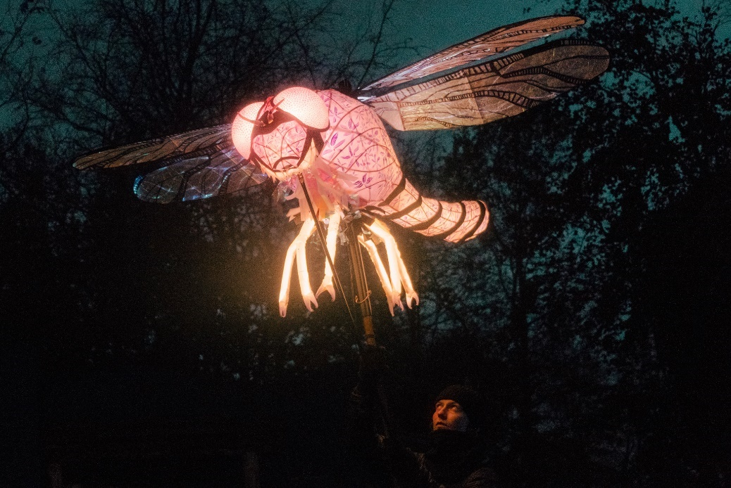

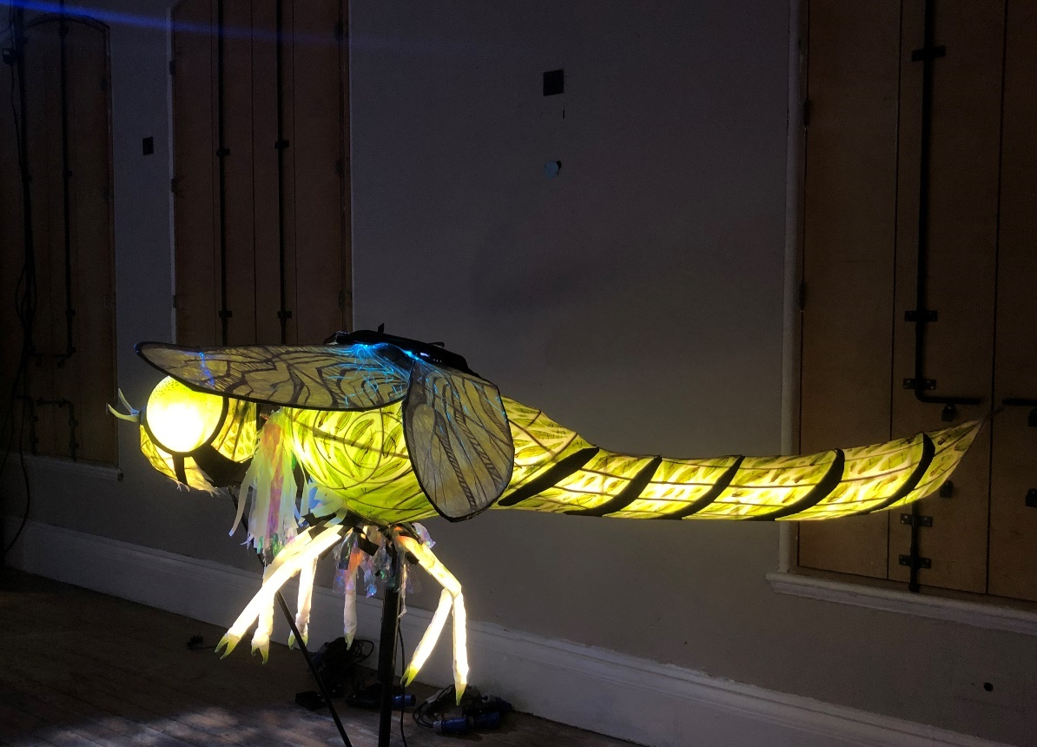

The Wolf - Winter
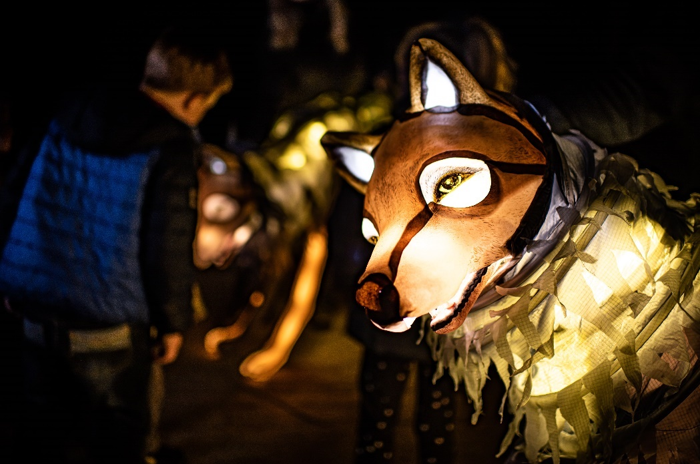

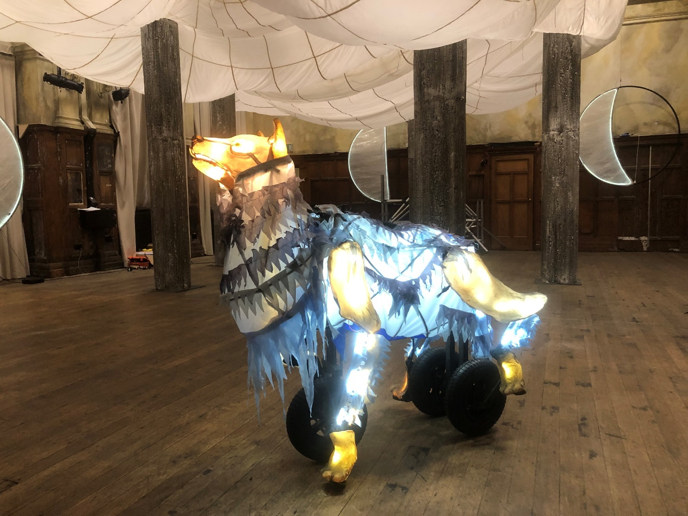

Audience Interaction

The ‘Opt-Out of Interaction’ Token
Please take one of these from the Front Desk if you would like to not be involved in the Audience Interaction.

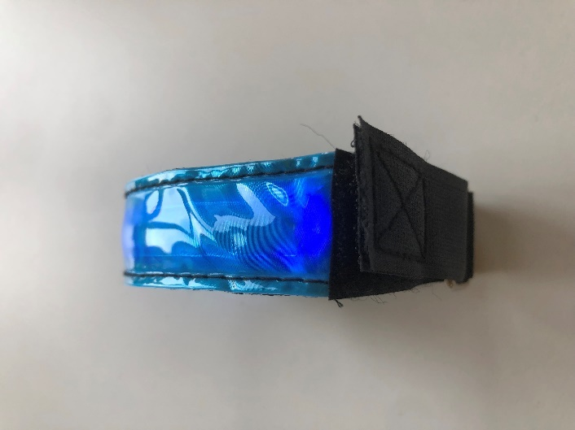
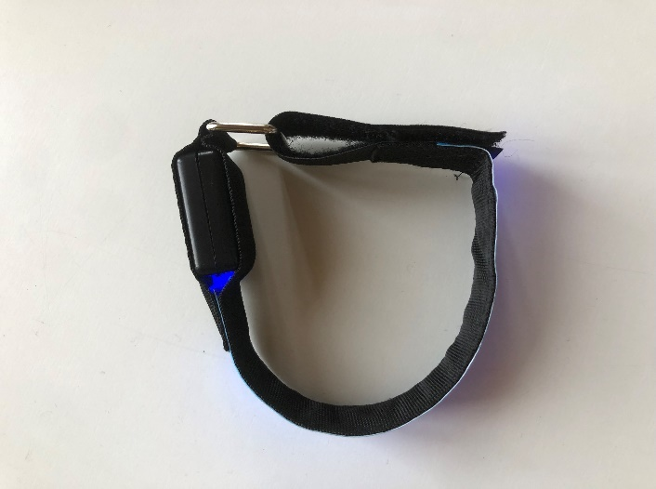
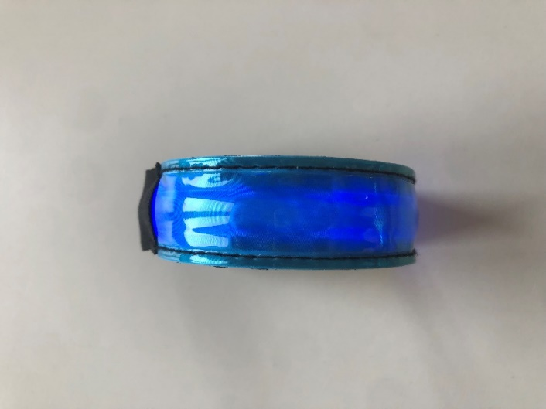
They look like this:

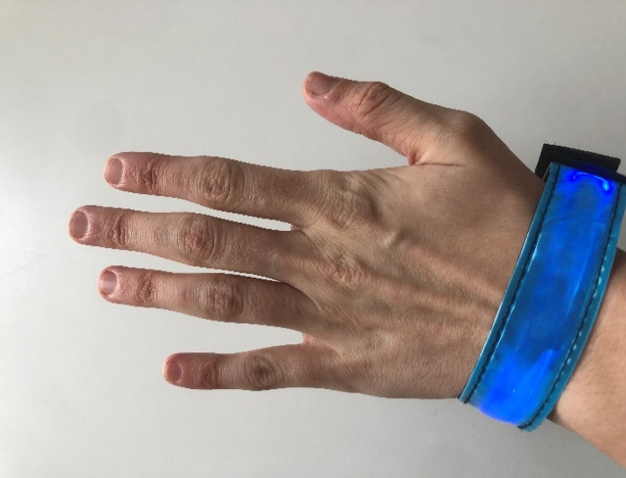
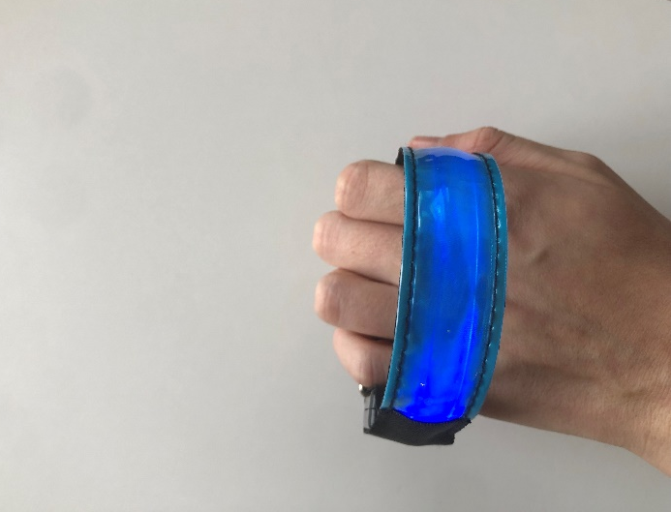
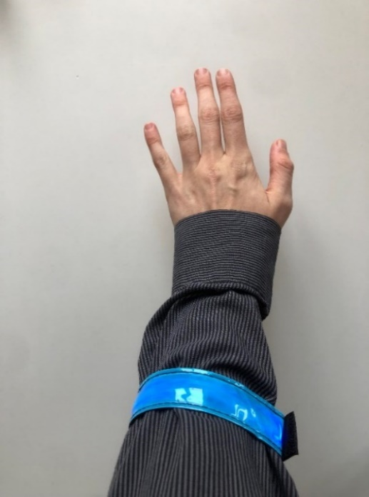
And you can wear them in any way you like, ensuring that they are visible, maybe like this:

Audience Activity

The Shadow Puppet Activity – Winter

Please note that although the reference picture is outside, the Solstice walking trail all takes place inside.
