Big Finish – Pre show Information

This information is to help you decide if Big Finish is for you. Content notes, including what happens in the show, are further in the document.

Big Finish is still in development so some elements may change.

The Space
- This performance takes place in the Council Chamber.
- The audiences are seated on a rake that takes up most of the room.
- The performance takes place in front of the rake.

The Performers
- Figs in Wigs are (left to right) Sarah Moore, Alice Roots, Rachel Porter, Suzanna Hurst and Ray Gammon
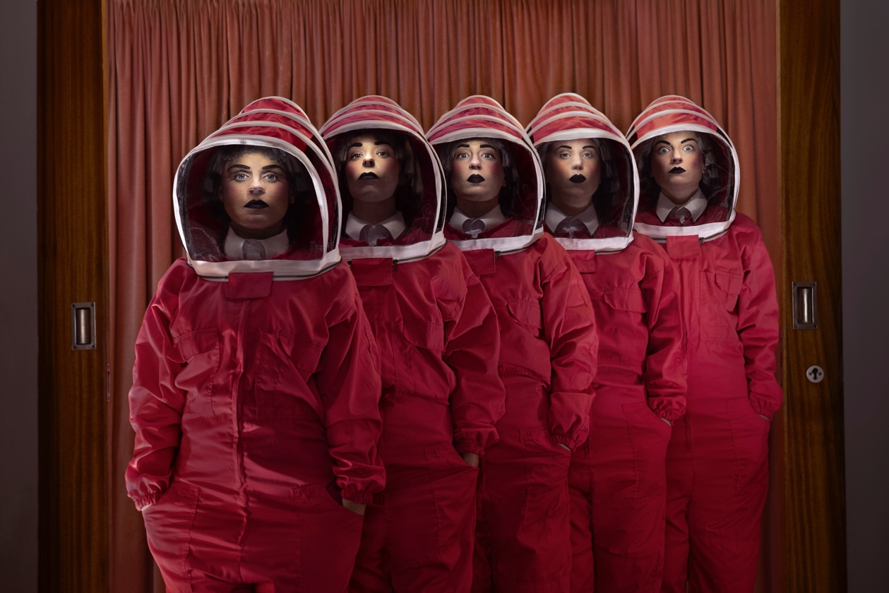

Lighting and Sound
- There is different lighting throughout. There are moments of complete darkness.
- There is loud music and sound used at different times in the show. There will be loud storm sound effects and live violins.
- There are flashing lights.
- There is haze used in the show.
- The Performers will talk over the music, and sometimes shout.

Participation
- The performers will speak to each other and the audience.
- There is no audience participation.

Content Notes
- The show is performed by five performers, wearing matching outfits.
- The performers will speak to the audience, perform movement in time to music, and play violins.
- The show is about endings, the end of world, and the end of a career. The show is also about friendship, collaboration and new beginnings.
- There will be mentions to the climate catastrophe, death, and the apocalypse.

Access Information
- The show is 60 minutes long.
- Latecomers will be permitted
- All performances are Relaxed. This means you can move or make noise if you need to and can go in and out of the performance space
- Ear defenders are available to borrow from the box office for anyone who might find these useful
- There is an accessible toilet on every floor of the building
- There is a chill out space outside the performance space that is available anytime the building is open

If you would like to know more about the performance, please contact access@bac.org.uk

