The Rest of Our Lives – Pre show Information

This information is to help you decide if The Rest of Our Lives is for you. Content notes, including what happens in the show, are further in the document. Please be aware this document may reveal spoilers for the performance.

The Space
- This performance takes place in the Council Chamber.
- The audiences are seated on three sides of the room, with an open space in the middle where the performance takes place.
- There is a table in the back of the room with computers and props including a hat, a table-tennis bat, and a book of raffle tickets. Above the table is a LED text box.

The Performers
- Jo Fong
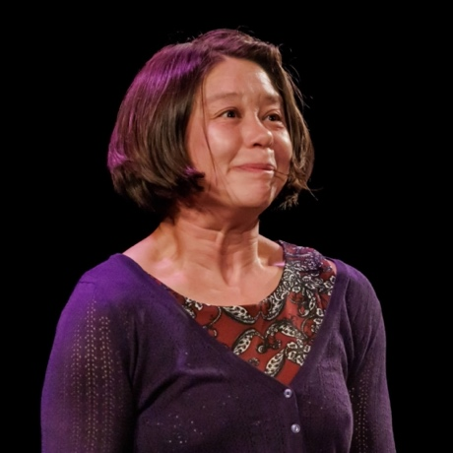
- George Orange
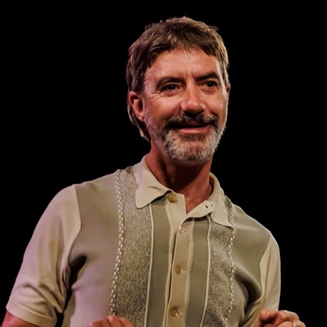

Lighting and Sound
- There is warm lighting throughout. There will be darker sections but no moments of complete darkness.
- There will be a disco section with coloured lights.
- In places there is loud music, and a sudden loud noise will feature twice in the show.
- There are flashing lights, but no strobe.
- There is no haze or smoke.
- Sometimes performers will shout over the music or use microphones

Participation
- Jo and George interact with the audience throughout.
- There is a mass ping pong game involving the whole audience, a raffle and dancing.
- You do not have to participate if you don’t want to.

Content Notes
- People are welcomed into the space by Jo and George and are seated. Jo and George perform around 35 short acts ranging from dancing together, balancing on one another, holding each other up, singing, spoken word, and lots of music.
- The show is about this moment, about everything we’ve all been through and about how to keep going. It is about anyone at any age and about how to live well. It’s funny, it’s empathetic, sad in places, sometimes wild and chaotic, sometimes confusing, celebratory, and mostly it’s loving.
- There is nothing particularly upsetting or traumatic.

Access Information
- The show is 80 minutes long.
- There are latex balloons featured in the show.
- All performances are Relaxed this means you can move or make noise if you need to and can go in and out of the performance space
- Latecomers will be permitted
- Ear defenders are available to borrow from the box office for anyone who might find these useful
- There is an accessible toilet on every floor of the building
- There is a chill out space outside the performance space that is available anytime the building is open

If you would like to know more about the performance, please contact access@bac.org.uk

