Get Off – Pre show Information

This information is to help you decide if Get Off is for you. Content notes, including what happens in the show, are further in the document.

The Space
- This performance takes place in the Council Chamber.
- The audiences are seated on a rake that takes up most of the room.
- The performance takes place in front of the rake, with a large white floor and white projection screen.

The Performers
- Katy Baird
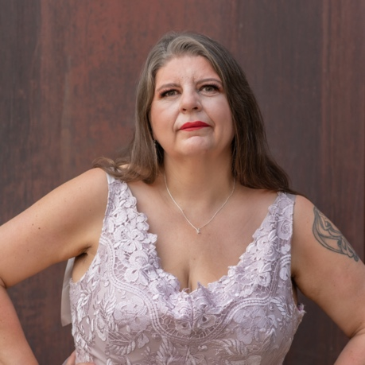
Lighting and Sound
- There is different lighting throughout. There are moments of complete darkness, and use of video projection.
- There is loud music used at different times in the show.
- There is strobe lighting.
- There is a smoke machine used.
- Performer will talk over the music, and sometimes shouts.

Participation
- The performer will walk into the audience section at one point in the show. The performer will hold an audience members hand.
- The performer will speak directly to the audience.
- You do not have to participate if you don’t want to.

Content Notes
- The show is hosted by one performer with large uses of video and audio. The performer will speak to the audience, perform dance and movement, and have costume changes.
- The show is about distraction, excess, consumption, power dynamics and class.
- This performance contains natural bodily functions
- The performance features a human naked body in the second half
- The performance includes imagery of perceived drug use

Access Information
- The show is 60 minutes long.
- All performances are Relaxed. This means you can move or make noise if you need to and can go in and out of the performance space
- Latecomers will be permitted
- Ear defenders are available to borrow from the box office for anyone who might find these useful
- There is an accessible toilet on every floor of the building
- There is a chill out space outside the performance space that is available anytime the building is open

If you would like to know more about the performance, please contact access@bac.org.uk

