Four Seasons – Pre show Information

This information is to help you decide if Four Seasons is for you. Content notes, including what happens in the show, are further in the document.

The Space
- This performance takes place in the Council Chamber.
- The audiences are seated on a rake that takes up most of the room.
- The performance takes place in front of the rake, with a variety of props and set dressings including a metal bin, wooden boxes, a kite, a mop, and shelving.

The Performers
- Clare Beresford
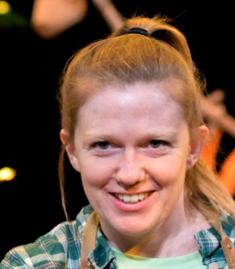
- Vic Llewellyn

- Alexander Scott

Lighting and Sound
- There is warm lighting throughout. There will be two moments of complete darkness near the end of the show.
- There is music throughout the show with some sound effects.
- There are no flashing lights or strobes.
- There is no haze or smoke.
- Performers will talk over the music.
- A hairdryer is used in the show

Participation
- The performers will ask for an adult volunteer from the audience during one section of the show.
- Some members of the audience will be asked to ‘baa’ like sheep at various points. They will do this whilst sat down in their chairs.
- You do not have to participate if you don’t want to.

Content Notes
- The show is hosted by two gardeners and one onstage stage manager. The gardeners travel through the four seasons, and the show follows the story of a farmer and his dog. In each season the performers animate the scenes with a variety of props to show scenes relating to the seasons.
- The show is about the seasons and the cycle of life.
- There is a lot of fast movement in the show.
- The farmer’s dog dies of old age at the end of the show. A lamb is born and blood is represented with red wool. A fox eats a chicken and feathers are thrown.

Access Information
- The show is 45 minutes long.
- All performances are Relaxed. This means you can move or make noise if you need to and can go in and out of the performance space
- Latecomers will be permitted
- Ear defenders are available to borrow from the box office for anyone who might find these useful
- There is an accessible toilet on every floor of the building
- There is a chill out space outside the performance space that is available anytime the building is open

If you would like to know more about the performance, please contact access@bac.org.uk

