Pieces of a Woman – Pre show Information

This information is to help you decide if Pieces of a Woman is for you. Content notes, including what happens in the show, are further in the document.

The Space
The performance takes place in the Grand Hall at BAC. The audience will be seated on a rake which takes up most of the room.

During Act One the audience watches the action like a film.
The action happens inside a flat which is built on the stage.

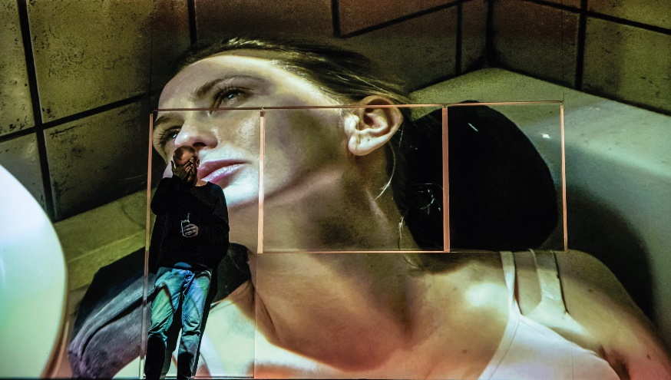

In the beginning of Act Two the flat is taken away with people dismantling the walls. The audience watch this. The rest of Act Two happens live on stage.

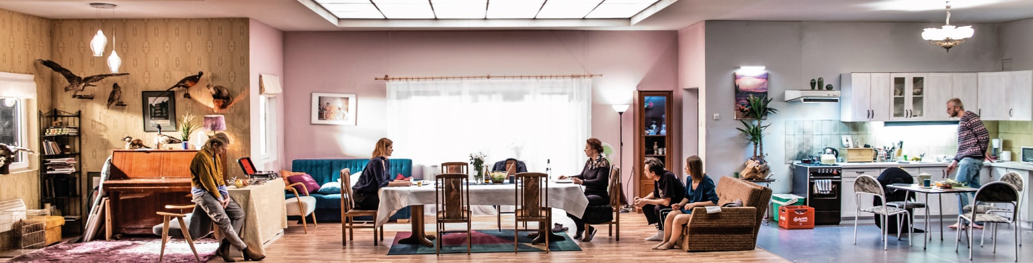

The Performers
The performers are:
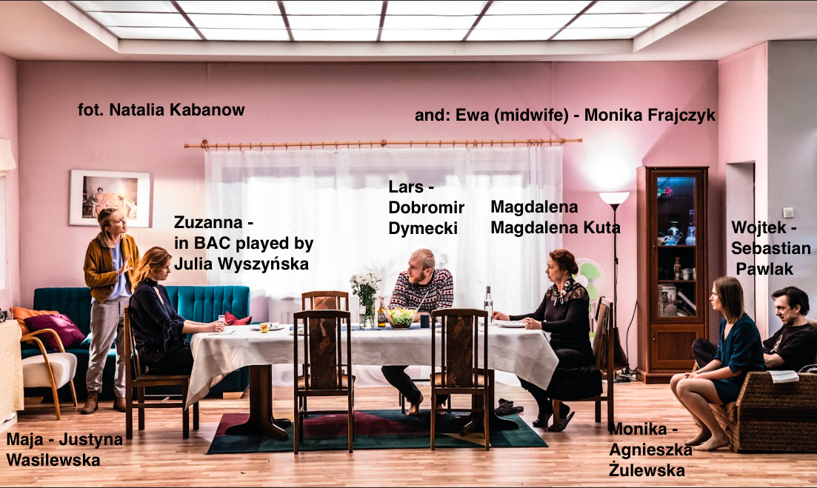

Lighting and Sound
Act One
- Strobe lights are used on stage
- There are flashing blue and red lights on stage and over the audience
- There is a period of complete blackout
- There is screaming, shouting and sounds of someone in pain
- There are raised voices

Act Two
- There is the sound of drills
- Strobe lights are used on stage
- The sound of a baby crying is played loudly
- There are raised voices in argument
- Loud music is played
- Small bright red lights shine directly into the audience

Access Information
- The show is 2 hours and 15 minutes long
- There is no interval
- The show is in Polish with English subtitles
- All performances are Relaxed this means you can move or make noise if you need to. You can go in and out of the performance space. There will be some quieter points during the show where the audience will be asked to wait to re-enter.
- Latecomers will be permitted
- Once the performance has started, only water will be permitted to be brought back into the performance space.
- There is an accessible toilet on every floor of the building
- There is a chill out space outside the performance space that is available anytime the building is open

Pieces of a Woman includes the use of:
- Haze
- Cigarette smoking
- Naked flame
- Real flowers
- Real food:
  - Raw & Roast duck
  - Tofu
  - Apples
  - Carrots
  - Onion
  - Oranges
  - Smoked salmon
  - Mandarins
  - Cherry tomatoes
  - Radishes
  - Green cucumber
  - Parsley
  - Fresh asparagus sprig
  - Lemons
  - Lettuce
  - Bread
  - Peppers
  - Sugar
  - Tic Tac
  - Carrot juice
  - A can of peaches
  - Biscuits
  - Cranberries
  - Crispy bread
  - Coffee
  - Rice
  - Pickled cucumber
  - Sauerkraut
  - Coca Cola

Content Notes

Pieces of a Woman is about loss, medical trauma, family relationships, and the rights we have over our bodies. It is set in modern day Poland.

Pieces of a Woman contains:

- Nudity
- Hyper-realistic portrayal of childbirth
- Potentially distressing scenes
- Vomiting
- Aggressive shouting and arguments

If you would like to know more about the performance, please contact access@bac.org.uk

