Performance Dork – Pre show Information

This information is to help you decide if Performance Dork is for you. Content notes, including what happens in the show, are further in the document.

This performance is still being made and this document is subject to change. If you would like to know more about the performance, please contact access@bac.org.uk

The Space
- This performance takes place in the Rec Room.
- There are chairs on all four side of the room.
- You might be invited to move around the space. You do not have to move if you don’t want to.
- The performance takes place in the centre of the room.

The Performers
- Daniel Oliver
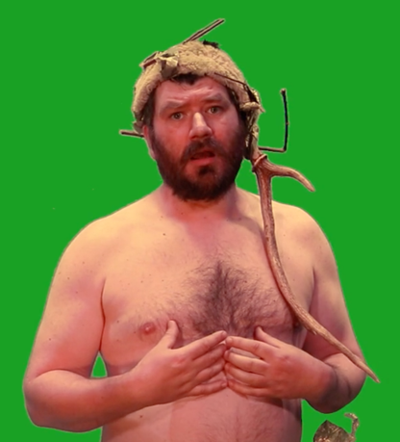

Lighting and Sound
- There are no moments of complete darkness.
- There may be loud music used in the show.
- There is no strobe lighting.
- There may be haze used in the show.
- The Performer may talk over the music.
- Lighting and sound is still being created for the show so these details may change.

Participation
- There will be audience participation in the show.
- You do not have to participate if you don’t want to.

Content Notes
- This performance might feature two performers.
- The performer will talk to the audience and perform movement.
- The show will be like a mix of escape rooms, roleplay games and immersive theatre.
- The show may contain nudity.
- The show may contain live music.

Access Information
- The show is 60 minutes long.
- Latecomers will be permitted
- All performances are Relaxed. This means you can move or make noise if you need to and can go in and out of the performance space.
- Ear defenders are available to borrow from the box office for anyone who might find these useful
- There is an accessible toilet on every floor of the building
- There is a chill out space outside the performance space that is available anytime the building is open

If you would like to know more about the performance, please contact access@bac.org.uk

