CHAOS BALLAD (or the trials and tribulations of Samir Campaign) – Pre show Information

This information is to help you decide if CHAOS BALLAD (or the trials and tribulations of Samir Campaign) is for you. Content notes, including what happens in the show, are further in the document.

The Space
- This performance takes place in the Members Bar.
- There is a mixture of chairs in the room. You may choose to stand or sit on a chair for this performance.
- The performance takes place in one corner of the room; there are three tables with various items including a laptop, a kettle, and an inflatable doll. There are numerous cables in the space, and a piano.

The Performers
- Samir Kennedy
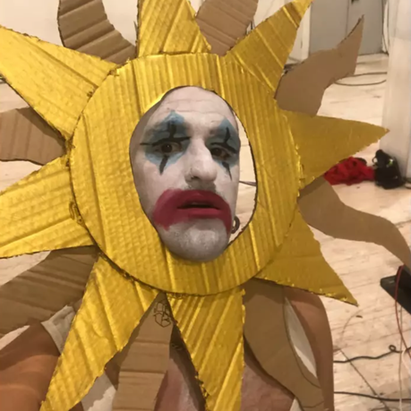
Lighting and Sound
- There is different lighting throughout. There space will remain lit with no moments of complete darkness.
- There is loud music used at different times in the show.
- There is no strobe lighting.
- There is no haze used in the show.
- The Performer will talk over the music, and sing into a microphone.

Participation
- The performer will sometimes come into the audience area.
- The performer will not interact with the audience.
- You do not have to participate if you don’t want to.

Content Notes
- Chaos Ballad features one performer dressed in clown face paint.
- The performer will record sounds from various props and make music, sing into microphone, and perform movement.
- The show is about a sad clown character trapped in a loop of rehearsing a show that might never happen.

Access Information
- The show is 60 minutes long.
- There will be latex balloons used in the show.
- Latecomers will be permitted
- All performances are Relaxed. This means you can move or make noise if you need to and can go in and out of the performance space.
- Ear defenders are available to borrow from the box office for anyone who might find these useful
- There is an accessible toilet on every floor of the building
- There is a chill out space outside the performance space that is available anytime the building is open

If you would like to know more about the performance, please contact access@bac.org.uk

