The Aching – Pre show Information

This information is to help you decide if The Aching is for you. Content notes, including what happens in the show, are further in the document.

The Space
- This performance takes place in the Members Library.
- There are chairs taking up most of the room.
- The performance takes place at one end of the room.
- The performance space is empty.

The Performers
- Samir Kennedy
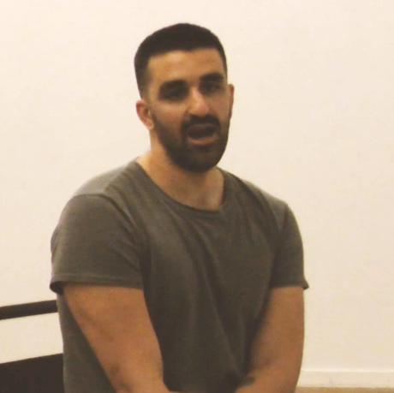
Lighting and Sound
- There is different lighting throughout.
- There is one moment of complete darkness.
- There is no loud music used in the show.
- There are loud sounds that come 3 times.
- There will be flashing lights for 8 seconds.
- There is no haze used in the show.
- The Performer will sing without a microphone.

Participation
- The performer will began sat in the audience area before entering the performance space.
- Near the start the performer will take the hand of an audience member.
- The performer will invite someone to sit on stage and the performer will interact with them.
- You do not have to participate if you don’t want to.

Content Notes
- This performance features one performer.
- The performer will perform movement and sing to the audience.
- The show is about grief, suffering and suicides.

Access Information
- The show is 60 minutes long.
- Latecomers will be permitted
- All performances are Relaxed. This means you can move or make noise if you need to and can go in and out of the performance space.
- Ear defenders are available to borrow from the box office for anyone who might find these useful
- There is an accessible toilet on every floor of the building
- There is a chill out space outside the performance space that is available anytime the building is open

If you would like to know more about the performance, please contact access@bac.org.uk

