Shooting from Below – Pre show Information

This information is to help you decide if Shooting from Below is for you. Content notes, including what happens in the show, are further in the document.

This performance is still being made and this document is subject to change. If you would like to know more about the performance, please contact access@bac.org.uk

The Space
- This performance takes place in the Recreation Room.
- There are chairs taking up most of the room.
- The performance takes place on a stage at one end of the room.

The Performers
- Tamm Reynolds as Midgitte Bardot
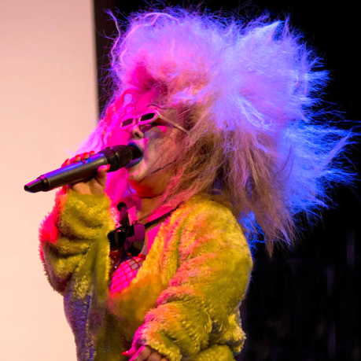
Lighting and Sound
- There is different lighting throughout.
- There are no moments of complete darkness.
- There is loud music used in the show.
- There is no strobe lighting.
- There is haze used throughout in the show.
- The Performer will talk over the music.

Participation
- There may be audience participation in the show.
- You do not have to participate if you don’t want to.

Content Notes
- This performance most likely features one performer.
- The performer will talk to the audience and perform movement.
- The show is will contain themes of sex, grotesque, and decadence and the performer’s dwarfism.

Access Information
- The show is 60 minutes long.
- Latecomers will be permitted
- All performances are Relaxed. This means you can move or make noise if you need to and can go in and out of the performance space.
- Ear defenders are available to borrow from the box office for anyone who might find these useful
- There is an accessible toilet on every floor of the building
- There is a chill out space outside the performance space that is available anytime the building is open

If you would like to know more about the performance, please contact access@bac.org.uk

