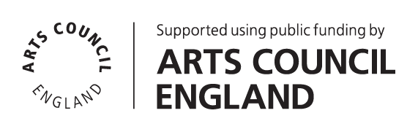

Technician
Applicant Information pack

Contents
Introduction / How to Apply 2
About Battersea Art Centre 3
Working at Battersea Arts Centre 5
The Role 6
Terms & Conditions 10

Feb 24

Introduction / How to Apply
Thank you for your interest in the role of Technician at Battersea Arts Centre (BAC). You will find information about the role and the person specification in the following pages. Before you fill out an online application form, please read the information included here.

Please use the online application form to apply. A link to the form can be found on the Work With Us page of our website. You will need to upload your CV as part of the online application.

All applications must be submitted by 10am 13 March 2024 Successful shortlisted applicants will be invited to attend an interview during the week commencing 25 March 2024. Interviews will take place in person at Battersea Arts Centre. We can provide a BSL interpreter if required.

We particularly welcome applicants with lived experience of disability and people from groups that are currently under-represented in the arts sector. If you share a commitment to BAC’s mission and values, we want to hear from you.

We have provided a number of different methods of capturing your application information (written text, audio and video) as a part of our commitment to ensuring that our application process is accessible. It is your responsibility as a candidate to ensure that your application text, audio or video is in a format that can be accessed by our shortlisters. BAC does not take responsibility for when an incorrect, or inaccessible link is provided in an application, and we may have to reject your application.

If you would like further information, support with access requirements or an informal chat about the post please contact us by email at recruitment@bac.org.uk.

We look forward to receiving your application.

People Team
Battersea Arts Centre

Technician
Job Description

About Battersea Art Centre
BAC is a home for the extraordinary.
We believe that bringing people together to connect, collaborate & be creative inspires positive change. Hence, our beautiful building is a home for reimagining what’s possible. Through our artistic programme, our community projects and our commercial events, we host extra-ordinary experiences that positively impact individuals and their communities.
The inclusive, generous and collaborative way we hope to work with colleagues and partners is encompassed by the old motto of our Town Hall building:
‘Not for You, Not for Me, But for Us’.

Project Working
BAC operates a project working structure, which means that teams and team members work flexibly across projects to deliver activity. Project working is about working collaboratively and bringing out the best in all our staff. It’s a structure that recognises people’s specialism, creating a more dynamic set of teams across everything we do.

Our projects all sit underneath the following areas of work:
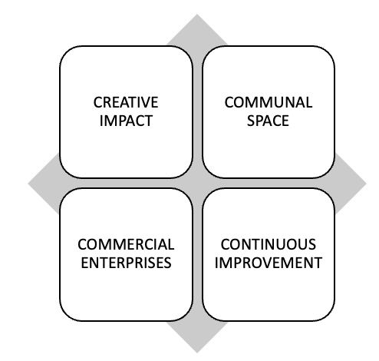
Creative Impact
- Projects that support the creative development, platforming and progression of contemporary performance makers and young people

Communal Space
- Projects that help us care for, celebrate and share our beautiful building with our local community and put access and inclusion at its heart.

Commercial Enterprises
- Projects that see us deliver an exceptional events and space hire service for commercial clients which in turn supports the growth of the charity.

Continuous Improvement
- Projects that build the resilience of BAC to futureproof the organisation and enable us to continue to take risks, fail, innovate, and succeed.
This role will work within the Production & Technical Team and will help deliver BAC’s artistic vision. This role will also frequently work across other strategies and projects within the building.

Working at Battersea Arts Centre
BAC’s office is an open-plan space on the second floor of our building, Battersea old Town Hall, accessed by two sets of stairs or a lift. BAC is wheelchair accessible throughout the building; there are accessible toilets and a mix of loud and quiet spaces. The nearest wheelchair accessible station is Clapham Junction and the route is 0.6 miles up a hill. There is a disabled parking bay on Theatre Street next to the building.
This role may include some office task and production meeting throughout the week. Some evening and weekend working will be required as part of this role. Attending performances, events and being part of the creative life of the organisation is part of everyone’s role at BAC.
BAC is a busy organisation and has around 50 members of staff. All staff are offered a flexible management structure through a combination of line management, in-house coaching, individual supporter and mentor options. Usual office hours are 10am-6pm and we offer flexible working where possible.

The Role Technician
Responsible to: Technical Manager & Head of Production & Technical
Responsible for: Weekly Payroll Technicians, External Technical Crew
As Technician you will work in our Production & Technical team, specialising in at least one of the following areas: Lighting, Sound, Stage, or Audio Visual.
Battersea Arts Centre’s Production & Technical team deliver a professional and helpful service to artists whilst in the rehearsal, development and performance stages of their work; at BAC and on tour. They also work on a wide range of high-end commercial events including filming, weddings, conferences etc; ensuring the highest standard of technical delivery expected by our clients.
BAC is a fast-paced working environment, with regular get ins and get outs happening across multiple performance and events spaces. The Technician’s role at BAC includes manual handling and regular evening/weekend work required of the whole team. As a Technician at the world’s first Relaxed Venue, you will also work to deliver an unrivalled quality of experience in terms of inclusive practice and accessibility.
A good working knowledge of one or more of the areas listed above is essential. You may work in one or across several of these disciplines, according to your skill set, and in agreement with your line manager. A detailed outline of the tasks and responsibilities for this role, contractual terms & conditions and a person specification is outlined below.

You will:
- Work as a skilled technician, fulfilling the expectations of your discipline (Lighting, Sound, Stage, or Audio Visual) while having a collaborative approach and providing help across all departments when needed;
- Work as Duty Technician, as assigned by the weekly rota, being available on radio as the technician on call for all BAC or incoming events and productions, for the whole shift (Duty Technician training will be provided);
- Rig, programme, and operate sound, lighting and/or audio visual on agreed productions;
- Actively ensure that the performance spaces, and technical storage and work areas of the building are kept in a safe, tidy, and presentable condition at all times;
- Ensure that BAC technical equipment is maintained and in good condition;
- Maintain a high level of Health & Safety practice in technical areas;
- Supervising Weekly Payroll Staff during fit ups and get outs.
- Proactively planning technical set ups of shows and events.
- Carry out additional responsibilities, as reasonably required by BAC leadership.

Person Specification
Essential
Experience:
- Training or equivalent industry experience in technical theatre
- Experience in programming ETC Lighting Desks (for Lighting roles)
- Experience in programming Yamaha Desks (for Sound roles)
- Experience of working one-on-one with artists and / or theatre companies
- Experience and willingness to Work at Height
Knowledge:
- Excellent working knowledge of modern theatre operation and lighting or sound
- Good working knowledge of theatre electrics, lighting technology, and electrical safety including 3 Phase power (for Lighting roles)
- Good working knowledge of QLab and Dante Network (for sound roles)
- Good working knowledge of rigging techniques
- A thorough understanding of production processes and theatre production techniques
Skills & abilities:
- Ability to communicate effectively and adaptably
- Excellent time management and prioritisation skills, with the ability to manage competing demands
- Ability and willingness to work flexible and/or unsociable hours
Interests & values:
- A commitment to Battersea Arts Centre’s purpose & values
- A passion for exciting, challenging and innovative performance

Desirable
- IOSH qualification
- IPAF licence
- PASMA training
- BS7909 certification
- Experience in fully flexible venues
- Ability to read technical drawings and ground plans
- Experience in operating Avolites Lighting Consoles (for Lighting roles)
- Knowledge of Lighting Networks, e.g. Art-Net/sACN (for Lighting roles)

Terms & Conditions
Salary: £27,300 gross per annum
Hours: 35 hours per week, excluding a daily one-hour lunch break.
Usual office hours are 10am-6pm, however we offer flexible working where possible.
Occasional evening and weekend work may be required. All staff at Battersea Arts Centre are expected to attend performances and be a part of the artistic life of the organisation.
Overtime: No overtime payments; we operate a Time Off in Lieu (TOIL) system, to be taken within two weeks of accrual.
Annual Leave: 4 weeks per year pro rata (5 weeks following one full year of service)
Probation period: 6 months, with a 3 month review
Notice period: 2 months
Contract Period: Permanent
Workplace Pension
Scheme: BAC’s pension scheme is provided by NEST

Staff Benefits Complimentary tickets for performances at BAC (subject to availability and staff ticket policy)
Cycle to Work Scheme
Discount on meals in the BAC cafe (subject to discount policy)
5 Development Days per annum

