Or What’s Left of Us – Pre show Information

This information is to help you decide if Or What’s Left of Us is for you. Content notes, including what happens in the show, are further in the document.

Or What’s Left of Us is still in development so some elements may change.

The Space
- This performance takes place in the Council Chamber.
- The audiences are seated on a rake that takes up most of the room.
- The performance takes place in front of the rake.

The Performers
- Shit Theatre are (left to right) Rebecca Biscuit and Louise Mothersole

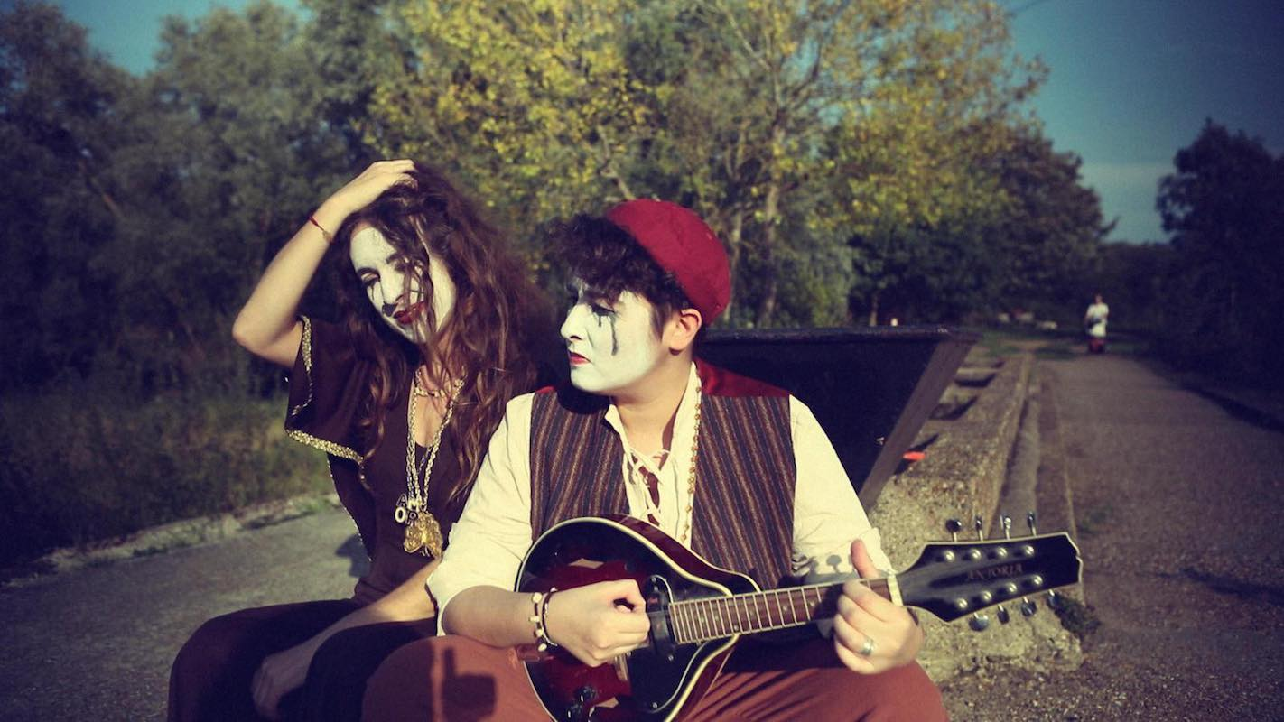

Lighting and Sound
- There is different lighting throughout. There are moments of complete darkness.
- There is loud music and sound used at different times in the show.
- There are no flashing lights.
- There is haze used in the show.
- The Performers will talk over music.

Participation
- The performers will speak to each other and the audience.
- Audiences are invited to sing along
- You do not have to participate if you don’t want to

Content Notes
- The show is performed by two performers.
- The performers will speak to the audience, perform movement in time to music, and play instruments.
- The show is about death, grief, suicide, illness.
- There will be discussion on themes highlighted above.
- This performance is a work in progress so may change up until the performance date.

Access Information
- The show is 60 minutes long.
- Latecomers will be permitted
- All performances are Relaxed. This means you can move or make noise if you need to and can go in and out of the performance space
- Ear defenders are available to borrow from the box office for anyone who might find these useful
- There is an accessible toilet on every floor of the building
- There is a chill out space outside the performance space that is available anytime the building is open

If you would like to know more about the performance, please contact access@bac.org.uk

