A Spectacle of Herself – Pre show Information

This information is to help you decide if A Spectacle of Herself is for you. Content notes, including what happens in the show, are further in the document.

The Space
- This performance takes place in the Council Chamber.
- The audiences are seated on a rake that takes up most of the room.
- The performance takes place in front of the rake, with a rope hanging in the centre of the stage and a thin layer of transparent fabric gauze is rigged across the stage in front of it.

The Performers
- Laura Murphy
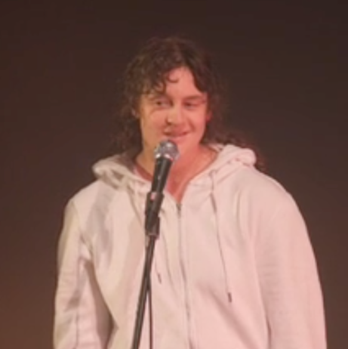
Lighting and Sound
- There is different lighting throughout. There are moments of darkness, with slight illumination from a projection.
- There is loud music used at different times in the show.
- There is no strobe lighting.
- In one scene various coloured lights will move across the stage and audience.
- There is haze used in the show.
- The Performer will talk over the music, and sometimes shouts.

Participation
- The performer will speak directly to the audience.
- At one point in the show the performer will ask the audience to compliment them.
- You do not have to participate if you don’t want to.

Content Notes
- The show is hosted by one performer with uses of video and audio.
- The performer will speak to the audience, perform aerial circus tricks, and lipsync to audio, in a variety of scenes.
- The show is about taking up space as a minority, and contrasts this against how powerful people take up space in the world.
- The performer will have no clothes covering their torso for the second half of the show, and will be fully naked at the end.

Access Information
- The show is 60 minutes long.
- There will be latex balloons used in the show.
- Latecomers will be permitted but may be held until a safe moment to enter
- All performances are Relaxed. This means you can come, go and make noise if you need, move and make yourself comfortable. We ask that if you feel you may need to leave during the show, please take a seat in the front rows. If you need to leave during the show, please be mindful of the performance, and move in between scenes where possible. You may also be held before re-entering until a safe moment. This is to support the access needs within the cast, where any sudden loud noise or persistent movement can become a barrier to performing.

- No photos or videos are permitted during the show and if you need to use your phone, we ask you to please exit the auditorium before doing so.
- Once the show begins, only water will be permitted back in the auditorium.
- Ear defenders are available to borrow from the box office for anyone who might find these useful
- There is an accessible toilet on every floor of the building
- There is a chill out space outside the performance space that is available anytime the building is open

If you would like to know more about the performance, please contact access@bac.org.uk

