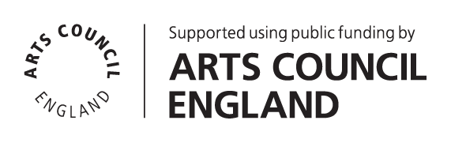

Production Manager
Applicant Information Pack

Contents
Introduction / How to Apply 2
About Battersea Art Centre 3
Working at Battersea Arts Centre 5
The Role 6
Terms & Conditions 8
Person Specification 9

April 2024

Introduction / How to Apply
Thank you for your interest in the role of Production Manager at Battersea Arts Centre (BAC). You will find information about the role and the person specification in the following pages. Before you fill out an online application form, please read the information included here.

Please use the online application form to apply. A link to the form can be found on the Work With Us page of our website. You will need to upload your CV as part of the online application.

All applications must be submitted by 10am X 2023. Successful shortlisted applicants will be invited to attend an interview during the week commencing X 2023. Interviews will take place in person at Battersea Arts Centre. We can provide a BSL interpreter if required.

We particularly welcome applicants with lived experience of disability and people from groups that are currently under-represented in the arts sector. If you share a commitment to BAC’s mission and values, we want to hear from you.

We have provided a number of different methods of capturing your application information (written text, audio and video) as a part of our commitment to ensuring that our application process is accessible. It is your responsibility as a candidate to ensure that your application text, audio or video is in a format that can be accessed by our shortlisters. BAC does not take responsibility for when an incorrect, or inaccessible link is provided in an application, and we may have to reject your application.

If you would like further information, support with access requirements or an informal chat about the post please contact us by email at recruitment@bac.org.uk.

We look forward to receiving your application.

People Team
Battersea Arts Centre

Production Manager
Job Description

About Battersea Art Centre
BAC is a home for the extraordinary.
We believe that bringing people together to connect, collaborate & be creative inspires positive change. Hence, our beautiful building is a home for reimagining what’s possible. Through our artistic programme, our community projects and our commercial events, we host extra-ordinary experiences that positively impact individuals and their communities.
The inclusive, generous and collaborative way we hope to work with colleagues and partners is encompassed by the old motto of our Town Hall building:
‘Not for You, Not for Me, But for Us’.

Project Working
BAC operates a project working structure, which means that teams and team members work flexibly across projects to deliver activity. Project working is about working collaboratively and bringing out the best in all our staff. It’s a structure that recognises people’s specialism, creating a more dynamic set of teams across everything we do.

Our projects all sit underneath the following areas of work:
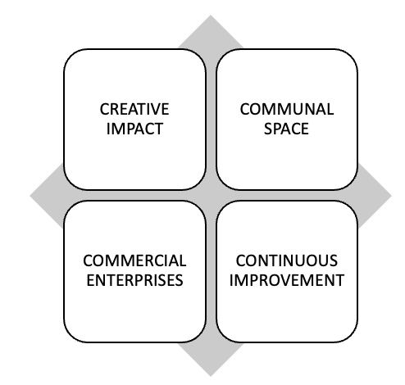
Creative Impact
- Projects that support the creative development, platforming and progression of contemporary performance makers and young people
Communal Space
- Projects that help us care for, celebrate and share our beautiful building with our local community and put access and inclusion at its heart.
Commercial Enterprises
- Projects that see us deliver an exceptional events and space hire service for commercial clients which in turn supports the growth of the charity.
Continuous Improvement
- Projects that build the resilience of BAC to futureproof the organisation and enable us to continue to take risks, fail, innovate, and succeed.
This role will help deliver all BAC’s strategies. This role will also work across other projects as and when the business needs.

Working at Battersea Arts Centre

BAC is wheelchair accessible throughout the building; there are accessible toilets and a mix of loud and quiet spaces. The nearest wheelchair accessible station is Clapham Junction and the route is 0.6 miles up a hill. There is a disabled parking bay on Theatre Street next to the building.
We have an office on the top floor of Battersea Arts Centre that is accessible by a number of staircases or a lift. Standard office hours are 10:00-18:00, Monday to Friday. Operational Hours are 09:30 – 20:00 Monday – Saturday, laer when shows and events are happening. Evening and weekend working, manual handling and working at height will be required as part of this role.
The role will involve regular meetings, communicating via phone/video, email and in person and using a computer for a few hours across the day.
Attending performances, events and being part of the creative life of the organisation is part of everyone’s role at BAC.
BAC is a busy organisation and has around 50 members of staff. All staff are offered a flexible management structure through a combination of line management, in-house coaching, individual supporter and mentor options. Usual office hours are 10am-6pm and we offer flexible working where possible.

The Role
Responsible to: Head of Production & Technical
Responsible for: Technicians, contracts & casual staff
The Production Manager will have a strong relationship with the Programming and Community projects. The Production team is made up of the Head of Production & Technical, Technical Manager, Production Manager, and a full time Technician, as well as an important group of casual technicians and crew.

We are looking for an inspiring and personable Production Manager to join this team through an exciting phase of development at Battersea Arts Centre. You will already be a strong and ambitious Production Manager who will relish the opportunity to lead a team. BAC has a strong track record for developing exceptional staff and this role is no exception.

A detailed outline of the tasks and responsibilities for this role, contractual Terms & Conditions and a Person Specification is outlined below.

Responsibilities | - Oversight of all Production Management aspects of BAC’s public programme, creative development work, and delivery of festivals, building takeovers, and young people and community activity.  - Cost, advance and deliver BAC’s Programme, ensuring efficient use and distribution of technical equipment and personnel across all visiting and BAC productions.  - Lead on the design & layout of BAC’s flexible auditoria and performance spaces, collating all required production information and sharing with the technical manager in a timely fashion  - Lead on the recruitment and maintenance of the pool of casuals and freelancers to ensure the adequate staffing of BAC Creative Impact activity  - Ensure the smooth deployment of permanent and casual staff to BAC’s programme, supporting the Technical Manager on permanent recruitment as required  - Ensure all training logs are updated and required compliance levels are met across the team and communicate all relevant BAC policies & codes of practice to casual freelance members of staff  - Lead the process of managing and maintaining BAC’s production equipment & facilities, ensuring all tech specs, plans of spaces & technical inventories are accurate & up to date.  - Hold an oversight of the P&T departments systems and processes, connecting with BACs dynamic digital transformation.  - Manage assigned budgets in line with monthly forecasting cycle, collaborating with the Technical Manager to ensure overall P&T Budget is on track.  - Under Guidance from the Operations Management Group, lead in the implementation of health and Safety policies to ensure the safety of BAC’s staff, artists & audiences  - Ensure appropriate technical support & advice is provided to supported artists during runs and residencies, providing all the required information to the technical manager in good time  - Keep up to date with industry standards and practises and advise on & research possible future developments in BAC’s Technical and Production infrastructure
Team Development & Leadership | - Establishing a positive culture of collaboration with BAC Teams, young people, artists, community users and clients  - Lead by example in your conduct and approach, providing mentoring, in depth training and support to team members across the P&T team  - Work with the rest of the Production and Technical department to create and maintain working relationships with industry suppliers  - Ensure all activity is delivered to a high quality and upholds BAC’s purpose and values
General | - Work in accordance with BAC’s Code of Conduct and organisational policies, such as Safeguarding, Health & Safety, Environmental and Access & Inclusion  - Consider ways to limit BAC’s carbon footprint in all areas of your work  - Undertake any other duties as reasonably required by the Head of P&T and the leadership of BAC

Terms & Conditions
Salary: £32,500 gross per annum
Hours: 35 hours per week, excluding a daily one-hour lunch break.
This role is rota-d across daytime, evening and weekend shifts and spends time both operationally and in the office. We offer flexible working where possible.
All staff at Battersea Arts Centre are expected to attend performances and events, and be a part of the artistic life of the organisation.
Overtime: No overtime payments; we operate a Time Off in Lieu (TOIL) system, to be taken within two weeks of accrual.
Annual Leave: 4 weeks per year, pro rata (5 weeks following one full year of service)
Probation period: 6 months, with a 3 month review
Notice period: 3 months
Contract Period: Permanent
Workplace Pension
Scheme: BAC’s pension scheme is provided by NEST

Staff Benefits Complimentary tickets for performances at BAC (subject to availability and staff ticket policy)
Cycle to Work Scheme by Cyclescheme
Discount on meals in the BAC cafe (subject to discount policy)
5 Development Days, pro rata

Person Specification
Essential
Experience:
- A Degree or equivalent industry experience in Technical theatre
- Minimum of 4 years working in a technical and production environment
- Experience of touring work
- Experience of public events
- Experience of budget management
- Experience of staff management
- Experience of health & safety management
Knowledge:
- Good knowledge of health & safety legislation
- Thorough working knowledge of drawing scale plans on AutoCAD, and experience of interpreting and analysing plans sent from third parties and advising on changes for compliance and building restrictions
- Thorough knowledge, understanding and application of Health & Safety legislation, including regulations such as PUWER, COSHH, LOLER and CDM
- Knowledge and understanding of theatre production techniques
Skills & abilities:
- Excellent communication and interpersonal skills and the ability to communicate with people at all levels
- Excellent office and administrative skills including budgeting
- A good level of organisational skills and clear ability to prioritise and seek solutions
- IT literate with working experience of MS Office Suite including Excel
- Working knowledge of CAD
Interests & values:
- Accuracy and attention to detail
- Strong efficiency and organisation
- A positive and flexible approach
- Confident, professional, enthusiastic and self-motivated
- Ability to work effectively in a team, whilst also being able to work independently
- A commitment to Battersea Arts Centre’s mission and vision
- A demonstrable enthusiasm for the arts
- Willingness to work flexible hours including weekends and evenings if necessary
Desirable
- Experience of working with ensembles or devised theatre makers
- Experience of working on site-specific shows or in non-traditional spaces
- Experience liaising with clients and supporting commercial hires business
- An IOSH or similar qualification
- Interest in cutting-edge theatre and new work
- Willingness to take part in professional development opportunities

