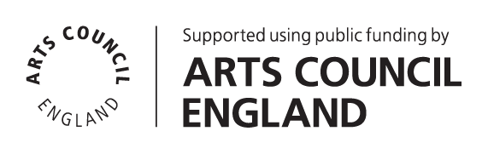

Technical Manager
Applicant Information Pack

Contents
Introduction / How to Apply 2
About Battersea Art Centre 3
Working at Battersea Arts Centre 5
The Role 6
Terms & Conditions 9
Person Specification 10

April 2024

Introduction / How to Apply
Thank you for your interest in the role of Technical Manager at Battersea Arts Centre (BAC). You will find information about the role and the person specification in the following pages. Before you fill out an online application form, please read the information included here.

Please use the online application form to apply. A link to the form can be found on the Work With Us page of our website. You will need to upload your CV as part of the online application.

All applications must be submitted by 10am Friday 10 May 2024. Successful shortlisted applicants will be invited to attend an interview on Thursday 23 May 2024. Interviews will take place in person at Battersea Arts Centre. We can provide a BSL interpreter if required.

We particularly welcome applicants with lived experience of disability and people from groups that are currently under-represented in the arts sector. If you share a commitment to BAC’s mission and values, we want to hear from you.

We have provided a number of different methods of capturing your application information (written text, audio and video) as a part of our commitment to ensuring that our application process is accessible. It is your responsibility as a candidate to ensure that your application text, audio or video is in a format that can be accessed by our shortlisters. BAC does not take responsibility for when an incorrect, or inaccessible link is provided in an application, and we may have to reject your application.

If you would like further information, support with access requirements or an informal chat about the post please contact us by email at recruitment@bac.org.uk.

We look forward to receiving your application.

People Team
Battersea Arts Centre
Technical Manager
Job Description

About Battersea Art Centre
BAC is a home for the extraordinary.
We believe that bringing people together to connect, collaborate & be creative inspires positive change. Hence, our beautiful building is a home for reimagining what’s possible. Through our artistic programme, our community projects and our commercial events, we host extra-ordinary experiences that positively impact individuals and their communities.
The inclusive, generous and collaborative way we hope to work with colleagues and partners is encompassed by the old motto of our Town Hall building:
‘Not for You, Not for Me, But for Us’.

Project Working
BAC operates a project working structure, which means that teams and team members work flexibly across projects to deliver activity. Project working is about working collaboratively and bringing out the best in all our staff. It’s a structure that recognises people’s specialism, creating a more dynamic set of teams across everything we do.

Our projects all sit underneath the following areas of work:
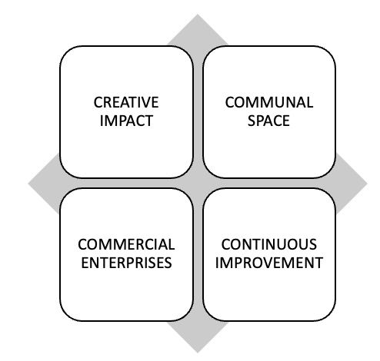
Creative Impact
- Projects that support the creative development, platforming and progression of contemporary performance makers and young people
Communal Space
- Projects that help us care for, celebrate and share our beautiful building with our local community and put access and inclusion at its heart.
Commercial Enterprises
- Projects that see us deliver an exceptional events and space hire service for commercial clients which in turn supports the growth of the charity.
Continuous Improvement
- Projects that build the resilience of BAC to futureproof the organisation and enable us to continue to take risks, fail, innovate, and succeed.
This role will help deliver all BAC strategies. This role will also work across other projects as and when the business needs.

Working at Battersea Arts Centre

BAC is wheelchair accessible throughout the building; there are accessible toilets and a mix of loud and quiet spaces. The nearest wheelchair accessible station is Clapham Junction and the route is 0.6 miles up a hill. There is a disabled parking bay on Theatre Street next to the building.
We have an office on the top floor of Battersea Arts Centre that is accessible by a number of staircases or a lift. Standard office hours are 10:00-18:00, Monday to Friday. Operational Hours are 09:30 – 20:00 Monday – Saturday, and later when shows and events are happening. Evening and weekend working, manual handling and working at height will be required as part of this role.
The role will involve regular meetings, communicating via phone/video, email and in person and using a computer for a few hours across the day.
Attending performances, events and being part of the creative life of the organisation is part of everyone’s role at BAC.
BAC is a busy organisation and has around 50 members of staff. All staff are offered a flexible management structure through a combination of line management, in-house coaching, individual supporter and mentor options. Usual office hours are 10am-6pm and we offer flexible working where possible.

The Role
Responsible to: Head of Production & Technical
Responsible for: Technicians, contracts & casual staff
The Technical Manager is primarily responsible for the management of the Technical team and resources ensuring that the team offers the highest standards of technical support to both emerging and established artists. The Technical Manager will be professional, enthusiastic and resourceful in planning the use of technical resources, managing equipment & storage across the building and ensuring technical delivery meets the standards expected by BAC.

A detailed outline of the tasks and responsibilities for this role, contractual Terms & Conditions and a Person Specification is outlined below.

Responsibilities | - Lead the technical team, including overseeing all technical fit ups, calling casual staff, managing the rota, TOIL & workload across the team, providing the Production Manager with timely updates on team recruitment and training needs  - Provide the Production Manager with all necessary information to ensure efficient use and distribution of technical equipment and personnel across all visiting and BAC productions.  - Manage the relevant budgets in line with monthly forecasting cycles, sharing updates with the Production Manager.  - Under Guidance from the Operations Management Group, lead in the implementation of health and Safety policies to ensure the safety of BAC’s staff, artists & audiences.  - Create and maintain risk assessments and method statements for technical areas and liaise on sign off with Operations Management Group  - Co-ordinate the maintenance and repairs of technical equipment, storage spaces and consumable stock across the building; ensuring all systems are in good working order and asset register is up to date  - Work with the Production Manager to ensure appropriate technical support & advice is provided to supported artists during runs and residencies  - Implement efficient day to day delivery of BAC Productions and Events and be the key technical contact for staff for last minute & ad-hoc technical requests such as presentations  - Actively ensure the performance and technical areas of the building are in a safe and presentable condition at all times. Maintain consistent technical presentation standards across all BAC productions & spaces  - Set an example of best practice in technical support for the rest of the technical team, both permanent & freelance  - Working with the rest of the Production and Technical department to create and maintain working relationships with industry suppliers  - Keep up to date with industry standards and practises and advise on & research possible future developments in BAC’s Technical and Production infrastructure  - Lead on the recruitment processes for permanent technicians when posts become available  - Work with the Head of Production & Technical to undertake regular pastoral care and performance management of the Technical Team in line with BACs processes and procedures.
Team Development & Leadership | - Establishing a positive culture of collaboration with BAC Teams, young people, artists, community users and clients  - Lead by example in your conduct and approach, providing mentoring, in depth training and support to team members across the P&T team  - Ensure all activity is delivered to a high quality and upholds BAC’s purpose and values
General | - Work in accordance with BAC’s Code of Conduct and organisational policies, such as Safeguarding, Health & Safety, Environmental and Access & Inclusion  - Consider ways to limit BAC’s carbon footprint in all areas of your work  - Undertake any other duties as reasonably required by the Head of P&T and the leadership of BAC

Terms & Conditions
Salary: £32,500 gross per annum
Hours: 35 hours per week, excluding a daily one-hour lunch break.
This role is rota’d across daytime, evening and weekend shifts and spends time both operationally and in the office. We offer flexible working where possible.
All staff at Battersea Arts Centre are expected to attend performances and events, and be a part of the artistic life of the organisation.
Overtime: No overtime payments; we operate a Time Off in Lieu (TOIL) system, to be taken within two weeks of accrual.
Annual Leave: 4 weeks per year, pro rata (5 weeks following one full year of service)
Probation period: 6 months, with a 3 months review
Notice period: 3 months
Contract Period: Permanent
Workplace Pension
Scheme: BAC’s pension scheme is provided by NEST

Staff Benefits Complimentary tickets for performances at BAC (subject to availability and staff ticket policy)
Cycle to Work Scheme by Cyclescheme
Discount on meals in the BAC cafe (subject to discount policy)
5 Development Days, pro rata

Person Specification
Essential
Experience:
- Degree or equivalent industry experience in Technical theatre
- Previous Technical Management or Crew chief experience
- Working knowledge of AutoCAD, Lighting and Sound consoles
- Experience of innovative problem solving & an ability to provide flexible solutions in a theatre setting
- A good understanding of Health & Safety including PUWER, COSHH, and LOLER
- A combination of at least three of the following:
- A good working knowledge of theatre electrics, lighting technology and electrical safety
- A good working knowledge of modern theatre sound, live sound set ups, live mixing and sound operation
- Competency in stage carpentry and working experience of scenic fit ups
- A good working knowledge of AV
Knowledge:
- Thorough working knowledge of drawing scale plans on AutoCAD, and experience of interpreting and analysing plans sent from third parties and advising on changes for compliance and building restrictions
- Thorough knowledge, understanding and application of Health & Safety legislation, including regulations such as PUWER, COSHH, LOLER and CDM
- Knowledge and understanding of theatre production techniques
- Knowledge and understanding of rigging techniques
- Knowledge of current lighting and sound equipment, consoles and practices
- Knowledge of the application and fault finding processes for lighting and sound data networks such as ArtNet/sACN and Dante
- Knowledge of ETC family consoles
- Knowledge of Yamaha mixing consoles and Qlab4 along with other types of playback
Skills & abilities:
- Strong administration & communication skills
- A thorough understanding of rigging techniques
- Good IT proficiency
- Ability to read and draw lighting plans and ground plans
- The ability to take the lead role when working with a group of staff and ensure good working practice within the team
- The ability to work on your own initiative and to solve problems
- The ability to communicate complex information clearly and to maintain effective communication with colleagues and external contacts at all levels
- Strong budgeting & scheduling skills
Interests & values:
- An enthusiastic & helpful attitude & a desire to work well across teams & project groups
- Willingness to work flexible hours including weekends and evenings if necessary
Desirable
- IOSH Qualification or similar
- IPAF and/or PASMA licence
- Knowledge of ETC lighting equipment and Digital sound desks
- Experience of managing stock, equipment & inventories
- Experience of electrical building maintenance
- ABTT rigging qualifications or equivalent
- Interest in cutting-edge theatre and new work
- Experience liaising with clients and supporting commercial hires business
- Willingness to take part in professional development opportunities

