Get Off – Pre show Information

This information is to help you decide if Get Off is for you. Content notes, including what happens in the show, are further in the document.

This performance is still being made and this document is subject to change. If you would like to know more about the performance, please contact access@bac.org.uk

The Space
- This performance takes place in the Council Chamber.
- The audiences are seated on a rake that takes up most of the room.
- The performance takes place in front of the rake, with a large white floor and white projection screen.

The Performers
- Katy Baird
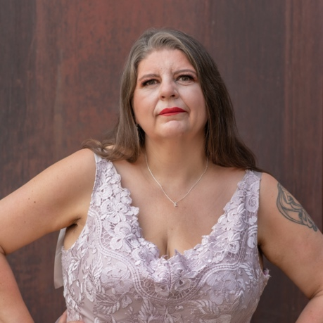
Lighting and Sound
- There is different lighting throughout. There are moments of complete darkness, and use of video projection throughout the show.
- There is loud music used at different times in the show.
- There is strobe lighting which takes place roughly 40 minutes into the show. It follows the second conversation the performer has with an audience member.
- There will be haze used in the show.
- There will be a snow machine used in the show.
- The performer will talk over the music.

Participation
- The performer will walk into the audience section at one point in the show, and interact with one member of the audience.
- The performer interacts with the same audience member later in the show.
- The performer will ask the audience member questions about the show, about the performer, and about themselves.
- You do not have to participate if you don’t want to.

Content Notes
- The show is hosted by one performer with large uses of video and audio. The performer will speak to the audience, perform dance and movement, and interact with the set.
- The show is about distraction, excess, consumption, power dynamics and class.
- This performance contains videos of human defecation.
- The performance features a naked human body throughout.
- The performance includes video imagery of perceived drug use.

Access Information
- The show is 60 minutes long.
- All performances are Relaxed. This means you can move or make noise if you need to and can go in and out of the performance space
- Latecomers will be permitted
- Ear defenders are available to borrow from the box office for anyone who might find these useful
- There is an accessible toilet on every floor of the building
- There is a chill out space outside the performance space that is available anytime the building is open

If you would like to know more about the performance, please contact access@bac.org.uk

