**BEAT-FLYS – Pre show Information**

This information is to help you decide if BEAT-FLYS is for you. Content notes, including what happens in the show, are further in the document.

**The Space**

The show is in the Council Chamber.

The space will be a circle of chairs for the audience. At one end is the ‘Sun’ (pictured below), and at the other a light curtain. There are also four light up boxes (also pictured below) which move around the space, and a speaker (which is also moved).

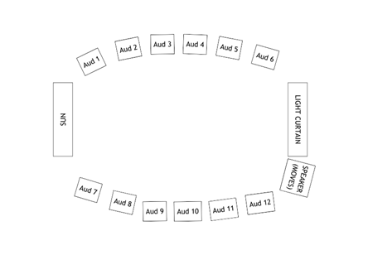

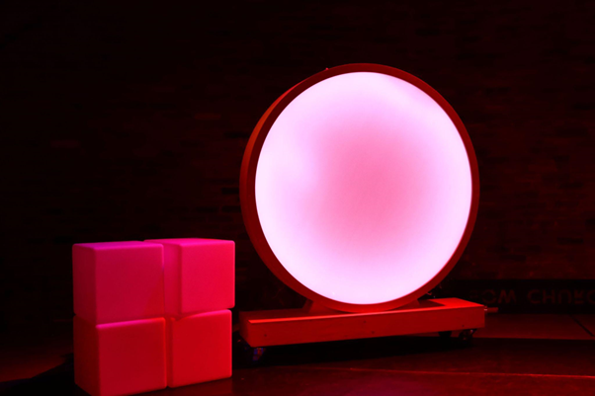

**The Performers**

The show is performed by members of BLINK Dance Theatre and BAC Beatbox Academy.

|  |  |
| --- | --- |
|  | This is Sabir. He plays the Love Dragon. |
|  | This is Aisha. She plays the Evil Butterfly. |
|  | This is Siobhán. She plays the Angel Old Woman. |
|  | This is Vicki. She plays the Party Panda. |
|  | This is Nate, Nadine and Tyler. They are Beatboxers. |
|  | This is Greg. He is a member of the Ensemble. |
|  | This is Josh. He is a member of the Ensemble. |
|  | This is Delson. He is a member of the Ensemble. |

**Sound**

* The show can be quite loud at some moments, particularly in the stormy scene and the Angel Old Woman scene.
* When she enters, the Angel Old Woman screams quite loudly and suddenly.
* There is some singing throughout, over the top of music. This is the only ‘talking’ during the show, and isn’t essential for understanding the story of the show.
* There will be ear defenders available if needed.

**Lighting**

* The sun and curtain both have lighting effects, which including some slow flashing lights, and lights that react to sounds. There is no strobe lighting.
* There are no moments of complete darkness. There is also some level of ambient light, although there are some darker moments. The lighting changes are not sudden.

**Participation**

* There is some audience participation throughout. There are one-to-one moments between performers and audience members, which the performer will also get consent for. This includes:
  + The tactile dance in the first scene. This happens again at the end
  + A game/dance competition run by the Love Dragon, where the audience will be put into two groups and asked to copy a movement
  + The Party Panda may choose an audience member to dance with in the middle
  + The Party Panda plays a game where there is a call and response rap, and audience members will be asked to make a noise for everyone to copy
  + Everyone is invited to dance with the performers at the end

Access Information

* The show is 60 minutes long
* There is a social story available [here.](https://static1.squarespace.com/static/56d33ad9d51cd456e60ec023/t/664ddbf72a590a691d877ae8/1716378621076/BEAT-FLYS+Social+Story.pdf)
* The audience will be offered a drink and sweet as part of the show. We also use some sensory props, which audience members may handle. These have no known allergens - however we do advise anyone with an allergy to get in touch with us ([zoe@blinkdancetheatre.org](mailto:zoe@blinkdancetheatre.org)) so we can double-check for specific allergens.
* All performances are Relaxed this means you can move or make noise if you need to. You can go in and out of the performance space
* Latecomers will be permitted
* There is an accessible toilet on every floor of the building
* There is a chill out space outside the performance space that is available anytime the building is open

**Content Notes**

The show starts in a market in Bow. There are lots of people greeting each other and walking around. The Beatboxers sing about the area, while the performers do a tactile dance with the audience. This is where they dance while gently touching the audience’s arms and legs to the rhythm of the music.

Then, the area changes, and there is lots of rubbish flying around. A storm starts, and there is some loud drumming.

Through the storm, the audience and performers get trapped in the Evil Butterfly’s Den. She is very angry. There are nasty smells and glowing lights. The audience is saved by the Angel Old Woman, who sings a song and creates a breeze with her wings.

The Angel Old Woman leads the audience to a safe place: the Love Dragon’s home. He dances and plays a game with the audience.

The Party Panda interrupts the Love Dragon’s party, and brings everyone a drink. But they drink too much, and have to throw up in the bathroom. They then share some treats with the audience.

After the party, it’s time to go home. The audience are cocooned, and beautiful butterflies emerge. They lead the way back to Bow. There’s a big party at the end to celebrate getting home.

The themes of the show are:

* Being yourself
* Finding your home
* Having fun and a celebration!

The Evil Butterfly may be a little scary for some people.

There is some reference to alcohol and drug taking, and in one scene someone throws up.