Blood Show – Pre show Information

This information is to help you decide if Blood Show is for you. Content notes, including what happens in the show, are further in the document.

The Space
- The show is in the Members Bar
- The performance will happen in the middle of the space
- The audience sit on all four sides of the performance space

The Performers
The performers are:

Ocean Hester Stefan Chillingworth | 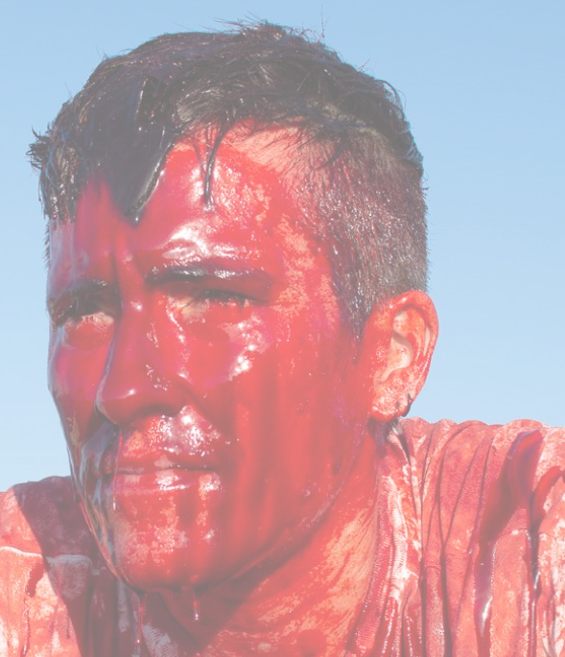
Craig Hamblyn | 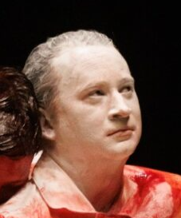
Tim Bromage | 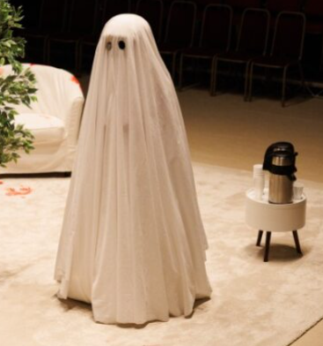

Lighting and Sound
- The performers scream and shout loudly
- A song is played over the sound system
- Sometimes there is live singing
- The lighting state stays the same. The performance space is well lit.

Participation
- There is no audience participation

Access Information
- The show is 60 minutes long
- There will be an Audio Described performance on Friday 22 Nov, by Dot Alma
- All performances are Relaxed this means you can move or make noise if you need to. You can go in and out of the performance space
- Latecomers will be permitted
- There is an accessible toilet on every floor of the building
- There is a chill out space outside the performance space that is available anytime the building is open

Content Notes
- One performer is covered in fake blood throughout the performance.
- One performer’s face and body is painted white.
- There is also a ghost figure covered in a white sheet.
- Two of the performers begin to pretend to fight. It is stage fight, so they are not hurting each other.
- They grunt and shout and scream as though they are hurt.
- The pretend to hit, kick and strangle each other.
- It looks and sounds very violent.
- Fake blood stains the carpet.
- The fight scene is repeated throughout the performance.
- Between each fight, the performers cover themselves in more fake blood and white paint.
- The audience sitting closest to the performance are offered plastic ponchos, in case they fake blood splashes them
- The fights start to get less realistic towards the middle of the performance. Sometimes objects are used to represent the performers body.
- More and more fake blood is used towards the end of the performance

