L’Addition – Pre show Information

This information is to help you decide if L’Addition is for you. Content notes, including what happens in the show, are further in the document.

The Space
The show is in the Council Chamber. There will be a stage and space for the audience.

The space is clear except for one table and chair.

The Performers
The performers are:
Bertrand Lesca | 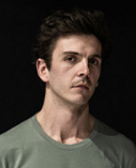
Nasi Voustas | 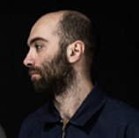

Lighting and Sound
- The stage is well lit
- Sometimes lights on the side of the stage pulse
- Sometimes electronic music is played over the scene, it repeats
- Sometimes piano music is played over the scene, it repeats

Participation
- There is no audience participation

Access Information
- The show is 1 hour 10 minutes long
- There will be a BSL interpreted performance on Wednesday 13 November
- All performances are Relaxed, this means you can move or make noise if you need to. You can go in and out of the performance space
- Latecomers will be permitted
- There is an accessible toilet on every floor of the building
- There is a chill out space outside the performance space that is available anytime the building is open

Content Notes
- After the performers introduce the show, a scene is played over and over again. The scene is in a restaurant, a waiter pretends to pour a glass of wine and spills it. There is no liquid in the bottle. This is repeated.
- Sometimes the performers speak directly to the audience
- Sometimes they speak over each other
- Sometimes there is loud shouting
- Sometimes the performers speak over the music

L’Addition explores:
- Power
- Hierarchy
- Theatrical conventions

