**Nowhere – Pre show Information**

This information is to help you decide if Nowhere is for you. Content notes, including what happens in the show, are further in the document.

**The Space**

* The show is in the Council Chamber. There will be a stage and space for the audience.
* The performance space will be end on and you will sit in raised seating.
* There will be one performer and projection will be used.

The performance is still being made and there will more information provided in July 2024.

**The Performers**

Nowhere is performed by Khalid Abdalla.

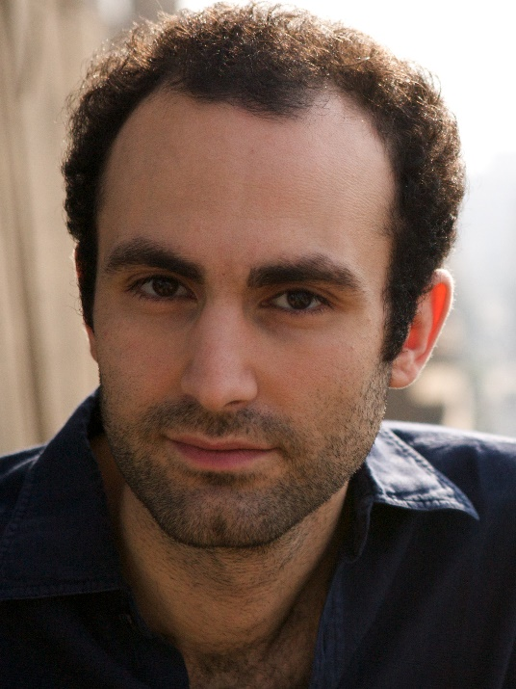

**Lighting and Sound**

* The lighting for the performance space is still being made.
* The sound for the performance is still being made.
* Torches might be used.
* There might be low lighting at times.
* There is likely to be use of haze.
* There will be some scenes where music and talking happens at the same time.

**Participation**

* There might be moments when the audience is asked to respond to questions about where they are from and where they have travelled, visited, lived.
* There might be a moment when the audience is asked to draw themselves.

**Access Information**

* The show is still being made, but will likely last 90 minutes long
* Latex might be used, it will be confirmed when the show is made.
* All performances are Relaxed this means you can move or make noise if you need to. You can go in and out of the performance space
* Latecomers will be permitted
* There is an accessible toilet on every floor of the building
* There is a chill out space outside the performance space that is available anytime the building is open

**Content Notes**

* The show is still being made, so we do not know exactly what will happen at this stage.
* The themes of the show are:
  + Being political
  + Belonging
  + Identity
  + Family
  + Control
  + Power
  + Violence

Nowhere explores world events and their impact on society. This includes:

* Political prisoners and activism in Egypt
* Unfair treatment based on where someone is from or what they look like
* Terrorist attacks
* Violent events and history of Israel, Gaza and Palestine

The performance will jump between different times and places.