**Soliloquio – Pre show Information**

This information is to help you decide if Soliloquio is for you. Content notes, including what happens in the show, are further in the document.

**The Space**

The performance happens in two parts.

The first part takes place **outside**, in a public space.

* The audience will be stood together to begin with and then will walk with the performer, as part of a parade.
* The walk might mean walking up and down hill.
* There might be other members of the public passing by.
* It might be cold.

The second part takes place **inside** Battersea Arts Centre, in the Council Chamber.

* There will be a stage space and a seating area.
* You will be seated in raised seating.

**The Performer**

The performer is Tiziano Cruz

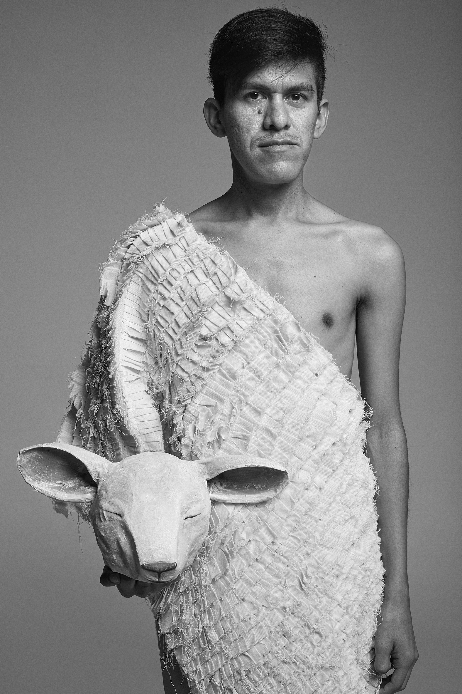

**Lighting and Sound**

* During the parade, there might be live instruments played and lots of sounds happening at the same time.
* Drums, shakers, and bells are used during the performance.
* There is a large screen at the back of the stage. Sometimes text, images and video are projected onto the screen.
* At one point, there is a recording played of the performer saying different things at the same time.
* Sometimes the stage is very dark.
* At one point, the sounds of lots of sheep bleating is played, it is quite loud.

**Participation**

* As you move from outside to inside, you will be invited to greet the performer, with a hug, or a handshake, or a wave.

**Access Information**

* The performance is 1 hour 40 minutes long
* The performance is in two parts.
  + The first part, which takes place outside, is about 30 minutes long.
  + The second part, in the Council Chamber, is about 50 minutes long.
* The performance is in Spanish. During the first part, you will be given a transcript to read in English. During the second part there will be English subtitles.
* You can go in and out of the performance space if you need to.
* No alcoholic drinks will be allowed in the Council Chamber.
* There is an accessible toilet on every floor of the building
* There is a chill out space outside the performance space that is available anytime the building is open

**Content Notes**

**Part One**

* The first part of the performance takes place outside, in a public space.
* The performer will read out a text they have written in response to working with local people.
* They will use a megaphone to read out the text.
* They will speak in Spanish, and you will have a transcript in English to read.
* After the text has been read, there will be a parade. You will follow the performer.
* Local people may perform live music with instruments and wear costumes.
* It might be loud, with lots of different sounds happening at the same time.
* You might need to walk up and down hill for this part.
* There might be other members of the public who stop to watch the parade.

**Part Two**

* In the second part, you will watch the performer in the theatre space.
* Sometimes the performer will only be wearing white pants.
* Sometimes the performer will be naked.
* They will speak in Spanish. There will be English subtitles projected onto a screen.
* Sometimes videos of sheep walking in fields is projected on the screen.
* Sometimes images of a woman is projected on the screen.
* Sometimes text is projected on the screen.
* The performer will move into different positions and speak directly to the audience.

The themes of Soliloquio are:

* Power
* Control
* Violene
* Injustice
* Memories
* Identity
* Childhood