Burnt Toast – Preshow Information

This information is to help you decide if Burnt Toast is for you. Content notes, including what happens in the show, are further in the document.

The Space
- The show is in the Council Chamber
- The performance will happen in the middle of the stage
- The audience sits front on to the stage

The Performers
- The performers are:
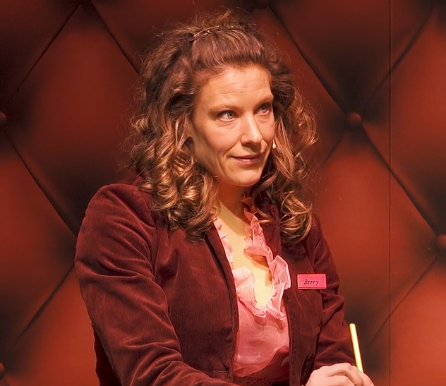 | Receptionist: Betty
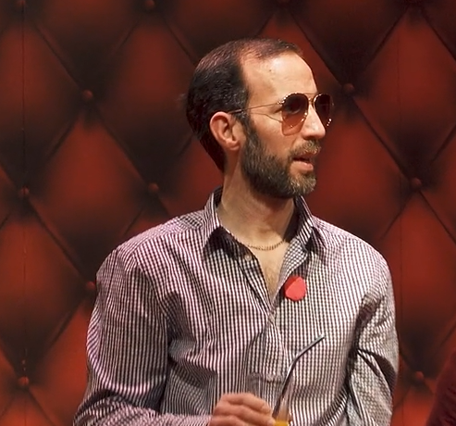 | Male customer Danny Iwas
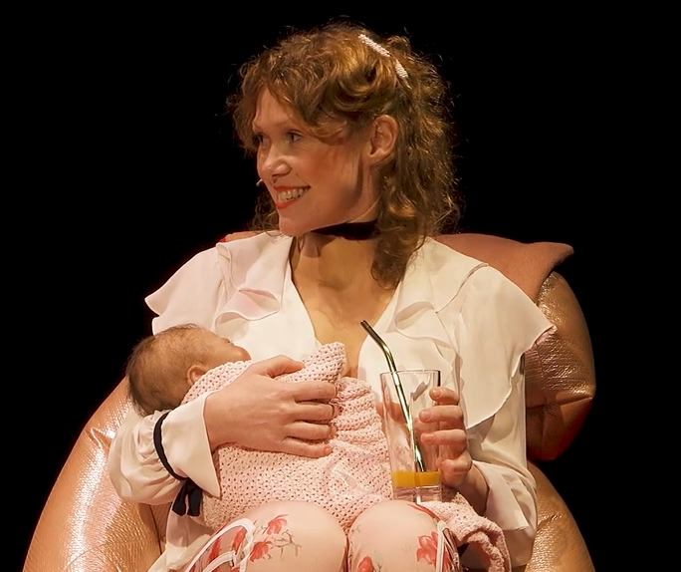 | Female customer Mother Violet holding a baby
 | Male customer 2
 | Other customers

Lighting and Sound
- The performers are well lit
- The show is relatively quiet with some background music
- There will be background music played as people talking
- At the middle of the show, the performer Betty screaming loud

Participation
There is no audience participation

Access Information
- The performance is 80 minutes long
- There is an accessible toilet on every floor of the building
- There is a chill out space outside the performance space that is available anytime the building is open
- All performances are Relaxed this means you can move or make noise if you need to and can go in and out of the performance space
- Latecomers will be permitted
- Ear defenders are available to borrow from the box office for anyone who might find these useful

Content Guidance
- Fake blood
- Body horror
- Simulated breast feeding
- Prosthetic embryos
- Fake wounds and amputations
- Sudden loud noise and scares

Content Notes
- The male customer Iwas will keep his left hand locked with a suitcase together most of the time
- Violet will breastfeed throughout the first part of the show
- Violet will expose her fake red abdominal wound
- There is a scene that male customer Iwas will be trapped in the lift and the lift falls down
- There will be bloody scene at the middle of the show, fake blood will be squirting on Violet’s face
- There will be a bloody scene around 1h of the show, Violet pretended to cut out of baby’s belly and take out of another smaller baby
- There will be a scene in which Iwas cuts open Violet’s prosthetic belly and puts his head and torso inside her

