Goner – Preshow Information
This information is to help you decide if Goner is for you. Content notes, including what happens in the show, are further in the document.

The Space
- The show is in the Council Chamber
- The performance will happen in across the whole stage
- The audience sit at the front of the stage

The Performers
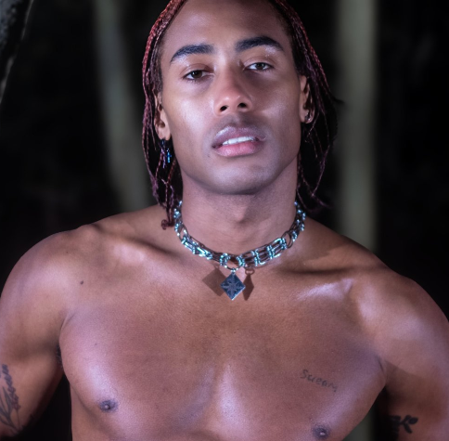

This show will be performed by
Malik Nashad Sharpe

Lighting and Sound
- This show contains flashing lights and moments of complete darkness
- The performer is well lit most of the time
- The performance uses haze
- There are loud and sudden music/sounds including gunshots
- Sometimes the performer speaks over the music, sometimes they will sing
- After the first 15-minutes of the performance, the stage is quite dark
- There is a huge blast towards the end of the performance

Participation
There is no audience participation

Access Information
- This performance is 55 mins long
- Latecomers will be permitted in the first 15-minutes
- After the first 15 minutes latecomers and re-entry will not be permitted
- There is an accessible toilet on every floor of the building
- There is a chill out space outside the performance space that is available anytime the building is open
- There will be an Audio Described performance on Fri 9 May at 7:30pm, by Adae Bajomo
- There will be BSL interpreted performances on Wed 7 May at 7:30pm and Sat 10 May at 2pm by Ali Gordon
- Ear defenders are available to borrow from the box office for anyone who might find these useful

Content Notes
- The show contains strong language, with verbal references to sex, murder, and violence.
- The performer wears different items throughout the performance, including short shorts, trainers, chaps, a choker, a vest, a long braid, a balaclava.
- Most of time the performer keeps their upper body naked.
- The performer performs in a large translucent plastic film box, which resembles a shower. They are lit from behind which creates a large shadow on the box.
- Fake blood will be used during the performance.
- The performer will cover themselves with fake blood and break through the plastic film box.
- A dialogue includes the performer saying, "I killed some people..."
- A male narrator shouts loudly towards the end of the show.
- A gunshot sound effects will be used, and the performer pretends to be shot towards the end of the show.
- The performer will expose his bum at the show.
- The performer will put on mask.

