**Paradise Lost – Pre show Information**

This information is to help you decide if Paradise Lost is for you. Content notes, including what happens in the show, are further in the document.

**The Space**

* The show is in the Council Chamber
* The performance will happen in the middle of the stage
* The audience sits on front side of the performance space

**The Performer**

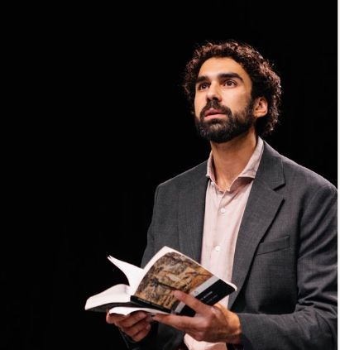

Paradise Lost is performed by

**Sharif Afifi**

**Lighting and Sound**

* The stage will be blacked out, but the performer is well lit
* The stage will be quite dark at some scenes when the performer moving around dancing
* During one scene, haze will be used
* Various songs are played over the scenes
* Sometimes there is loud shouting

**Participation**

There is no audience participation

**Access Information**

* The Performance is 1 hour and 10 minutes long, no interval
* No potential allergens onstage such as peanuts or latex
* There is an accessible toilet on every floor of the building
* There is a chill out space outside the performance space that is available anytime the building is open
* All performances are Relaxed, this means you can move or make noise if you need to and can go in and out of the performance space
* Latecomers will be permitted around minute 4 and minute 10
* Ear defenders are available to borrow from the box office for anyone who might find these useful
* There will be BSL interpreted performance on 28th March and the 4th April. BSL interpreter will be Clare Edwards.

**Content Notes**

* The performer sits in the stool at the middle stage, with a book in hand and speak directly to the audience
* There will be a thick rope dropped from the top of the centre of the stage, the performer climbed up
* The performer will dance and speak over the music at the same time, their lines can be heard clearly
* At some scenes of storytelling, the performer will play different roles in turn
* The performer will get undressed and playing God wearing flesh colour bodyguard, then dressed back with shirt again
* Some occasional use of swearing and adult themes
* By the end, water will be dropping down from top of the stage, the performer will get totally wet, but the audience will not get wet from distance.