**TESTO– Preshow Information**

This information is to help you decide if TESTO is for you. Content notes, including what happens in the show, are further in the document.

**The Space**

* The show is in the Council Chamber
* The performance will happen in the middle of the stage
* The audience sits front on to the stage

**The Performers**

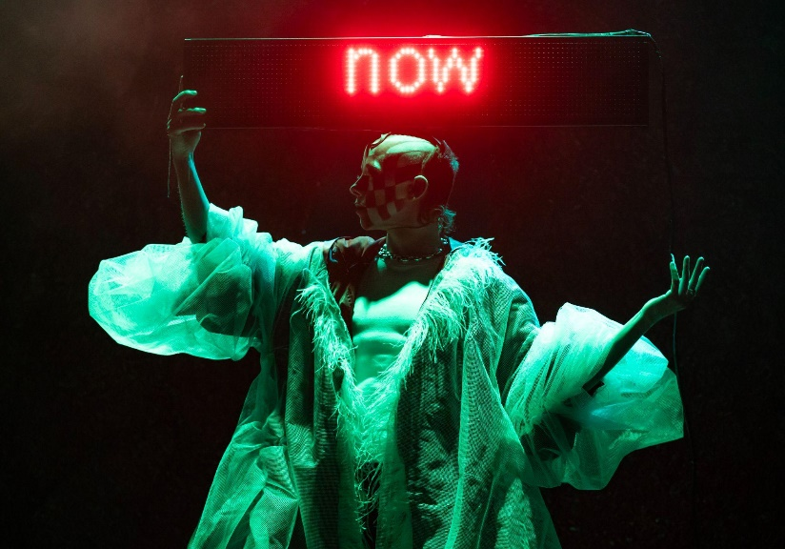

This show will be performed by **Wet Mess**

**Lighting and Sound**

* The performer is well lit most of the time
* This show contains strobe lights and flashing lights throughout, and there are moments of complete darkness
* The performance has recorded dialogue which is lip-synced to
* There is a few loud and sudden music/sounds throughout the performance, and club music is included

**Participation**

There is no audience participation

**Access Information**

* The performance is 55 minutes long, with no interval
* The age guidance is 14+ but parental discretion is advised
* There is an accessible toilet on every floor of the building
* No potential peanuts on stage
* Some set and props are made of latex
* There is a chill out space outside the performance space that is available anytime the building is open
* Latecomers and readmittance will be permitted, at specific safe moments, throughout the show
* All performances are Relaxed this means you can move or make noise if you need to and can go in and out of the performance space
* Ear defenders are available to borrow from the box office for anyone who might find these useful
* There will be a BSL interpreter for the performances on 13th and 20th February
* Audio description will be available 18th – 22nd February

**Content Notes**

* The show contains physical references to sex, verbal references to transphobia
* The performer will wear checkerboard facial makeup
* A display screen will show a series of rolling sentences in red
* The performer will get undressed early in the show and underneath will be wearing a flesh colour muscle body suit
* From the middle of the show, the performer will take off the flesh colour muscle body and be naked until the end
* The performer will pull out 3 long cushioned limbs from the stage
* At the end of the show, the performer will collect and lie on the limbs