Koulounisation – Preshow Information

This information is to help you decide if Koulounisation is for you. Content notes, including what happens in the show, are further in the document.

The Space
- The show is in the Council Chamber
- The performance will happen in the middle of the stage
- The audience sits front on to the stage

The Performers
This show will be performed by
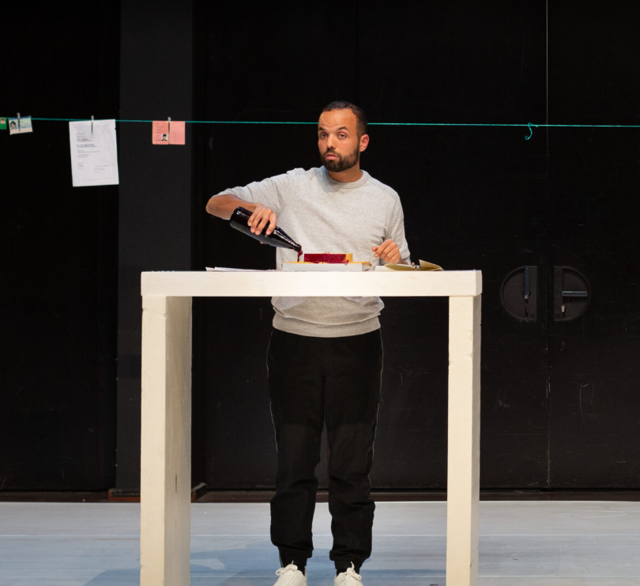

Salim Djaferi

Lighting and Sound
- The performance space is well lit
- There are sudden, loud noises in the performance around 35 minutes
- No background music throughout the show

Participation
Please scroll to the bottom of the document for more information about audience participation. The details there will reveal more about surprise content of the show.

Access Information
- The performance is 1 hour long, with no interval
- There is an accessible toilet on every floor of the building
- There is a chill out space outside the performance space that is available anytime the building is open
- All performances are Relaxed this means you can move or make noise if you need to and can go in and out of the performance space
- Latecomers will be permitted
- Ear defenders are available to borrow from the box office for anyone who might find these useful

Content Notes
- The show is French, and will subtitled in English.
- The scenography table setting is made up of polystyrene sheets, some of which are broken or damaged during the performance, in unexpected and potentially stressful ways
- There's also a red liquid that suggests blood (it's actually beetroot juice)
- There's a scene where Salim hits his face on a Styrofoam plate around 35 minutes (he is actually faking it, without pain)
- These elements are metaphorical, they create images that are significant and are explained

Audience Participation
Salim invites someone from the audience to take part. However, the person in the audience is an actress and is part of the show.

