Language No Broblem – Preshow Information

This information is to help you decide if Language No Broblem is for you. Content notes, including what happens in the show, are further in the document.

The Space
- The show is in the Council Chamber
- There will be a stage and space for the audience.
- The audience sits in front on to the stage

The Performers

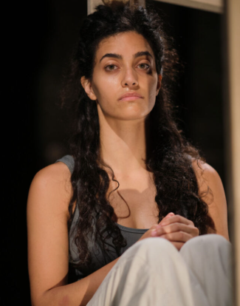
This show will be performed by

Marah Haj Hussein

Lighting and Sound
- The performance space is well lit most of the time
- The performance has recorded dialogue in different language
- The dialogues will be clearly captioned/projected on the surface of different box/screen on stage
- Loud music: There is music mixed with instrumental music and dialogue at the end of the performance, which comes in softly and then accelerates with strong bass

Participation
The audience is sometimes asked to answer some questions, but nobody is asked on the scene

Access Information
- The performance is 70 minutes long, with no interval
- There is an accessible toilet on every floor of the building
- There is a chill out space outside the performance space that is available anytime the building is open
- All performances are Relaxed this means you can move or make noise if you need to and can go in and out of the performance space
- Latecomers will be permitted
- Ear defenders are available to borrow from the box office for anyone who might find these useful

Content Notes
- Themes of the show:
Occupation
Racism
Apartheid & Violence

