WRESTLELADSWRESTLE – Preshow Information

This information is to help you decide if WRESTLELADSWRESTLE is for you. Content notes, including what happens in the show, are further in the document.

The Space
- The show is in the Council Chamber
- The performance will happen in the middle of the stage
- The audience sit on one side of the stage

The Performers
Character | Performer
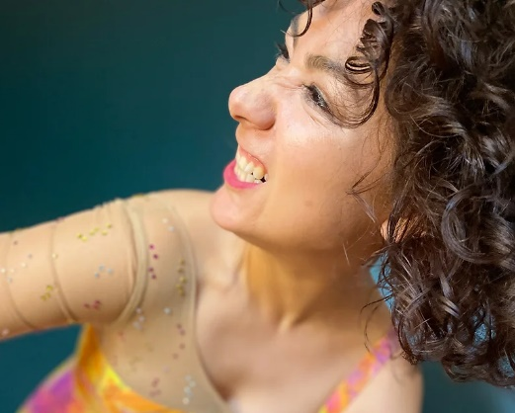 | Jenni Jackson
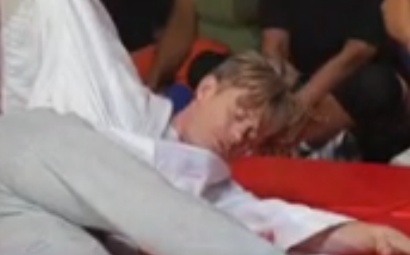 | Assistant
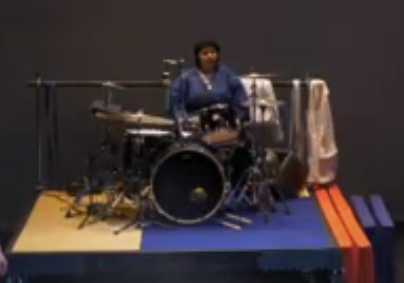 | Drummer
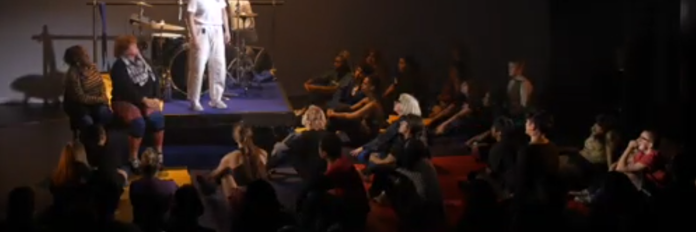 | GirlGang

Lighting and Sound
- The performance space is well lit throughout the show, the background will be black
- Flashing lights and strobe included
- At the beginning of the show, there will be some sudden loud sound effect
- Loud music will be played throughout the show
- The performer will talk while performing, subtitle will be applied
- At the end of the show, performer and girl gang will sit on the stage chatting and drinking, whilst the music is played

Participation
There is no audience participation

Access Information
- The performance is 70 minutes long
- The show is fully captioned
- There is an accessible toilet on every floor of the building
- There is a chill out space outside the performance space that is available anytime the building is open
- All performances are Relaxed this means you can move or make noise if you need to and can go in and out of the performance space
- Latecomers will be permitted
- Ear defenders are available to borrow from the box office for anyone who might find these useful

Content Notes
- The show includes strong language; references to racist language and mentions of violence and weapons
- There will be a drum set at the middle of stage, and the drummer will sometimes play live loudly in the performance
- The performers pretend to hit, kick and strangle each other
- The fight scene is repeated throughout the performance
- The performer is repeating the story of their mom, and changing the narratives constantly
- More and more girl gang come onto the stage throughout the show, and they will act the judo moves in turn
- The performer will tell a story of women being raped

