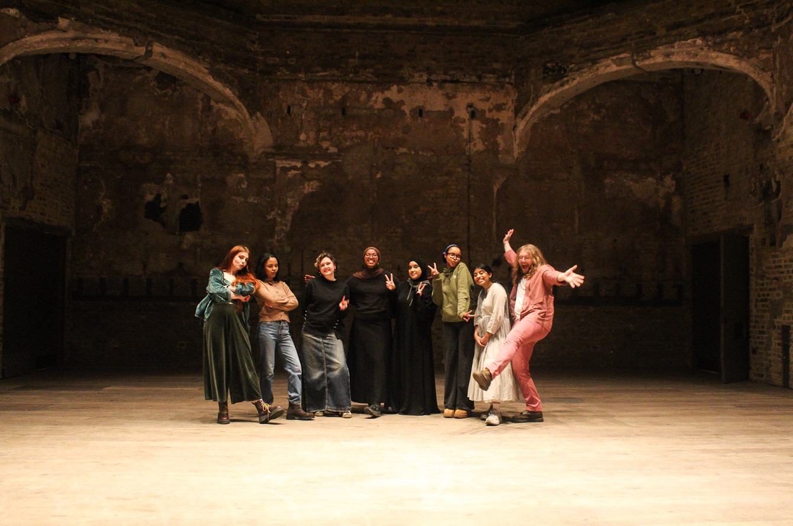

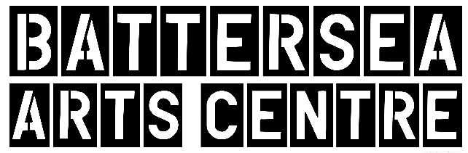

Photograph: Takenya Holness

**Trustee**  
Recruitment Pack

**Welcome to Battersea Arts Centre**

We are looking for an individual with Human Resources expertise and an interest in the creative industries to join our Finance & Audit Committee as a strategic advisor.

This is an exciting opportunity for someone who may be interested in supporting the cultural sector, contributing to BAC’s vision and activities, learning more about organisational governance, or who just wants to be in a position where they can really make a difference.

Read this recruitment pack and the links below to find out more about being an advisor on one of our governance committees at BAC and how to apply.

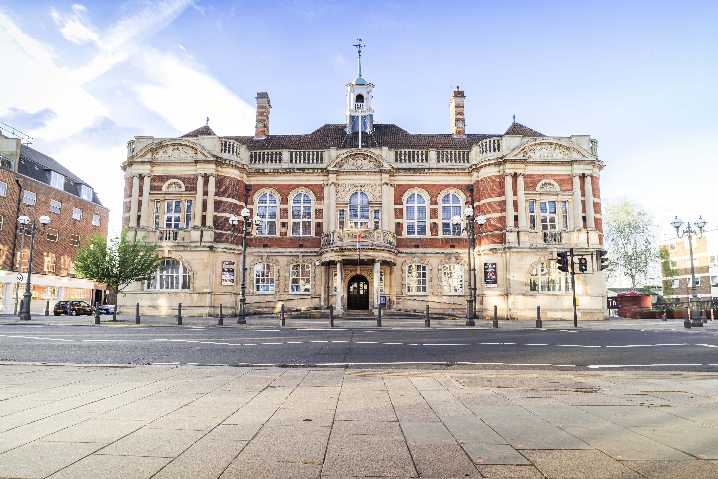**Battersea Arts Centre**

Photograph: Harry Elletson

**Our Vision**

**Our Values**

**The Role**What will you be doing?

You will act as an advisor on our Finance & Audit Committee, a sub-group of our **Board of Management**, which holds responsibility forensuringBAC’s governance responsibilities are carried effectively and in line with requirements of Charity Commission, Companies Acts and BAC’s status as an Arts Council England National Portfolio Organisation.

Your main duties will be to:

* Attend and contribute to quarterly committee meetings.
* Support and guide key staff and issues relating to your area of expertise
* Attend BAC events and support with stakeholder management

This role is not an appointed trustee and as such will not be listed as a Director at the Charities Commission. However, if progression toward that position is appealing, this is a common route by which individuals become full trustees at BAC.

**Person Specification**Who are we looking for?

We are looking for someone who wants to help push BAC to be the best version of itself over the next few years.

Specifically, we want a group member who will support BAC with matters of personnel, employment law and compliance, and organisational culture. A professional and personal interest in diversity and inclusion would be a significant benefit.

No prior experience of supporting Boards or acting on supplemental committees is necessary, and we will collectively support you to contribute fully to our governance. Our Board and Sub-Groups are dynamic, diverse and engaged, made up of people from a wide range of backgrounds and with complementary expertise. We are hoping this new appointment will further contribute to this exciting mix.

We don’t have a fixed idea of what makes an ideal candidate. We are simply seeking someone who can bring experience in the areas set out above and has an interest in supporting cultural arts sector.

**Current BAC Board of Management**

**Sara Apps**, Councillor, Wandsworth Borough Council

**Rachel Bagshaw**, Artistic Director, Unicorn Theatre

**Chris Cabot**, President, Value Retail Mgmt Ltd.

**Marsha de Cordova**, Labour MP for Battersea

**Liz Fosbury**, COO, National Theatre (Chair of Finance & Audit Committee)

**Ali Gannagé-Stewart**, Commercial Director, Tate (Chair, BAC Enterprises)

**Anu Giri**, Executive Director, English National Ballet (Deputy Chair, Main Board)

**Malik Gul**, Director, Wandsworth Community Empowerment Network

**Patrick Harrison**, CEO, Royal Ballet School

**Claudia Kenyatta**, Director of Regions, Historic England (Chair, Main Board)

**Susie Thornberry**, Artistic Director & CEO, Metal Culture

**Finance & Audit Sub Committee**

**Liz Fosbury**, COO, National Theatre (Chair)

**Anu Giri**, Executive Director, English National Ballet

**Michael Dixon**, Finance & Business Resource Director. Roundhouse

**Francesca Valli**, Strategic Change Management Consultant, Freelance

**Terms & Conditions**

Length of Appointment: **3 years**

Time Commitment: Four Sub Committee meetings per year, plus advisory contact between meetings.

Remuneration: In line with charitable governance rules, we are unable to remunerate people for being Trustees or advisors, therefore this role is **voluntary**. However, we can support reasonable expenses and travel costs.

**How to apply**

Interested parties should email an expression of interest to [recruitment@bac.org.uk](mailto:recruitment@bac.org.uk)

Your expression of interest should outline why you are interested in BAC and what you’d like to offer in terms of skills and expertise. You should also attach your CV.

We will arrange an informal interview with the Artistic Director and Executive Director at a convenient time and if agreeable to both parties, a formal invitation to join the sub-group will be made.

We would like to onboard someone with the skills set outlined in this pack by June 2025 and will therefore apply a closing date of 31 March 2025.

Access at Battersea Arts Centre

At BAC we are committed to access and inclusivity in everything we do. We aim to provide as much information about access up front, but if there’s anything not mentioned here that you want to know, get in touch at the email address below.

**Our building**BAC is wheelchair accessible throughout the building. There are accessible toilets and a mix of loud and quiet spaces, including a chill out room. The nearest wheelchair accessible station is Clapham Junction and the route is 0.6 miles up a hill. There is a disabled parking bay on Theatre Street next to the building.

**Interviews**For the interview, we can provide a BSL interpreter if required.

If you would like any further information, support with access requirements or an informal chat about the role, please contact us by email at [recruitment@bac.org.uk](mailto:recruitment@bac.org.uk).