
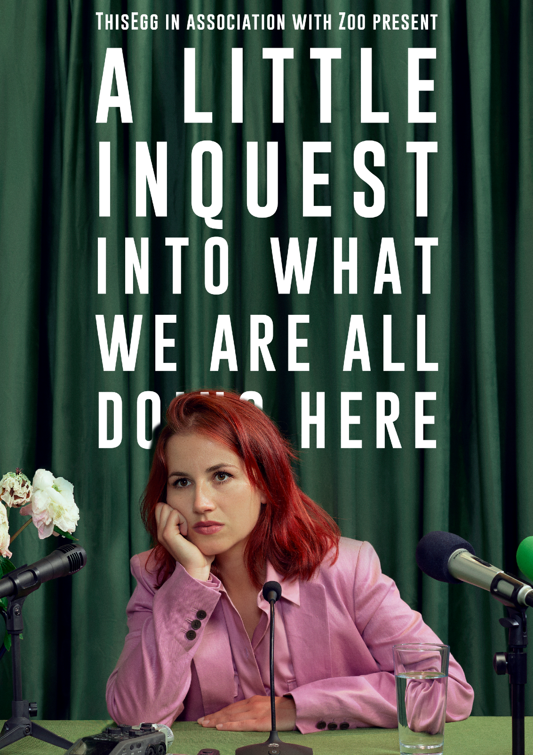

Photo Credit: Rich Lakos

Who is in the show?
There are two performers in the show.

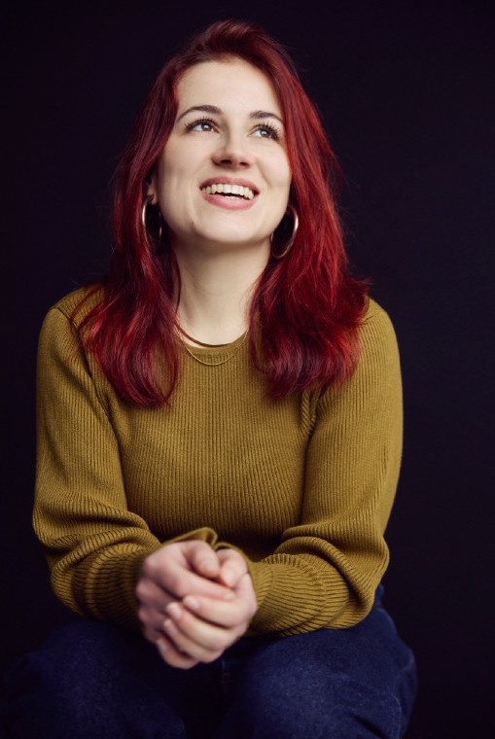

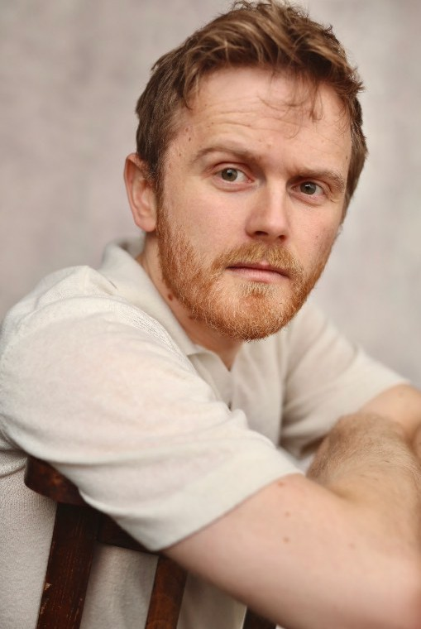
Photo Credit: Rich Lakos

This is Josie. She uses the pronouns she/her.
Josie is a white woman in her early thirties with died red hair.
This is Laurence. He uses the pronouns he/him.
Laurence is a white man with blonde hair and a beard in his early 30s.

When you arrive

- There will be a chair behind a small desk downstage right.
- On the table is a water jug and a glass, a laptop and a pair of glasses.
- Around the table there will be three microphones on stands.

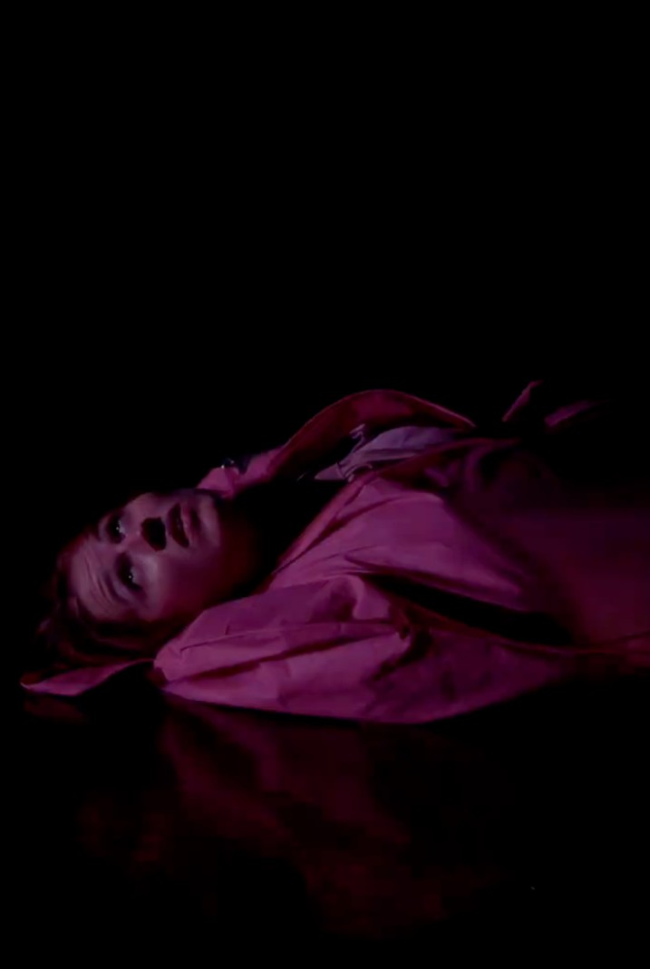


How does the show start?

- the lights go down, and as the lights come up again
- some music (a snippet of “Ode to Joy”) plays. If you want to sit somewhere quieter, sit at the back, away from the stage
- someone in a pink body bag wiggles across stage towards the table, they might peak their head out occasionally

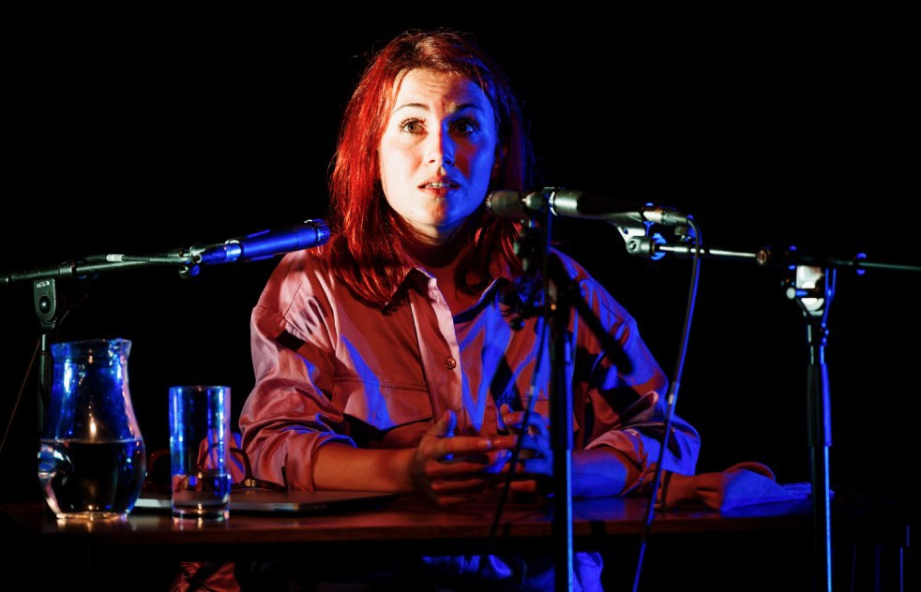

Act One
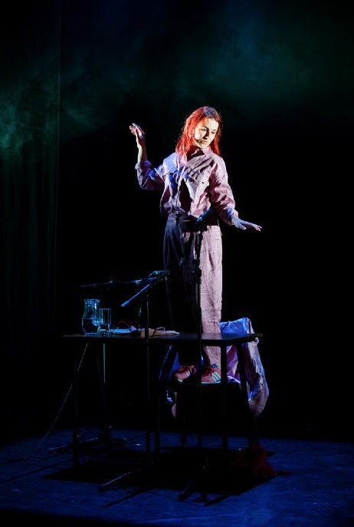

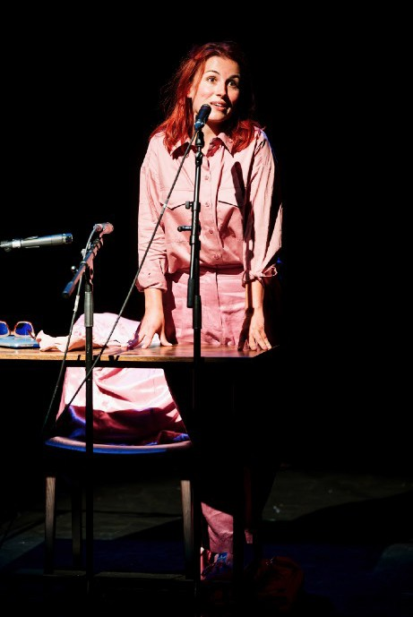
- Josie climbs out of the body bag. She is wearing a pink suit.
- She will sit at the table and talk to the audience
- Sometimes Josie listens to audio clips that play
- There is one moment where she pours some water, reads from her laptop, one moment where she stands to speak and one moment where she stands on a chair and poses as statues

Photo Credits: Alex Brenner

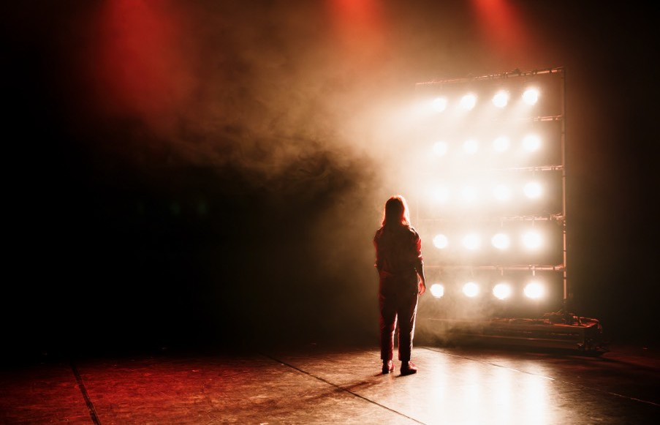

There is one moment in the first half of the show where Josie goes off stage and brings on a wall of theatre lights. This can be very bright. If you need to, close or cover your eyes.

She stands and looks at them for a moment.

Photo Credit: Alex Brenner

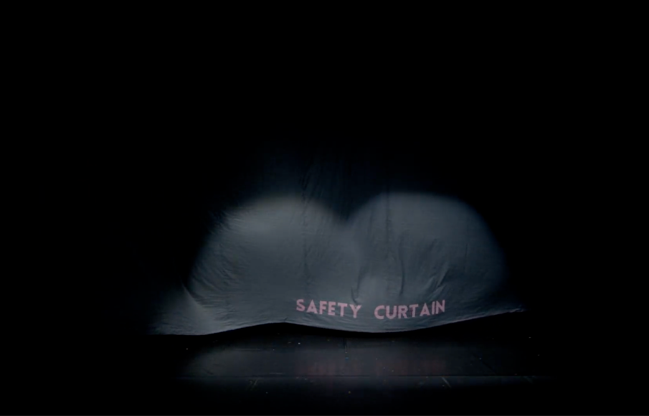
Act One ends with a “Safety Curtain” that drops across the front of the stage. This is not real, and is planned.

It is a very large grey parachute material with the words ‘Safety Curtain’ stitched onto it in pink felt.

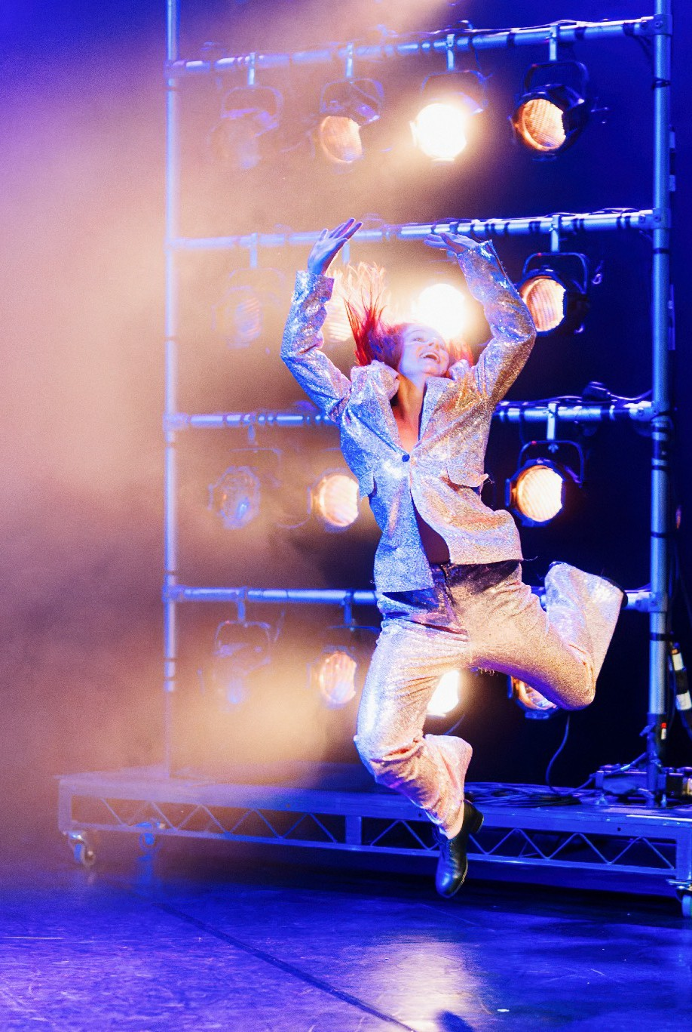

Act Two

- The Safety Curtain drops to the floor to reveal Josie in a pink sequin suit
- Josie does a dance to the song ‘That’s Entertainment’ by Judy Garland. Half way through the dance she puts tap shoes on and does a tap routine.
- As soon as the song and dance ends the lights on the desk flicker and there is a glitching sound effect
- Josie uses the safety curtain to cover the table and microphones
Photo Credits: Alex Brenner

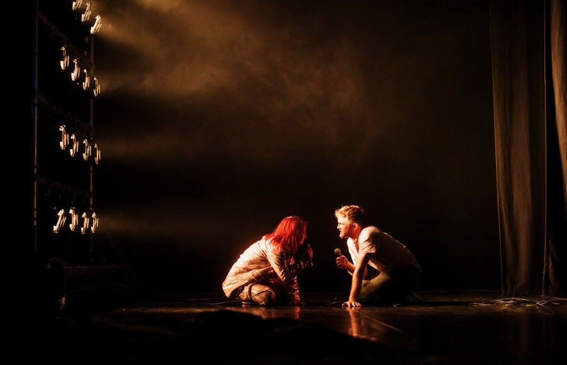
Act Three

- Laurence wheels the wall of theatre lights around the stage. The lights end up facing stage left.
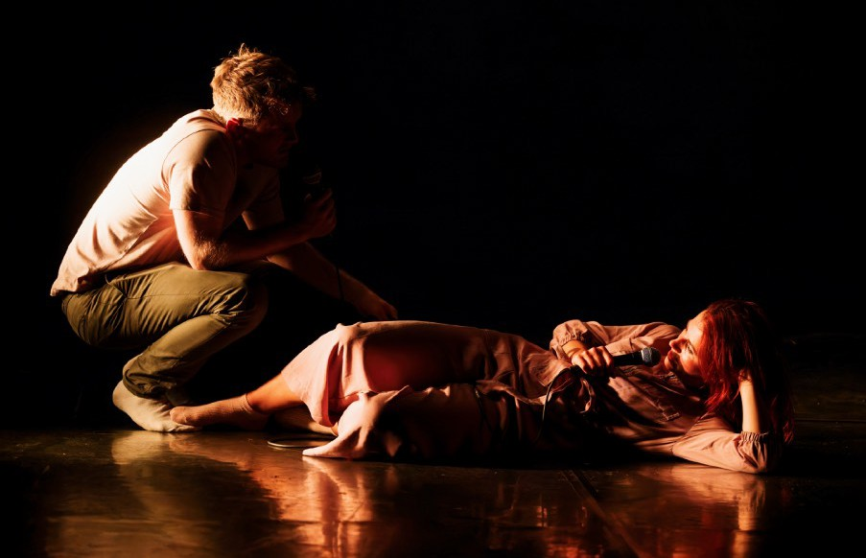
- Josie and Laurence use microphones with long cables.
- They perform a naturalistic scene in front of the lights upstage left. The scene is a break up scene between a couple.
- Josie might lye her head on Laurence’s knee. Sometimes they argue with each other (they are pretending for the show).
- There is one moment in the scene where Josie leaves the stage. When she comes back on she is
wearing pink pyjamas. Photo Credits: Alex Brenner

- The scene changes when Josie tells Laurence that he isn’t real, she “doesn’t have a boyfriend” and that “this is a solo show”.
- Josie moves the wall of theatre lights so the whole stage is visible again.
- The stage becomes an imaginary space. The dialogue becomes abstract.
- The scene becomes more physical. Sometimes they fight (but it is a set choreography for the show, the performers are safe).
- The performers pretend we are inside Josie’s mind. Laurence plays lots of different characters.
- Laurence goes offstage for a moment and brings on a body bag. He puts Josie inside the body bag.
- There is a moment where Laurence comes into the audience. He sits on the steps.
- Laurence will start taking the “Safety Curtain” off the desk to uncover what is underneath it.
- Towards the end of the scene, Laurence leaves and Josie will be on stage in the pink body bag.
- The lights on the desk will flicker and there will be a glitching sound effect.
- The lights will go out and some music (a snippet of “Ode to Joy”) plays.
- The lights will come on again and the performers will bow.

