NO SIGNAL – Preshow Information

This information is to help you decide if NO SIGNAL is for you. Content notes, including what happens in the show, are further in the document.

The Space
- The show is in the Members Bar
- The performance space will be in a thrust formation, surrounded by cabaret tables (with 4-5 people per table)

The Host/Performers
- The performers are:

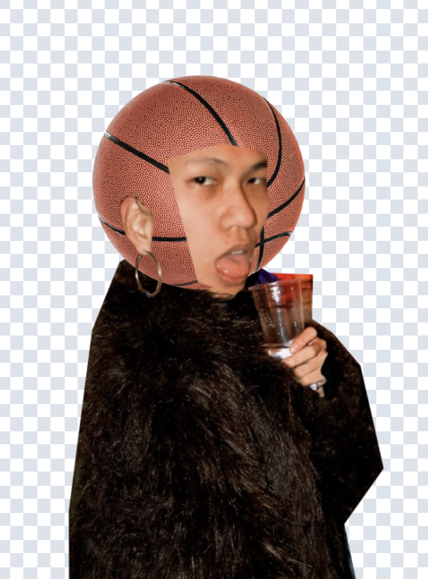  Hugo Ball (DJ) | 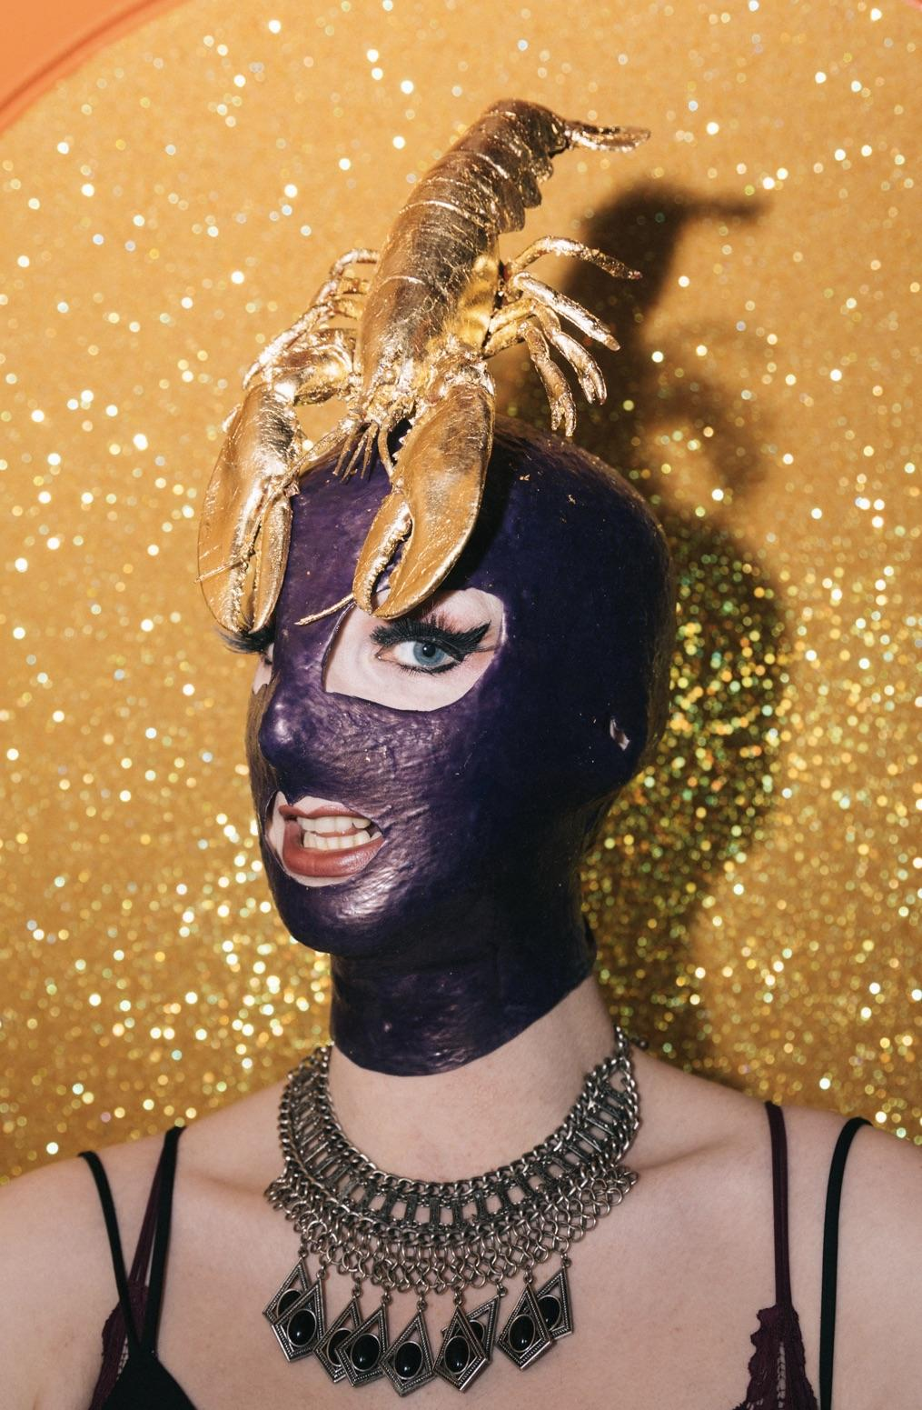  Charlie Wood  (Host) | 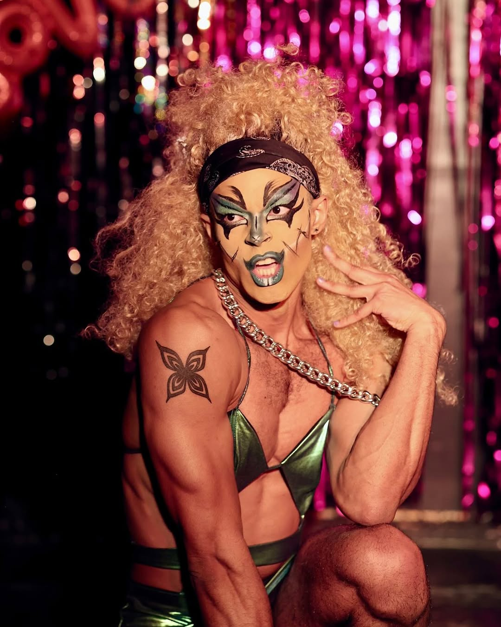  Izzntshe  (Performer)
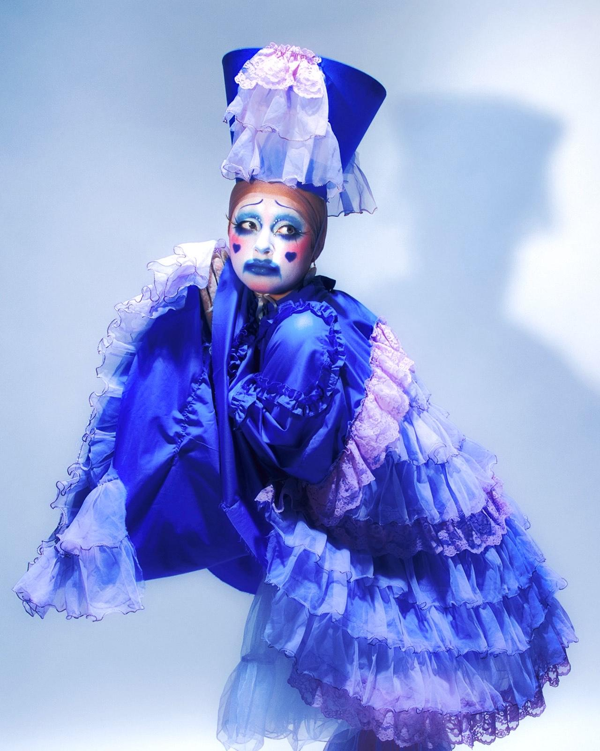Cabbage  (Performer) |  | 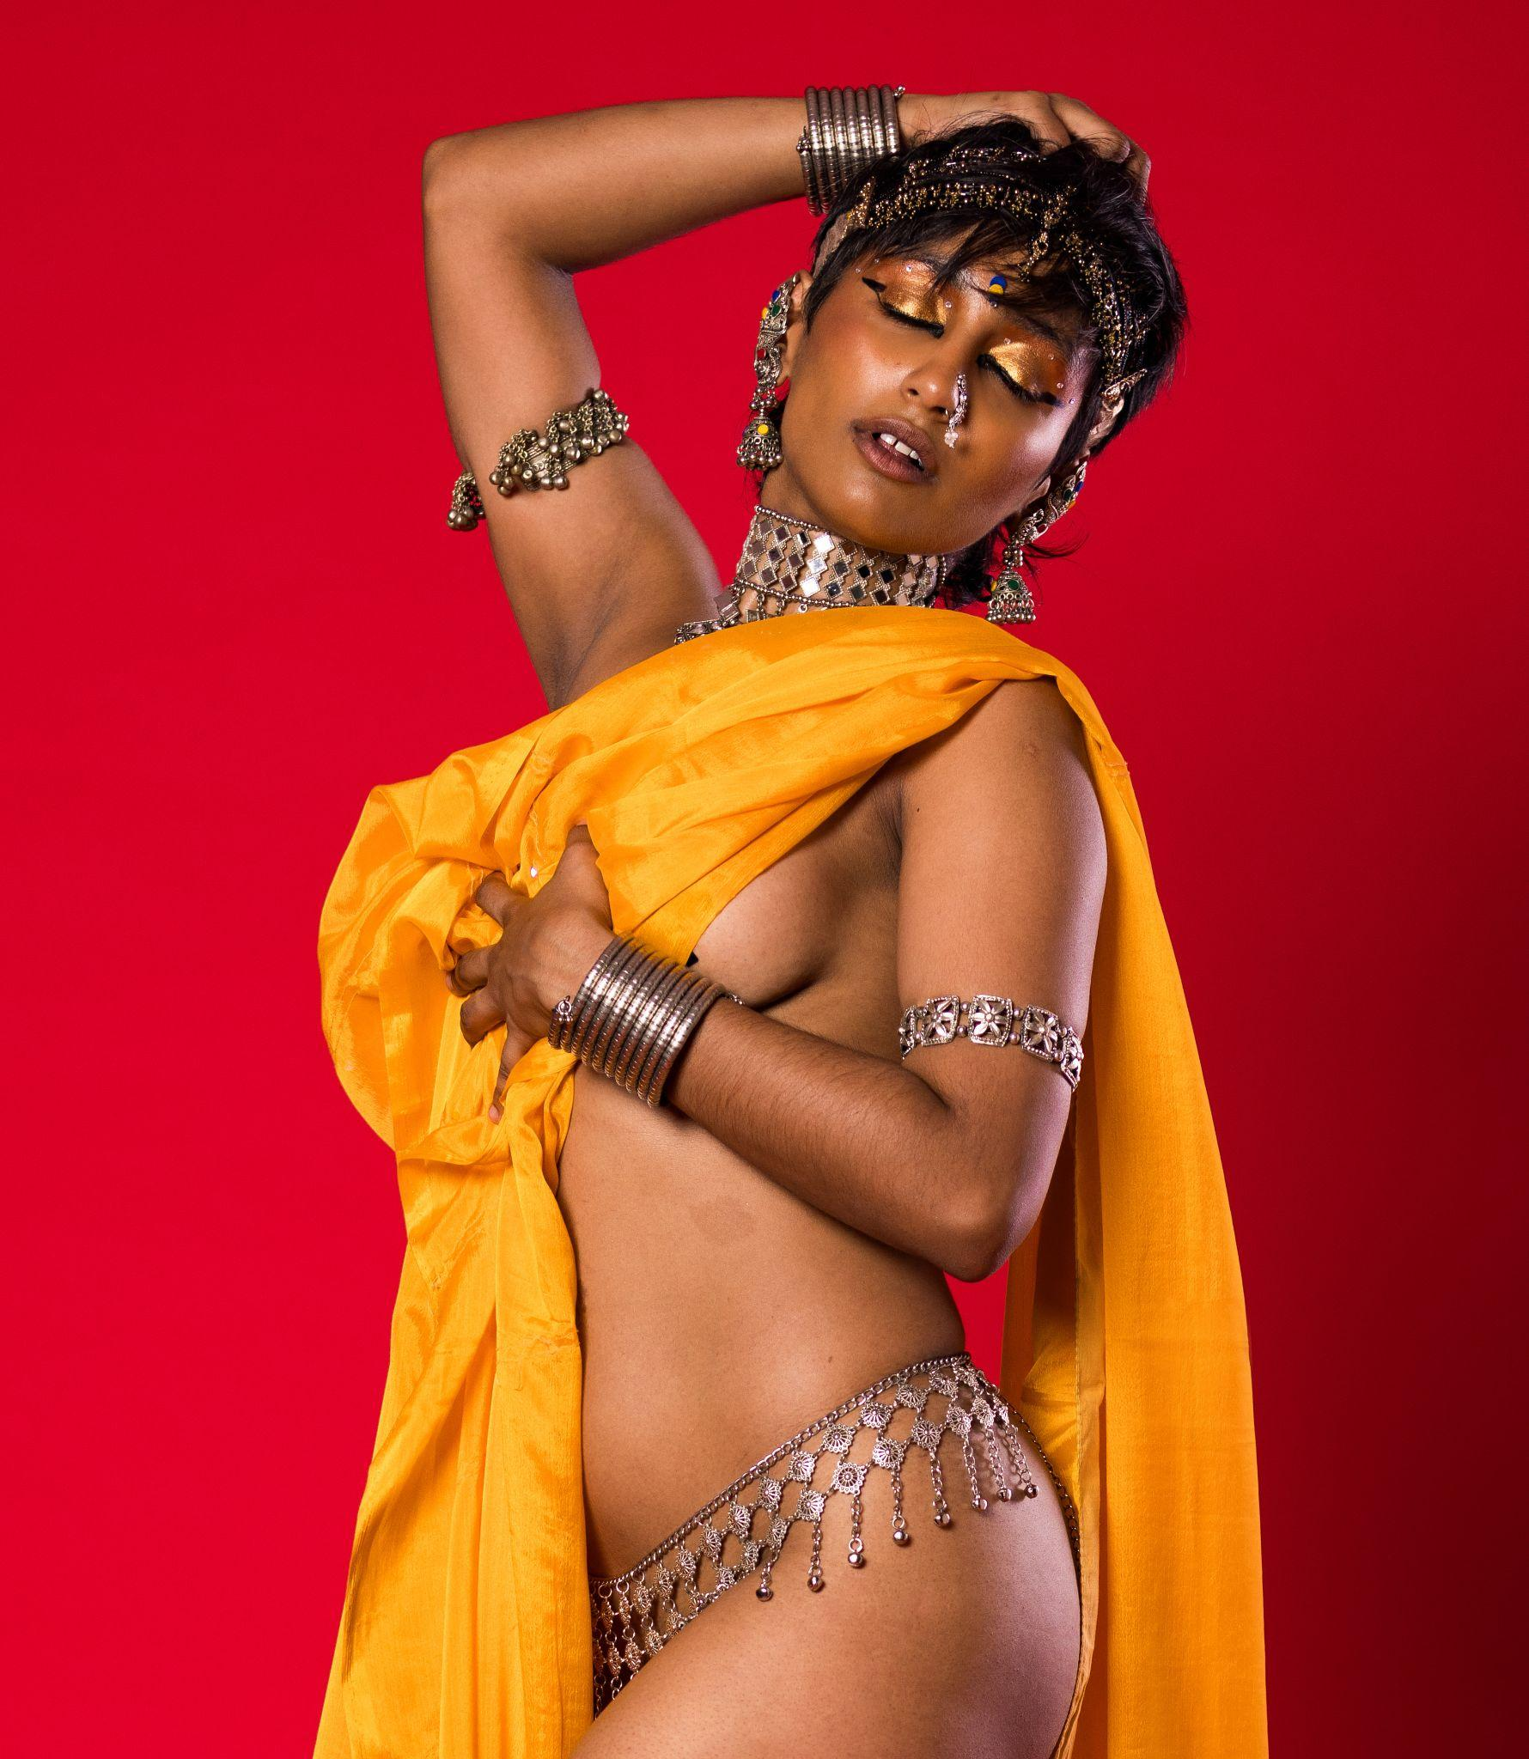  Sarjana Singh  (Performer)

Lighting and Sound
- There will be haze
- Flashing bright lights
- Disco ball illuminating the space
- The sound will be at 75%
- Sudden scream in one of the performance in ACT II by Izzntshe
- There will be sudden loud noise

Participation
- There is audience participation throughout the show.
- There will be star shaped stickers & party hats provided if you do not wish to interact with the performers.

Access Information
- There is an accessible toilet on every floor of the building
- There is a chill out space outside the performance space that is available anytime the building is open
- This performance is Relaxed
- Latecomers will be permitted
- Readmission will be allowed
- People are free to come and go as they wish throughout the night
- Ear defenders are available to borrow from the box office

Captions
- There will be an auto-generated captions, created on Zoom.
- It is important to note that this is not Speech To Text and there can be some potential spelling and interpretation error.

Content Notes
- Frontal nudity in Sarjana Singh’s performance in Act I & II
- Explicit descriptions of cause of death
- Themes of death, grief and loss
- References to religion

