Natural Behaviour – Preshow Information

This information is to help you decide if Natural Behaviour is for you. Content notes, including what happens in the show, are further in the document.

The Space
- The show is in the Council Chamber
- The performance will happen in the middle of the stage
- The audience sits front on to the stage.
- There is no set used in the performance. There is a black sprung dance floor.
- The performers will enter and exit through a black slash curtain at the upstage centre of the stage, in the style of British TV show ‘Stars in Their Eyes’.

The Performers
This show will be performed by
Performer | Images
Daniel Hay-Gordon | 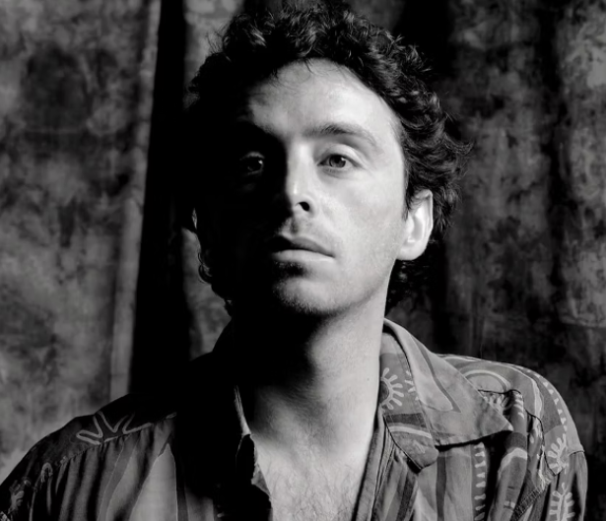
El Perry | 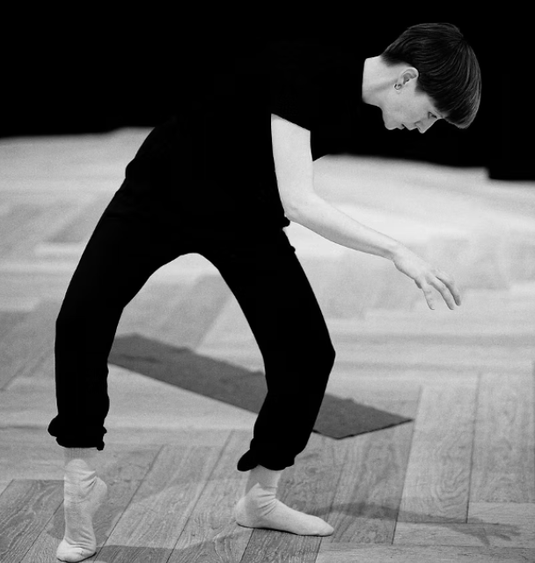
Annie Edwards | 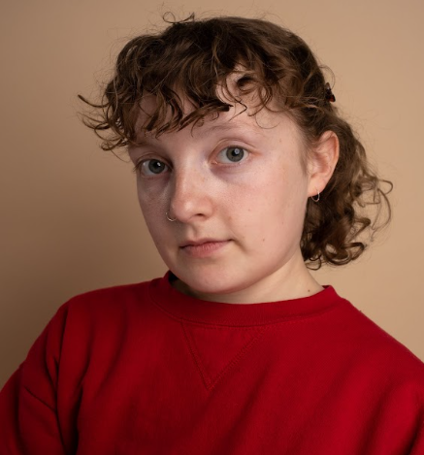
Jahmarley Bachelor | 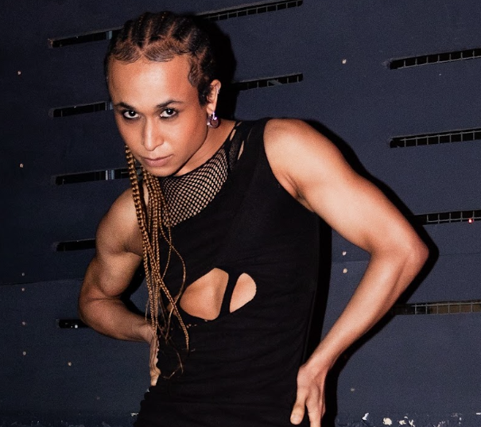
Azara Meghie | 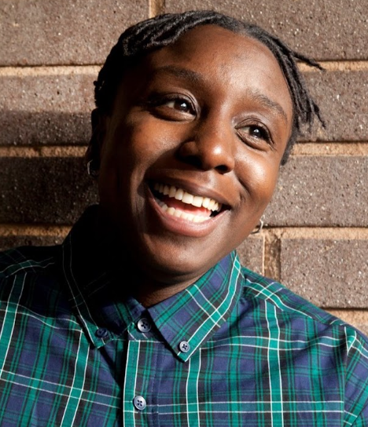
Luigi Nardone | 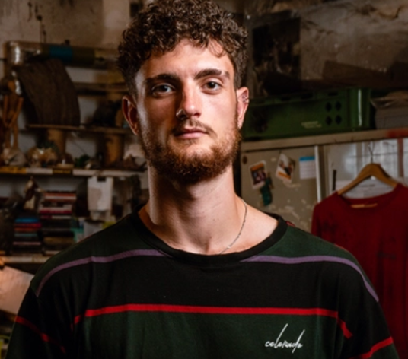
Jackie Ryan | 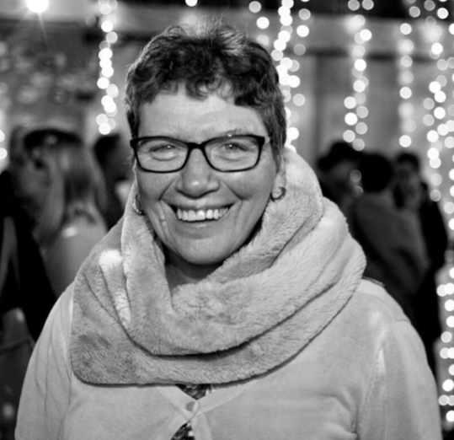
Alice Haddock | 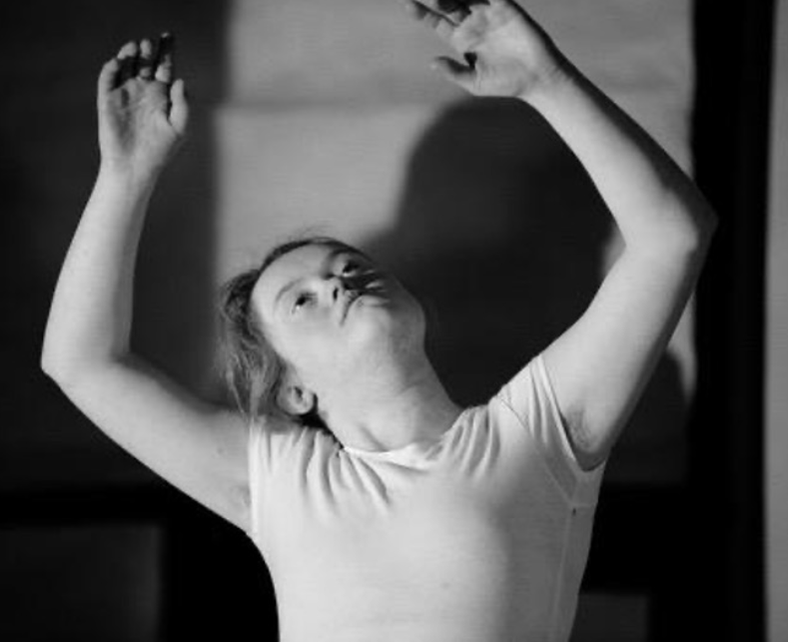
Sheri King | 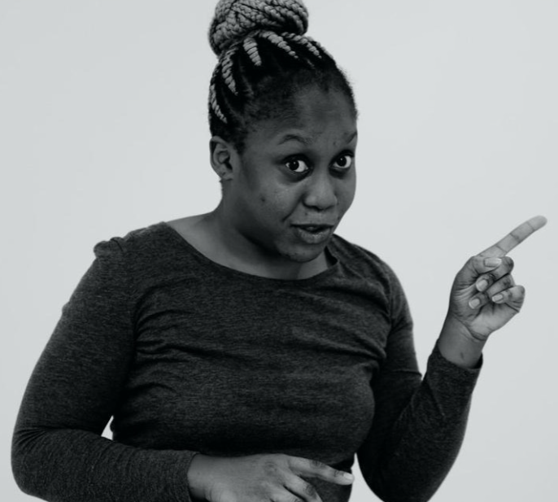
DJ Hassan | 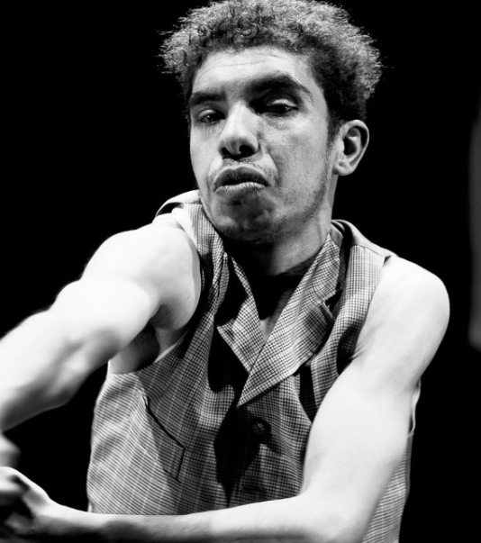
Paul Davidson | 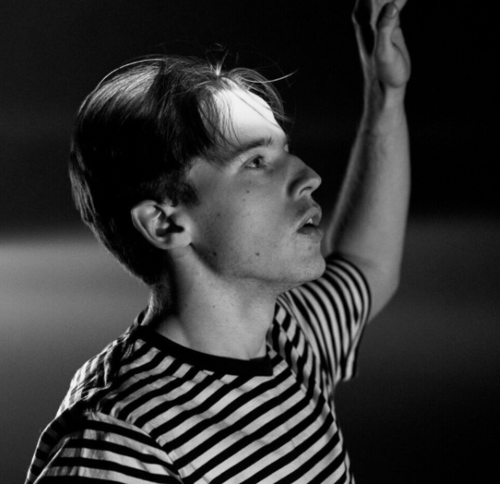
Lighting and Sound
- There will be some sudden loud noises and sounds.
- There will be music at the same time as people talking.
- There will be flashing/moving lights, no strobe.
- There will be some sudden blackouts, approximately 10 seconds. There may also be longer periods of darkness but there will be little bit of light spill from the captions.
- Haze will be used.

Participation
There is no audience participation.

Access Information
- The performance is 2h 10 minutes long, including 20 minutes interval
- There are captions integrated in every shows
- There will be use of mica flakes (not a known allergen) made up of natural silicate minerals that form in thin metallic sheets.
- There is an accessible toilet on every floor of the building
- There is a ‘chill out space’ outside the performance space that is available anytime the building is open
- All performances are Relaxed this means you can move or make noise if you need to and can go in and out of the performance space
- Latecomers will be permitted
- Ear defenders are available to borrow from the box office for anyone who might find these useful

Content Notes
- Themes of the show: Natural world, queerness, natural/unnatural, biology, diversity
- There will be discussion of upsetting topics - extinction, climate collapse, racism, queerphobia, violence. These are all handled with sensitivity, and the intention is to raise awareness and care, rather than to shock or upset
- A recording of a James Baldwin interview is used in the piece ‘Baldwin’s Room’, at one point he uses homophobic and racist slurs, including the N word once
- The show is made up of several short dance pieces, including solos, duets and a group performance. Different performers will appear throughout the show, with some appearing more than once

